Reconciling Operational Transactions

Table of contents
Operational reconciliation overview 1
Preparers and approvers 1
Department responsibilities 2
Reconciliation preparer responsibilities 2
Reconciliation approver responsibilities 6
Reconciliation retention 6
Journal source definitions 7

Operational reconciliation overview
Reconciling the monthly revenue and expense detail report is a critical fiscal management control to ensure revenue and expenditure transactions are correct, allowable and applied to the appropriate accounts.
Fiscal management officially rests with the department director, chair or other designated official. Account management is often the responsibility of specific administrative staff who report each month to the director, chair or other designated official on the status of departmental accounts. Departments are responsible for reconciling accounts and proving and documenting that an account balance is correct at least once a month for the previous month’s activity.

Preparers and approvers
The required reconciliation roles are preparer and approver. Preparers are administrative staff who handle a department’s day-to-day fiscal responsibilities and should be familiar with routine transactions for a department’s accounts.
Approvers are typically administrative staff who report monthly on the status of departmental accounts to the director, chair or other designated official.
Departments with limited staff that do not have a preparer and approver should consult with their dean’s office or vice president financial administrators to determine how to handle these roles appropriately.

Department responsibilities
Departments must provide evidence that the account reconciliation has been prepared and approved. The preparer and approver can do so by noting their names and the date on the reconciliation. Departments should document reconciliation procedures. Complete monthly reconciliations before the month-end close of the previous month. Month-end close is typically the fourth business day after the last day of the month.

Reconciliation preparer responsibilities
Before the preparer begins the monthly reconciliation, they should identify the cost center hierarchy or cost centers they are responsible for. Use one or a combination of the following reports to complete your monthly operational transaction reconciliation:
- Sponsored grant, gifts and programs reconciliation report
- Summary of funding sources by revenue category
- Summary of funding uses by spend category
Run the Summary of Funding Sources by Revenue Category report in Workday. Enter the report name in the search bar or refer to the department reports worklet to locate the report. In the example below, we are reconciling all programs, gifts, grants and projects within the cost center hierarchy CCH075 Financial Services for the month of August in fiscal year 2027.
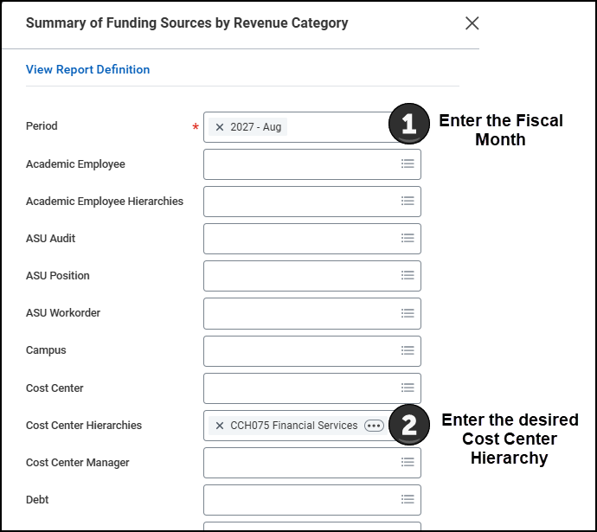
Select “OK” at the bottom of the screen.
Since you filtered the report by cost center hierarchy, the report will include all programs, projects, grants and gifts associated with the selected cost center hierarchy. Review the current month’s transactions. Transactions may be reconciled without physically verifying supporting documentation if the reviewer knows the nature of the transactions.
If you identify an unfamiliar transaction:
- Drill into the revenue category “Current Period Revenue” amount by selecting the number. A window will appear with the individual transactions.
- Select the journal to view the transaction and attachments.
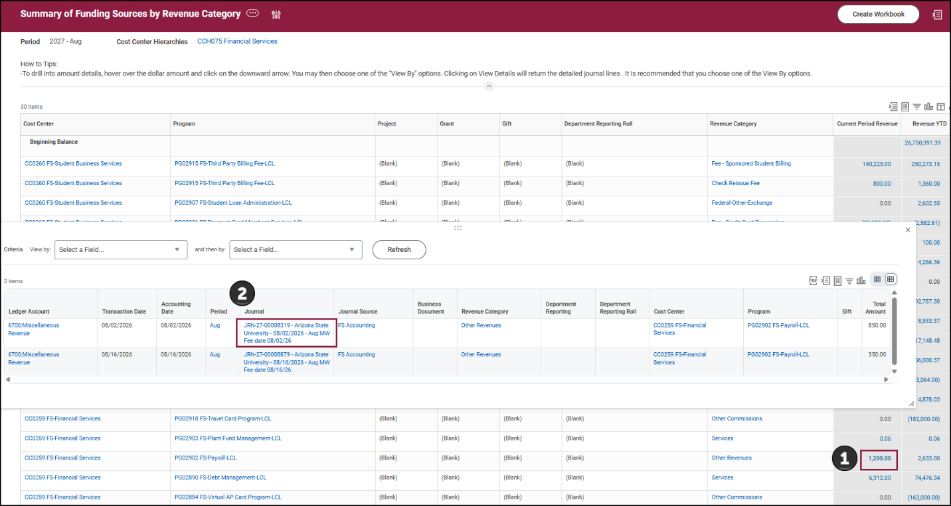
The transaction will display. To view the attachment:
- Scroll down and select the “Attachments” tab.
- Select the attachment to view.
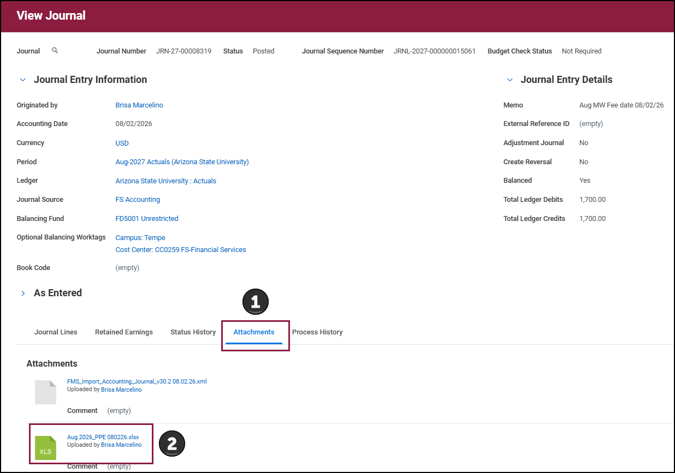
Continue reviewing the remaining transactions while researching any questionable ones. After you complete reconciling the revenue transactions, run the Summary of Funding Uses by Spend Category report and follow the same steps to reconcile the operational expenses.
Run the Sponsored Grant, Gifts and Programs Reconciliation Report in Workday. Enter the report name in the search Workday bar to locate the report. In the following example, we are reconciling all programs, gifts, grants and projects in the cost center hierarchy CCH075 Financial Services for the month of August in fiscal year 2027.
Note: This report is defaulted to exclude the following:
- Facilities and administrative costs
- Internal allocation expenses
- Payroll and ERE transactions
- Transfers In
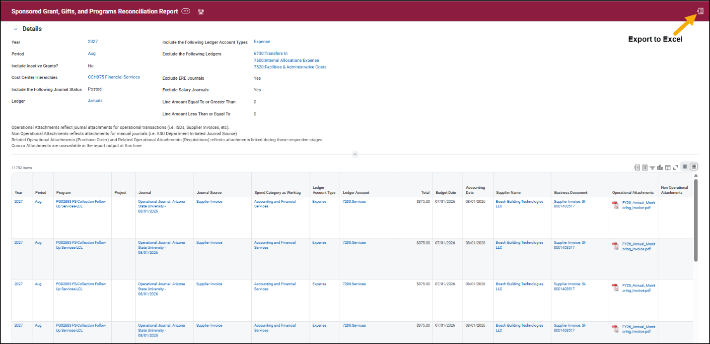
Once you have completed the reconciliation for the month, export the Workday report to Excel using the Excel icon on the report.
From the Excel spreadsheet, note any transactions that need to be corrected. Enter your name and the date in the Excel spreadsheet as the reconciliation preparer and save the file in your department-approved network drive or Dropbox folder.
Notify the reconciliation approver that the month’s reconciliation is ready for review and provide them with the file location.
Refer to the Best Practices Reconciling Payroll Expenses Procedures guide on the Best practices webpage or within the Financial Workspace worklet in Workday.

Reconciliation approver responsibilities
Once you have been notified that the reconciliation for the month has been completed, review the report and verify the appropriateness and legitimacy of the transactions recorded against the department’s account. Review any unusual or unexpected high-dollar amount transactions in detail.

Reconciliation retention
Retain all reconciliations and supporting documentation for non-sponsored accounts for at least three fiscal years per FIN 103. Sponsored accounts have a retention period of seven fiscal years after the grant close date. Refer to the research administration webpage for additional guidance on reconciling sponsored accounts.

Journal source definitions
Contact the Financial Services Accounting staff for assistance with researching questionable transactions.
Journal source | Description
Accounting adjustment | Accounting adjustment tasks processed on a supplier invoice, expense report or procurement card transactions.
Allocation | Internal allocation activities, like an administrative service charge, Risk Management fee or telecommunications fee.
ASU Department Initiated | Non-transfer accounting journals initiated by an ASU department.
ASU Department Transfers | An ASU department-initiated accounting journal transferring in or out between another ASU department.
ASU ISD Corrections | An ASU department-initiated accounting journal used to process adjustments related to internal service delivery transactions.
Customer Invoice | Customer invoice task.
Expense report | Expense report task or Concur expense reports.
Facilities and administration expense | Facilities and administration expenses posted in real-time as applicable charges are recorded.
Fringe Benefit | Employee-related expenses.
Fringe Benefit Actual Adjustment | Accounting adjustment tasks processed on a payroll transaction automatically, moving employee-related expenses with the personal service adjustment.
Fringe Benefit Forward Accrual | The year-end employee-related expenses accrual and subsequent reversal.
FS Accounting | Accounting journals processed by the Financial Services Accounting department.
FS Commitment Accounting | Accounting journals processed by the Financial Services Commitment Accounting department.
FS Credit Card Allocation | Credit card fees allocated to departments per transaction.
FS Payroll Accrual and Reversal | Manual year-end payroll accrual and subsequent reversal journals.
FS Payroll Adjustment | Manual payroll journals processed by Financial Services.
FS Plant | Accounting journals processed by the Financial Services Plant and Debt department.
FS PSCS Cashiering | Manual correction related to the integration.
FS SBS Financial Aid | Journal entries processed by Student Business Services for transactions on financial aid accounts.
FS SBS Scholarship Transfers | Journal entries to fund scholarships, requested by departments via scholarship transfer requests and processed by Student Business Services.
FS SBS Tuition | Tuition and fee adjustments processed by Student Business Services.
FS Student Business Services | Accounting journals processed by Financial Services and Student Business Services.
FS Tax | Accounting journals processed by the Financial Services Tax Services department.
FS Travel | Accounting journals processed by the Financial Services Travel department.
FS Treasury Services | Accounting journals processed by Financial Services Treasury Services.
GU Transfers | General University transfers at the request of the Office of Planning and Budget.
Integration — F and A encumbrance | Facilities and administration encumbrances.
Integration — Banking | Items related to the bank reconciliation process, including ad hoc bank transactions.
Integration — Concur | Travel export fee and carbon offset fees from Concur.
Integration — PSCS cashiering | Cash, check and electronic deposits from PeopleSoft cashiering.
Integration — PSCS student financial accounting | The interface of student financial accounting activity from PeopleSoft.
Internal service delivery | Interdepartmental transactions processed by an ASU internal service provider.
ORSPA-ACP | Revenue and spend transfers or corrections processed by award and cash management. The transaction is related to award cost processing and should be, if an expense, available for billing.
ORSPA-No ACP | Revenue and spend transfers or corrections processed by award and cash management. The transaction is not related to award cost processing and should not be available for billing.
PCard Manual | Manual corrections related to the integration.
Payroll Accounting Adjustment | Accounting adjustment tasks processed on a payroll transaction.
Payroll Actual Accrual | Gross personal services and graduate tuition remission benefits expenses.
Payroll Forward Accrual | The year-end personal services expense accrual and subsequent reversal.
Procurement Card Transaction Verification | Integration of P-Card transactions from Bank of America.
Supplier contract | Supplier contract task.
Travel ghost card manual | Travel charges paid on the ghost card.

