Deck of Cards
Hearts – Red  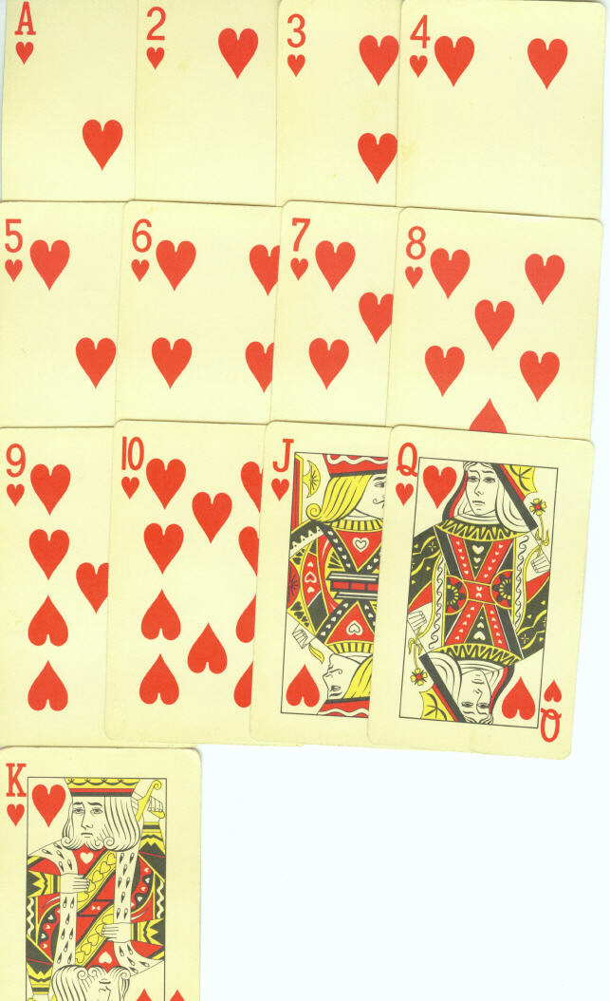 |  | Diamonds – Red  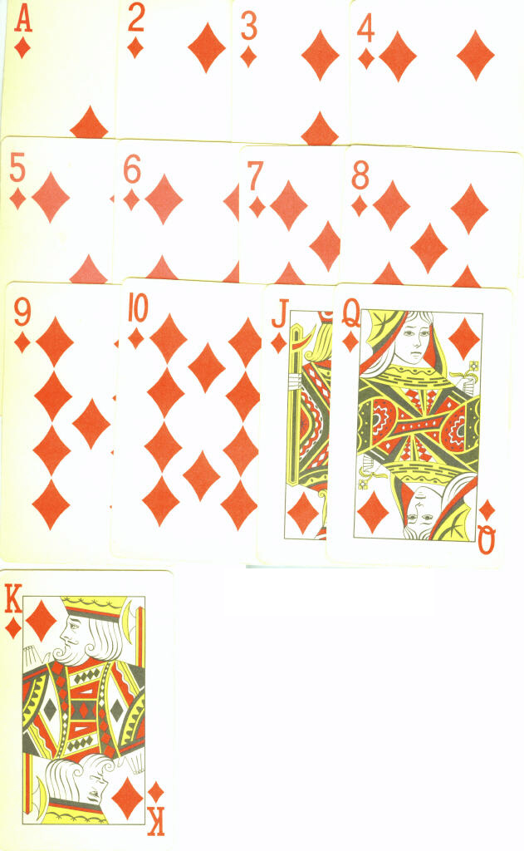
Clubs – Black  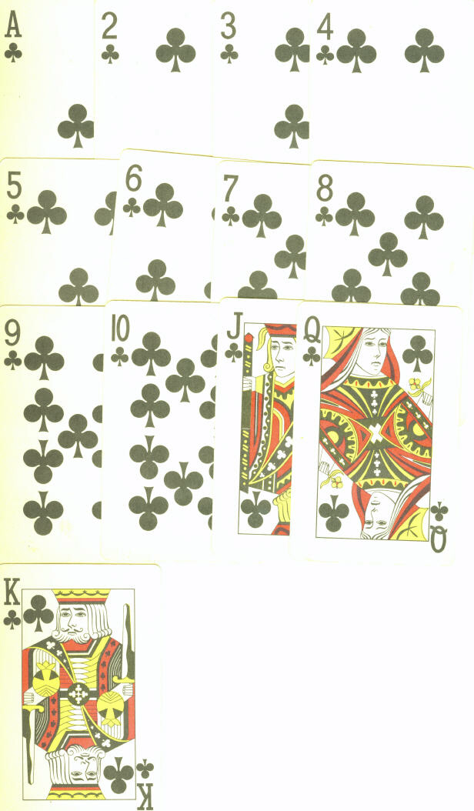 |  | Spades – Black  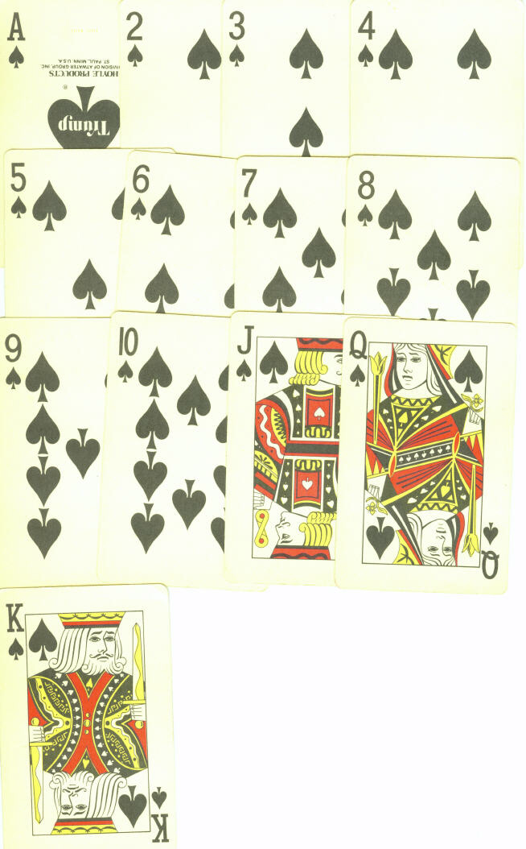

Deck of Cards: 52 total, 4 suits of 13 each. Clubs (♣) and Spades (♠) are black, Hearts (♦) and Diamonds (♥) are red. Jack (J), Queen (Q) and King (K) are face cards.
♣: 2 3 4 5 6 7 8 9 J Q K A
♠: 2 3 4 5 6 7 8 9 J Q K A
♦: 2 3 4 5 6 7 8 9 J Q K A
♥: 2 3 4 5 6 7 8 9 J Q K A

