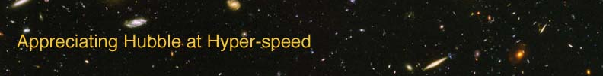

Name: Date:

PROPERTIES OF WAVES EXERCISE

The goal of this laboratory exercise is to introduce the student to the properties of waves. Waves are an important tool for understanding astronomy, because light can be described as an electromagnetic wave.

EQUIPMENT: Calculator, Ruler

INTRODUCTION

A wave can best be described as a traveling disturbance. This means that the wave travels through a region without resulting in a net displacement of the material located in that region. For example, when a thrown rock causes ripples in a pond, those ripples pass and then the pond looks as it did before. A wave can transfer energy from one point to another without transferring material between the two points, which is important because astronomers use the energy of light to understand distant celestial objects.

MEASURING PROPERTIES OF WAVES

There are some basic definitions needed to describe a wave. A wavelength is the length between two consecutive similar points on a wave (peak to peak, valley to valley, etc…). The amplitude is maximum displacement of the wave, or the maximum height of the wave above the equilibrium position. The period is the time it takes for the wave to complete one wavelength. The frequency is how often a wavelength passes by a given point, which is also equal to one divided by the period.

Use Figure 1 provided below to answer the following questions:

A
B
C
D
E

- The wavelength is given by which letter?

- The amplitude is given by which letter?

- How many complete wavelengths are represented in Figure 1?

Use Figure 2 to answer the following questions:
- How many wavelengths are shown in Figure 2?

- What if you wanted to fit more wavelengths into the 25 seconds shown – would you shorten or lengthen the wavelength?

- If you fit more wavelengths into the 25 seconds shown, would you be increasing or decreasing the frequency of the wave?

- As the frequency of a wave decreases, the wavelength
  - Decreases
  - Increases
  - Remains the same

PROPAGATION OF WAVES

It is important to understand how waves propagate (travel). Regardless if they’re waves on a string or seismic waves, sound waves or light waves, the speed of a wave can always be defined as: speed = wavelength × frequency.

- What is the period for the wave in Figure 2?

- Recalling that frequency = 1/period, what is the frequency?

- Use a ruler to measure the wavelength of the wave in Figure 2. Give your answer in cm.

- Calculate the speed of the wave represented in Figure 2.

Now that you’ve become more familiar with the general properties of waves, we can better understand light waves and how astronomers learn from them.

