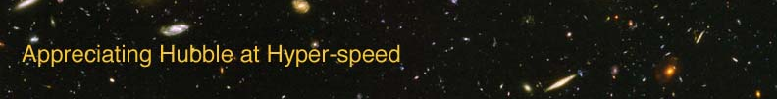

Name: Date:

LOOK-BACK TIME EXERCISE

The goal of this laboratory exercise is to introduce the student to the concept of look-back time. Because the speed of light is not infinitely fast, the light from distant objects takes time to reach us here on Earth. At the end of this lab, the students should have greater appreciation of how this allows us to look back in time as we look out in the universe.

EQUIPMENT: Calculator

WHAT DOES A LIGHT-YEAR MEAN?

- Is a light-year a time interval, a unit of length, or an amount of speed?

Imagine that four friends want to keep in touch with you over the vast reaches of space.

- Aaron lives on a planet orbiting Ross 154, which is 9.5 light-years from our Sun.
- Greg lives on a planet orbiting Barnard's Star, which is 6.0 light-years from our Sun.
- Kirsten lives on a planet orbiting Sirius, which is 8.6 light-years from our Sun.
- Lisa lives on a planet orbiting Alpha Centauri, which is 4.3 light-years from our Sun.
- You live on Earth, orbiting our Sun.

Using the information from the previous page and your knowledge of the definition of a light-year to answer the following questions:

1. Which friend lives closest to our Sun? How far away does he or she live?

- Your friends want to send a message to you. Which friend’s message will take the longest to reach you? How long will it take?

- You want to send birthday greetings to each of your friends for them to receive on their 18th birthday. How old is each friend when you send the message?

  - Aaron

  - Greg

  - Kirsten

  - Lisa

- Now imagine that all of your friends send you “thank you” messages back. How old will they be when you receive their messages?

  - Aaron

  - Greg

  - Kirsten

  - Lisa

LARGE DISTANCES

- This accompanying image is of the Cat’s Eye nebula. The estimated distance to this nebula is 3000 light-years. Are you seeing the nebula as it looks now, as it looked in the past, or as it will look in the future? Justify your answer.

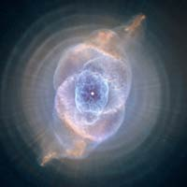

- This accompanying image is of the galaxy NGC 1309, which is located 100 million light-years away from us. Did the light we see from this galaxy leave it earlier, later, or at the same time as the nebula in the previous question? Justify your answer.

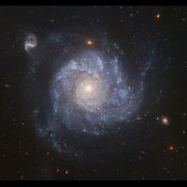

- The galaxy near the center of this image is 8 billion light-years away. If the estimated current age of Earth and the Solar System is 4.6 billion years, how old was the Earth when the light from this galaxy left it on its way to us?

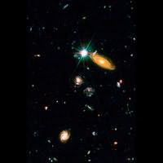

PUTTING IT ALL TOGETHER

- Do you ever see yourself as you “are” when you look in the mirror?

- Astronomers who study cosmology frequently refer to “look-back” time. From your answers to the preceding questions, write down a possible definition for “look-back” time.

Now that you understand look-back time, you understand how astronomers can directly observe the past!

Based on an exercise from Lecture Tutorials for Introductory Astronomy, Preliminary Ed., Adams, Prather, & Slater
Images from NASA/Hubble Space Telescope (http://hubblesite.org)

