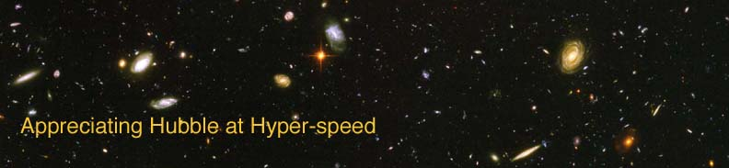

Name: Date:

HUBBLE LAW EXERCISE

The goal of this laboratory exercise is to introduce the student to the Hubble Law. The student will deduce the relationship and discover some of the uses and implications of the Hubble Law.

EQUIPMENT: Calculator, Ruler, Graph Paper or graphing software, Computer with AHaH applet installed

INTRODUCTION

The early twentieth century witnessed great progress in our understanding of the universe. One of the most important discoveries was made by Edwin P. Hubble. He discovered a relationship that now bears his name, the Hubble Law. Not long after it was discerned that the “spiral nebulae” were galaxies external to our own, astronomers cataloged the Doppler shifts of galaxies. Using Cepheid variable stars, astronomers were also able to estimate distances to some galaxies. Edwin Hubble showed that there was a correlation between the Doppler shifts and the distances of galaxies. This relationship is known as the Hubble Law.

The Doppler Shift is the change in the frequency (or wavelength) of light emitted by a source due to its relative motion with respect to the observer. The observed change in wavelength is dependent upon the relative speed between the source and the observer. If the relative motion between the two objects is towards each other, the resulting shift is called a “blueshift” and if the relative motion is away, the motion results in a “redshift.” One of the crucial discoveries of 20th century astronomy is that, with very few exceptions, galaxies show redshifts.

The typical notation for redshift: redshift $z=\frac{v}{c}$

PROCEDURE

Open up the “Appreciating Hubble at Hyper-speed” (AHaH) applet on the computer. To determine the Hubble Law for yourself, you will want to obtain redshift and distance information for 25 galaxies.

Click on a galaxy to bring up the Info Box. In the table below, record the Object ID, redshift, and distance to the galaxy. Do this for 25 galaxies, making sure to get a range of redshifts, say z = 0 - 3.

Object ID | Redshift z | Distance (Mpc)

- Type “H” to bring up the Help Box. Click on “Options”. Copy down the value for H_{o} here. (The default units for H_{o} are km/s/Mpc.)

ANALYSIS

Now that you have your observations, you can now discover the Hubble Law for yourself. On a piece of graph paper or using graphing software, plot redshift z on the y-axis and distance D (in Mpc) on the x-axis.

- Fit a line to your data and calculate the slope of the line. Write your slope here, and don’t forget the units!

The slope of the line for this data is known as the Hubble Constant, H_{o},. This constant is an important quantity for understanding the universe, as it represents the rate of expansion of the universe.

- Multiply the slope of your line by the speed of light: c = 3 × 10⁵ km/s to obtain your value for the H_{o} in units of km/sec/Mpc.

- In order for the AHaH program to step through the universe, a value for the Hubble Constant, H_{o} is incorporated into the program. How does your experimental value for H_{o} from question 3 compare to that used in the program that you listed in question 1?

Go back to the computer and the AHaH applet. Type “H” to bring up the Help Box. Then click on “Options”. Change the value of H_{o} to 42 and click “OK”.
Type “J” to bring up the Jump Dialog Box. Type in the Object ID of a galaxy from your table and answer the following questions:

- Is the redshift to the galaxy different due to the different value of H_{o}?

- Is the distance to the galaxy different due to the different value of H_{o}?

Based on your answers to the previous questions, what is a possible role that the Hubble constant plays in models of the universe?

PUTTING IT ALL TOGETHER

The Hubble Constant relates a speed (km/s) to a distance (Mpc). Let’s look at a practical application of speed and distance in your everyday life and see how it relates to the universe.

- If a car travels at a speed of 75 miles/hr for 60 miles, for how long does the car travel?

- If the Hubble constant is 75 km/s/Mpc, how long has the universe been expanding, i.e., what is the age of the universe? (Recall that 1 Mpc = 3.1 × 10²⁰ km)

Now that you’ve become more familiar with the Hubble Law, you have a better idea of its role in our understanding of the universe.

