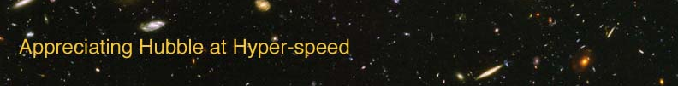

Name: Date:

GALAXY MORPHOLOGY EXERCISE

The goal of this exercise is to introduce the student to the different types of galaxies we see in the universe. The study of the shapes and types of galaxies is called galaxy morphology, and it has enabled us to learn much about galaxies.

EQUIPMENT: computer with AHaH software

INTRODUCTION

A galaxy is a gravitationally bound grouping of stars, dust and gas that is isolated in space. Our solar system resides in a galaxy called the Milky Way, which is also sometimes referred to as “the Galaxy.” As we have observed many galaxies, we have discovered that the number of stars can vary from millions to billions and that the amount of gas and dust varies between different galaxies. As part of an endeavor to better understand galaxies, in the early twentieth century Edwin Hubble developed a classification scheme in which the galaxies were separated into different types based on shape. These classifications are called “morphological” types, because morphology is the study of form or structure.

In the simplest form of the Hubble classifications, there are three primary types of galaxies:

- Ellipticals – Elliptical galaxies appear as smooth distributions of stars with little evidence of substructure. The usual designation for an elliptical galaxy is “En”, where the number n is a function of the relative size of the major and minor axes of the observed ellipse. In this scheme, an elliptical galaxy that was perfectly spherical would be an “E0”, whereas the most oblong elliptical would be an “E7”.

- Spirals – Spiral galaxies are characterized by a distinct spiral shape in the distribution of stars. Spirals also appear to have prominent dust lanes, which can be seen even if the galaxy is observed from a side view where the spiral structure is not evident. The subclasses of spirals are related to the size of the galactic nucleus and the tightness of the spiral arms. Also noted is whether or not the galaxy shows a bar; in a barred spiral, the spiral arms appear to trail from an elongated nucleus, as opposed to a spherical nucleus. Spirals are classified Sa, Sb, or Sc, whereas barred spirals are denoted SBa, SBb, or SBc. The nucleus of an Sc galaxy is smaller than in an Sa galaxy, and the arms of the Sc are wrapped more loosely.

- S0 – also called “lenticular galaxies” – S0 galaxies have the disk-like shape of spiral galaxies, but lack spiral arms.

- Irregulars – Irregular galaxies do not exhibit an obvious spiral or elliptical structure. Some astronomers hypothesize that irregulars may once have been spirals or ellipticals, but have lost those structures due to gravitational interaction with another galaxy(ies).

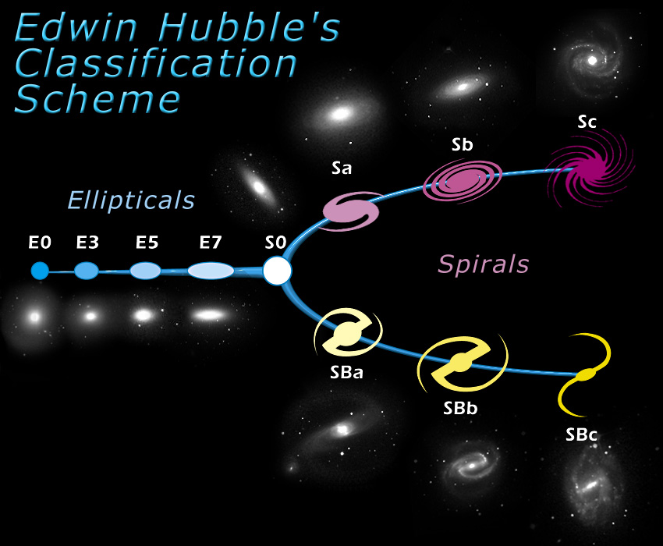

Procedure

Now it is your turn to decide the Hubble Morphological type for several galaxies. In the above figure are displayed the typical shapes of several morphological types. When deciding which classification to give to a galaxy, make certain to denote a subtype. Please use one of the subclasses given here. If you cannot decide between an Sa or Sb, make a choice and explain why you were having difficulty.

Use the classroom computers to access the “Appreciating Hubble at Hyper-speed” application. Your goal is to view the provided images of galaxies to determine their Hubble Classification type. Your instructor will either give you a list of object IDs or you will randomly choose galaxies. You can view a specific object by typing “j” and entering the object ID. If you are uncertain how to use the software, type “h” or “F1” to bring up the help screen.

Fill in the provided table with morphological type, overall color of the galaxy (reddish? bluish?), and whether or not dust is evident in the galaxy. Feel free to record any notes that might make answering the questions at the end of the lab easier. Make certain to include an estimate of subtype using the classes established above when determining the Hubble type.

Table: Determining Hubble Classifications
Object ID | Color? | Dust? | Hubble type? | Comments

Putting It All Together

- Which type of galaxies (spiral or elliptical) contains dark dust clouds/large regions of gas and dust? Name two examples from the listed galaxies to support your answer.

- If stars form out of large clouds of gas and dust, in which type of galaxy is there least likely to be ongoing star formation? (In other words, in which type (E,S,Irr) did not seem to contain much gas and/or dust?) Name two examples from the listed galaxies to support your answer.

- Recalling earlier work on colors and temperatures of stars, what is the typical color of a young group of stars?

- What is the typical color of an older group of stars?

- Which type of galaxy (elliptical or spiral) would be most likely to have the oldest population of stars? Explain your answer. Name two examples from the listed galaxies to support your answer.

Now you have a better understanding of the properties of galaxies!

Hubble Tuning Fork diagram courtesy of the NASA/Space Telescope Science Institute

