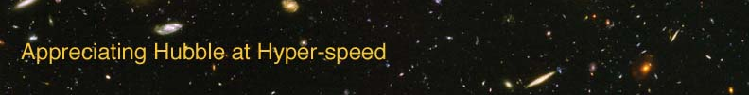

Name: Date:

GALAXY EVOLUTION EXERCISE

The goal of this laboratory exercise is to introduce the student the concept of galaxy evolution. The student will venture into the past of the universe to determine if galaxies remain the same or change with time.

EQUIPMENT: Computer with AHaH applet installed

INTRODUCTION

Until the early 20th century, the dominant view of the universe was that it was static – ever the same, never changing. Edwin Hubble’s discovery that the universe was expanding changed how we perceived the universe; the universe could and did change over time. The telescope that bears his name has revealed that galaxies can change over time as well, leading to the concept of galaxy evolution. The study of galaxy formation and evolution is a thriving area of astronomical research. This exercise will allow you to see some of the evidence for galaxy evolution.

PROCEDURE

Open up the “Appreciating Hubble at Hyper-speed” (AhaH) applet. For this exercise, you will be counting the number of spiral, elliptical, and irregular galaxies you see within specified redshift ranges. For each redshift range, count at least 20 galaxies.

To determine the redshift of a galaxy, click on the galaxy to bring up the Info Box, which includes the redshift. If you need to venture deeper into the universe to find galaxies at higher redshifts, you have two options: 1) you can open the Jump Dialog Box by typing “j” and specify which redshift you would like to jump to or 2) you can press “shift” and the “up” arrow to move smoothly into the universe.

Fill out the following table, remembering to find at least 20 galaxies in each redshift range.

Redshift range | Spiral | Elliptical | Irregular
0.0-0.3
0.3-0.5
0.5-1.0
1.0-1.5
1.5-2.0
2.0-2.5
2.5-3.0
3.0-4.0

Answer the following questions based on your observations :

- What type of galaxy is the most common at the lowest redshifts?

- What type of galaxy is the most common at the highest redshifts?

Recall what you learned about look-back time and the Hubble Law and answer the following questions:

- Which redshifts correspond to larger distances away from us – low or high redshifts?

- Which distances correspond to longer look-back times – smaller distances or larger distances away from us?

- Considering your answers to questions 3 and 4, which redshifts show us galaxies farther back in time – low or high redshifts?
- What type of galaxy is the most common in the early universe?

BRINGING IT ALL TOGETHER

Current models of galaxy formation start with small irregular blobs of gas and young stars merging and forming larger galaxies. What evidence did you see in this experiment to support or refute this idea?

Now that you’ve become more familiar with the properties of galaxies at different redshifts, you can better understand current models of galaxy formation and evolution.

