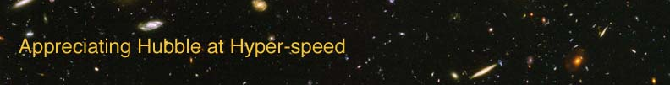

Name: Date:

DISTANCE MEASURES EXERCISE

The goal of this exercise is to introduce the student to some common units of distance measure used in astronomy.

EQUIPMENT: Ruler, Calculator, Objects that can be used to mark distances

DAILY MEASUREMENTS

In your daily life, you estimate distances all the time: to know when you need to leave your home to reach school on time, to gauge whether your car will fit in that space, to fit all the presents in a box to send for your best friend’s birthday

- What are some units of distance that you use in every day life?

- Can these units be used to measure the distances to astronomical objects? Why or why not?

ASTRONOMICAL DISTANCES

As you may have guessed in your answer to the previous question, the basic units of distance you use everyday can be unwieldy when describing the distances to celestial objects. You will not become familiar with some common astronomical distances measures.

In the solar system, it is convenient to use the average distance between the Earth and the Sun as a unit of distance. This distance is called the astronomical unit (AU).

- If the time it takes for the light from the Sun to reach us is 8.3 min and light travels at 3 × 10⁵ km/s, how many kilometers are in 1 AU?

The following table lists the distances from the Sun for the eight planets of the solar system.

Planet | Distance from Sun (AU)
Mercury | 0.387
Venus | 0.723
Earth | 1.000
Mars | 1.524
Jupiter | 5.203
Saturn | 9.539
Uranus | 19.19
Neptune | 30.07

Using the scale 1AU = 10 cm, make a model of the solar system.

- Does the Solar System look the way you expected? Explain your answer.

The AU is the distance measurement most commonly used in the Solar System, but to measure distances to celestial objects outside the Solar System, it is convenient to use other measures. One such measure is the light-year, which is the distance that light travels in one year.

- How many kilometers are in 1 light-year? Recall that the speed of light is 3 × 10⁵ km/s.

- How many AU can fit in 1 light-year?

- The nearest star is in the Alpha Centauri system, 4.24 light-years away. Using the scale you established for the solar system, would the Alpha Centauri system fit in your classroom with the Sun?

Another distance measure used in astronomy is the parsec (pc), which is equal to 3.26 light-years.

- If the Alpha Centauri system is 4.24 light-years away, what is the distance to Alpha Centauri measured in parsecs?

Galaxies are farther away than the stars you see in the night sky. To measure the distances to galaxies, astronomers often use megaparsecs (Mpc), where mega is the metric prefix meaning “million.”

- If the NGC 1309 galaxy is 30 Mpc away, what is the distance to it in parsecs?

- What is the distance to NGC 1309 (previous question) in light-years?

Now you’re prepared to deal with astronomical units of measure.

