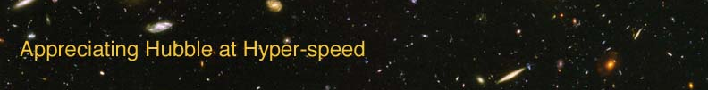

Name: Date:

COSMOLOGICAL PARAMETERS EXERCISE

The goal of this laboratory exercise is to introduce the student ***
EQUIPMENT: Calculator, Ruler

INTRODUCTION

***These are the cosmological parameters we have to play with: H, Ω_{m}, Ω_{R}, Ω_{Λ}

MEASURING PROPERTIES OF WAVES

Now that you’ve become more familiar with the general properties of waves, we can better understand light waves and how astronomers learn from them.

