Writing Across the Curriculum Resources:
Books & Websites:
The Online Writing Lab at Purdue University provides a wonderful resource for instructors and writing program administrators interested in creating or supporting a Writing Across the Curriculum program. OWL offers handouts, teaching materials, historical overview and provides a clear distinction between Writing Across the Curriculum, Writing to Learn, and Writing in the Disciplines. You can visit this section of the OWL website at http://owl.english.purdue.edu/handouts/WAC/.
Writing and Reading Across the Curriculum by Laurence Behrens and Leonard J. Rosen recently celebrated the 10th edition printing (paperback) and is now available on Amazon.com. From the Back Cover: This brief version of the best—selling cross—curricular classic retains its hallmark coverage of source—based writing skills combined with five popular readings chapters. This portable version represents a carefully—chosen selection from the original edition, with five (of the original seven) readings chapters included in their entirety. The abbreviated rhetoric section still covers the skills of summary, critique, and synthesis, taking students step—by—step through the process of writing papers based on source material. Students then put these skills to practice on thematically—linked essays on provocative topics in the discipline—specific readings chapters. A stronger focus on argumentation addresses the trend found in today's composition classrooms. Individuals interested in writing from sources and academic writing in different disciplines.
Link: http://www.amazon.com/Writing-Reading-Across-Curriculum-10th/dp/0321486439/ref=pd_bbs_1/105-8214457-1234845?ie=UTF8&s=books&qid=1187025251&sr=8-1

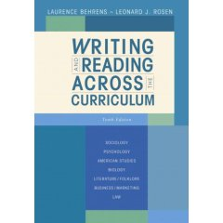

The WAC Clearninghouse website offers history, research and extensive resources about Writing Across the Curriculum. One of the more unique features of this website is the Research Exchange section which allows users to network with other researchers sharing similar interests. WAC Clearinghouse is free and open to all however users are strongly encouraged to join and participate in building the resources to help others. You can visit the WAC Clearinghouse at http://wac.colostate.edu.
The Writing Across the Curriculum website is maintained by Northern Illinois University and is based on the belief that “students learn critical thinking best when they actively engage in the subject matter of a course through writing. When students use writing as a means of inquiry and problem solving in various classes, they simultaneously learn the material and become better writers.” WAC/NIU offers workshops, newsletters, a webliography and archives of past newsletters. You can visit the WAC site at http://www.engl.niu.edu/wac/.
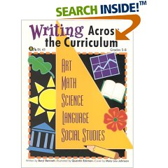
Writing Across the Curriculum by Beryl Bennett expands opportunities for writing with these exercises in the areas of math, science, art, language arts, and social science. Two complete lessons for each subject area include explicit writing prompts, prewriting activities, precomposing sheets, concise directions outlining the format of writing, and rubrics. Additionally, there are six writing prompts for each subject area. Grades 5-8. Available on Amazon.com at http://www.amazon.com/Writing-Across-Curriculum-Beryl-Bennett/dp/0931724775/ref=pd_bbs_2/105-8214457-1234845?ie=UTF8&s=books&qid=1187025251&sr=8-2

The UVSC CXC is a site offering information about Curriculum Across the Curriculum (CXC) and is based out of Utah Valley State College. This website offers WAC articles, a WAC Clearinghouse, bibliographies, 25 teaching ideas, a practices subsection of the website and online workshops. You can visit the UVSC CXC website at http://research.uvsc.edu/kyburz/cxc.html.
The University Writing Program at George Washington University has created a comprehensive annotated bibliography on Writing in the Disciplines Teaching Resources which is filed with useful information for WAC instructors. You can review the bibliography here: http://www.gwu.edu/~uwp/wid/wid-teachingresources.htm

