Title of your presentation for WINDS 2017
(Times New Roman, 14pt, bold)

Hikari Tomori¹, Masahiko Hayashi², and Akinobu Kanda¹
(Times New Roman, 12pt)

¹ Division of Physics and TIMS, Faculty of Pure and Applied Sciences, University of Tsukuba, Tsukuba, Ibaraki 305-8571, Japan
² Faculty of Education and Human Sciences, Akita University, Akita, Japan
e-mail: kanda@lt.px.tsukuba.ac.jp (e-mail address of the corresponding author)
(Times New Roman, 12pt, Italic)

The Workshop on Innovative Nanoscale Devices and Systems will be held from Nov. 26 to Dec. 1, 2017, at the Hapuna Beach Prince Hotel on the Kohala Coast of the Big Island of Hawaii [1]. The abstract text should fit in one A4 page (210 mm x 297 mm, portrait, printable area 160 mm x 240 mm – top/bottom margins of 30 mm and left/right margins of 25 mm). An additional page is allowed for figures (see the second page of this template for the suggested format). Please underline the presenting author. Ensure that the e-mail address is correct, as it is used for further communications. Please do not insert any page number, header or footer. Please use Times New Roman font and do not forget to remove all ( )’s for instruction. Save your abstract as a single pdf (Portable Document Format) file with the file name, (presenter’s first name)_(presenter’s family name).pdf. For example, when the presenter is Akinobu Kanda, the file name is akinobu_kanda.pdf. If you submit more than one abstract as presenter, you may add a number at the end of the file name (e.g., akinobu_kanda _2.pdf). Make sure that the pdf file of your abstract is of camera-ready quality with all fonts embedded.
(Times New Roman, 12pt)

[1] H. Tomori et al., Appl. Phys. Express, 4, 075102 (2011).
(Times New Roman, 11pt)

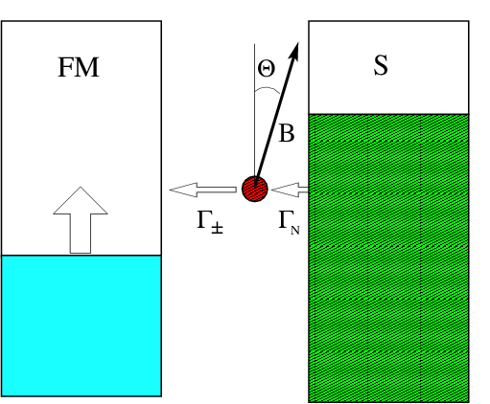 | 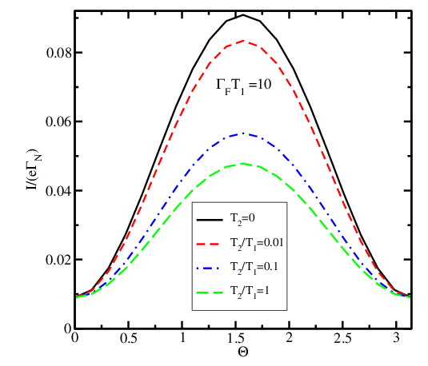
Fig.1: The trap is connected to electrodes with the rates Γ_{N} and Γ±. A magnetic field B defines the trap spin quantization axis OZ’ at an angle Θ to the magnetization orientation OZ in the ferromagnet. | Fig.4: Current as a function of Θ, for p=1, Γ_{N}/Γ_{F} = 10, ω_{L}/Γ_{F} = 1, Γ_{F} T₁ = 10, and several values of T₂/T₁.
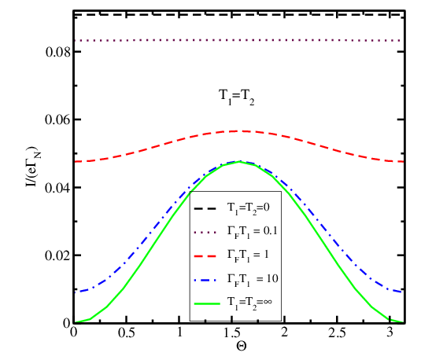 | 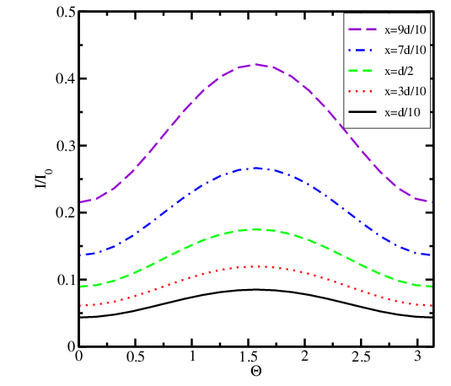
Fig.2: Current in units of eΓ_{N} as a function of Θ for p=1, Γ_{N}/Γ_{F} = 10, ω_{L}/Γ_{F} = 1, and several values of T₂=T₁. | Fig.5 Normalized current as a function of the position x relative to silicon, for p=1, Γ_{N}=Γ₀ exp(-x/d) , Γ_{F}=Γ₀ exp(-(d-x)/d), T₂=T₁, ω_{L}T₂ = Γ₀T₂ =10,
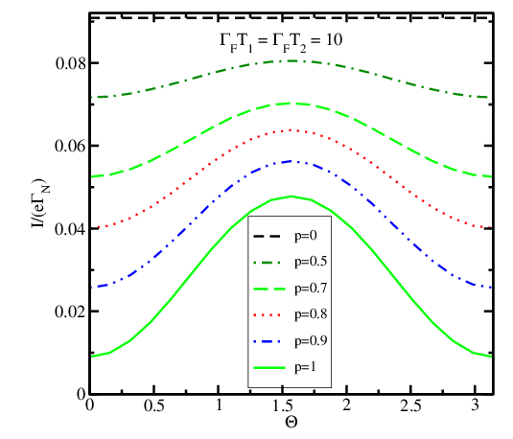 | 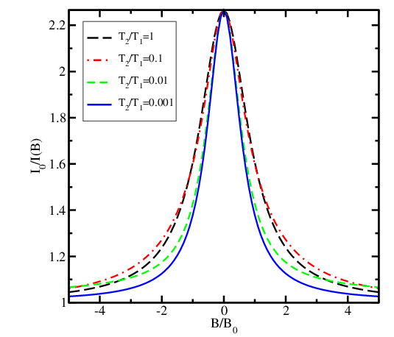
Fig.3: Current as a function of Θ, for Γ_{N}/Γ_{F} = 10, ω_{L}/Γ_{F} = 1, Γ_{F} T₁ = Γ_{F} T₁ = 10, and several values of p. | Fig.6: Magnetoresistance signal as a function of the perpendicular magnetic field B for several T₂/T₁, for p=0.8 and Γ_{F} T₁ = 10. The field B₀ is parallel to the magnetization in the ferromagnet.

