REQUEST FOR QUALIFICATIONS / INVITATION TO NEGOTIATE

DEVELOPMENT OF A HOTEL AND CONFERENCE CENTER

RFQ NO. 091302

Issued: October 22, 2012

DUE: 3:00 P.M., MST, December 10, 2012

Time and Date of Pre-Proposal Conference 9:00 AM, MST, November 5, 2012
Deadline for Inquiries 5:00 PM, MST, December 3, 2012
Time and Date Set for Closing 3:00 PM, MST December 10, 2012
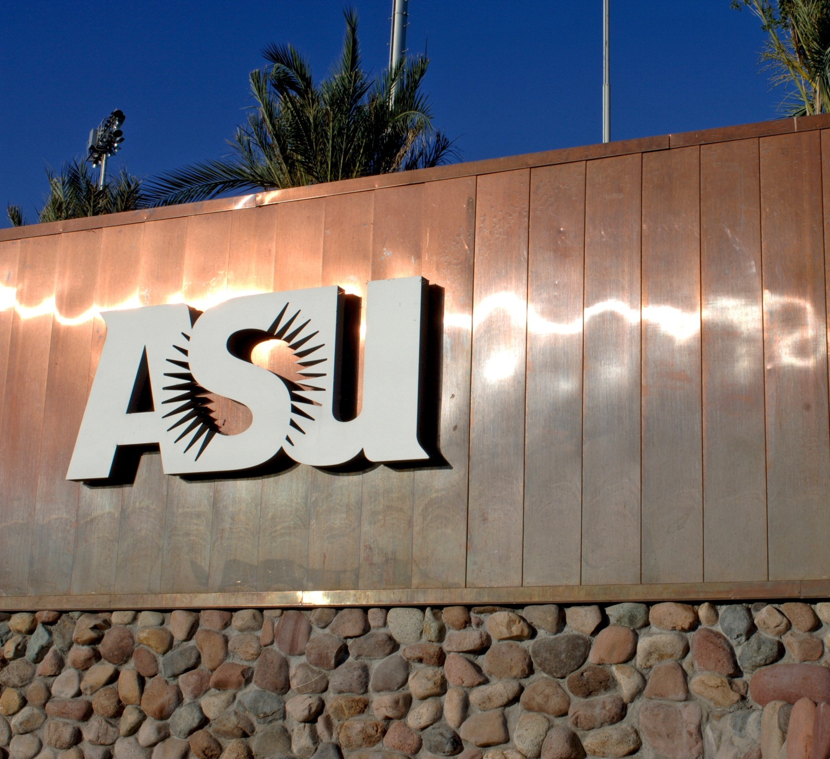

The University
Arizona State University is a New American University, and one of the nation’s premier metropolitan public research universities. Enrolling more than 73,000 undergraduate, graduate and professional students on four campuses in metropolitan Phoenix, ASU maintains a tradition of academic excellence in core disciplines, and has become an important global center for innovation, interdisciplinary teaching and research. ASU offers outstanding resources for study and research, including libraries and museums with important collections, studios and performing arts spaces for creative endeavor, and unsurpassed state-of-the-art scientific and technological laboratories and research facilities.

ASU is research-driven but focused on teaching and learning in a context that encourages the creation of new knowledge. The faculty includes recipients of prestigious academic and professional awards, including membership in the national academies and holders of the Nobel Prize. ASU currently ranks sixth among public universities in its enrollment of freshman merit scholars. The University champions diversity, and is international in scope, welcoming students from all 50 states and more than 140 nations across the globe. ASU is an active partner with the private sector in initiatives to enhance the social well-being, economic competitiveness, cultural depth, and quality of life of metropolitan Phoenix and the state.

University Goals
2020 Goals
100,000 enrolled students
18,000 undergraduate degrees awarded
6,200 graduate degrees awarded
$700 million in research expenditures
2011-12 Outcomes
73,700 enrolled students
12,200 undergraduate degrees awarded
4,800 graduate degrees awarded
$344 million in research expenditures

The Intent

Arizona State University is partnering with the City of Tempe to bring a new hotel and conference center on a six acre site at the southeast corner of Mill Avenue and University Drive. This strategic property is owned by the University and is a gateway to both the university campus and Downtown Tempe. Guests of this facility would be on the campus of the nation’s largest public university (by enrollment) and adjacent to Downtown Tempe, one of the premier arts and entertainment districts in the southwest.

The intent of the University in this Request for Qualifications/Invitation to Negotiate is to gauge interest in this development opportunity and to select a team for the planning and development of this site. Our hope is to identify the entity (or team) that has the vision, experience, financial strength and capacity to transform this highly visible and accessible property in a manner that delivers significant, tangible and measurable environmental, social, cultural, and economic impact to the University and the community.

The Opportunity

The University is offering six acres at the southeast corner of Mill Ave & University Drive to be developed as a hotel and conference center facility. While the ultimate size and configuration of the project will be determined at a later date, the University and City believe the project should include, at a minimum, the following elements:
- A high quality full-service hotel
- An adjacent parking garage
- At least 30,000 square feet (gross) of conference/meeting space containing a ballroom that can seat at least 1,000 people.
Proposals that include additional University property and uses adjacent to the offered site may be considered, however, this solicitation is focused on delivering the above program. Additional uses or development which do not directly support or enhance this program will not enhance a respondent’s score or improve their position relative to other respondents.

The potential drivers for demand are evident for this location given its proximity to Downtown Tempe and ASU’s Tempe campus. Focusing on the University as a demand driver, there are many events that offer potential opportunities for consideration including, but not limited to, commencements, orientations, special events, visiting speakers/professors, meetings and conferences. A survey conducted in February of 2012 with select ASU personnel responsible for arranging room and meeting space bookings revealed that there are approximately 1,400 and 2,300 room nights annually associated with University demand. Further, departments across ASU indicated that the development of conference/meeting space near the campus could afford more options for larger University conferences and events which could generate additional room night demand. In the past three years, ASU Intercollegiate Athletics has utilized on average more than 4,500 room nights per year.
ASU Tempe Campus

The Assumptions

There are several requirements the University has included for the development of this property, based on established University policies and/or existing agreements. Disclosure of these is intended to aid in transparency of the process and to state plainly the University’s expectations and, in some cases, limitations as it relates to the development of the site.
- The hotel property will be conveyed via a long-term ground lease of 65-years or longer, Specific lease terms will be negotiated.
- The University is required to receive fair market value for all land transactions, which is anticipated to be determined through a valuation approach that uses the average of multiple independent appraisals as the basis for land value. Depending on the lease structure, the University may also seek some form of additional rent or payment as a “true-up” to ensure the University is receiving fair compensation over time.
- For the purposes of project financing, the University’s fee interest in its property cannot be pledged as collateral or equity.
- It is anticipated that the Conference Center might ultimately be owned by the University or the University and City. However, other ownership scenarios may also be considered.
- The University and City will consider proposals which pledge certain project-generated revenues to pay for all, or a portion, of this facility. Specific revenues to be identified and terms to be negotiated.
- Private Sector Financing for both the Hotel and Conference Center will be required.
- The University and City are not able to guarantee room nights.
- The Hotel Operator will be responsible for all operating costs.
- For planning purposes, the developer should assume that the University may develop additional academic space and/or student housing on the remaining University property immediately south of this site.

The Requirements

The University selection process is designed to identify the firm or team that, in the University’s sole discretion, best meets the University’s objectives and needs. Review of all responses will be conducted by a panel of University and City employees who may also be assisted by outside consultants or advisors. The following provides an outline for responses. Failure to provide the requested information may result in disqualification.

Qualifications
Qualifications will be reviewed to identify respondents who demonstrate, in the sole discretion of the University, the best qualifications in the following areas:

Team Capability
The Development Team - Respondents must submit a list of members of the team including (as applicable): the ownership entity, design, management, and construction professionals, groups, and any other applicable firms or individuals. Qualifications and experience of each with applicable ventures should be described.
  - Company information - For each company/entity which comprises the team, respondents should provide the name; legal status; company or corporation number; address; full names of officers, and brief biographical summaries of officers.
  - Legal Claims - Respondents must identify any recent or currently outstanding legal claims against team members or any key personnel, including the source of such claims, their amount, and status. The development team shall reveal any criminal convictions of any key employees other than simple traffic convictions.

Previous Experience
Describe projects which best represent the team’s direct applicable experience and capability to design, develop and operate a hotel and conference facility as contemplated by this solicitation. Include brief project descriptions; a statement regarding the duration, financial and operational involvement with each such project following completion; and the name, address and telephone number of principal investors, architects, and principal consultants for each project listed. Provide a list of any previous direct experience in the creation of successful public/private partnerships. Teams who have successfully collaborated previously will be scored higher than those who have not previously worked together.

Financial Capability
The University is seeking firms or teams who can demonstrate the financial capability to undertake this project. Respondents should submit information regarding financial wherewithal and capability. Relevant information includes, but is not limited to, available funding sources, funding commitments and/or access to capital, and banking relationships. Financial and banking references should include a telephone number of the contact for each of these, together with written authorization permitting the University to solicit the information.

Design and Operation
Respondents should outline both their vision for the project as well as their proposed plan for implementation. Elements must include:

Conceptual Plan. This aspect of the proposal is intended to provide the University with a representative example of the development team’s proposed vision for the Project. The conceptual plan shall include the following:

- Conceptual Design – depicting the Project elements in a massing plan as well as a building layout. Conceptual elevations would be welcome but not required. The concept design should include a corresponding narrative explaining the design philosophy.

- Hotel Flag and Tenant Commitments (as applicable). Respondents should include any commitments from their proposed hotel partner and any applicable retail and/or restaurant tenants (those respondents with firm commitments will be scored higher). If a respondent does not have commitments, they should include a proposed plan for partnering with a hotel and signing any proposed tenants.

- Operations – Respondents must outline their proposed operations plan for the hotel and conference center.

Financial Structure and Plan.
Respondents must provide a detailed financial structure and plan for the Project including (1) a description of the proposed ownership entity/structure (2) approach to securing construction and permanent funding sources including type(s) and sources of financing, (3) the proposed participation structure for the conference center (4) the proposed ground rent structure (5) a projection of the Project’s proposed operating expenses (6) any other proposed involvement by the University or the City.

The Process

The University and City will first screen the responses for Qualifications and Experience, then evaluate the Finance and Concept Plans. The goal of the review is to rank the responses based on their combined strength in Qualifications, Design/Operations and Financial Strength.

Upon review and ranking of the responses, the University may select, at its sole discretion, one or more respondents deemed most qualified to undertake the development of the site and best serve the needs of the University, and invite them to make a formal presentation to a panel of University and City representatives. It is the University’s expectation that the participants in the interview will include the representatives of the teams who are expected to function in the more significant management/leadership roles for the first five years of the project development.

Following the interview, the University may, at its sole discretion, continue discussions and enter negotiations with one or more of the prospective developers. The University may request additional information from the selected firms at any time during the selection process.

It is the intent of the University to offer the selected team a ninety (90) day exclusive negotiation period. In the event that there is an impasse in the negotiations, the University reserves the right to commence negotiations with the next most qualified team or reject all proposals.

The University reserves the right to reject any and all submittals for any reason, and to act in the best interest of the University. Each respondent will be notified as to the status of their response as the University moves through the selection process.

When, Where & How

Phase I: Issuance: October 23, 2012
Pre-Proposal Conference November 5, 2012
Due Date for Phase I Responses December 10, 2012
Notification of Short List for Interview December 20, 2012
Phase II: Interviews January 10, 2013
Notification of Final Selection January 15, 2013
Exclusive Negation Period 90 days

Questions: Direct all questions via e-mail to: Joan Stockmaster, Senior Buyer, at Joan.Stockmaster@asu.edu . Joan’s telephone number is 480-965-2316. Responses to questions will be shared with all known potential respondents.

Note that the University will answer informal questions orally. The University makes no warranty of any kind as to the correctness of any oral answers and uses this process solely to provide minor clarifications rapidly. Oral statements or instructions shall not constitute an amendment to this Request for Qualifications/Invitation to Negotiate. Proposers shall not rely on any verbal responses from the University. If you have formal questions about any part of this Request for Qualifications/Invitation to Negotiate, which could result in a material issue or a formal amendment to this Request for Qualifications/Invitation to Negotiate, then submit them via e-mail to Joan.Stockmaster@asu.edu .

The University’s single point of contact for this Request for Proposals is Joan Stockmaster.

Proposal Submittal and Review
Phase I responses shall be submitted in the form of:

  - One (1) hardcopy clearly marked ‘original’ in 8.5” x 11” non-binding form. No metal or plastic binding – may use binder, folder, or clip for easy removal of proposal. The Phase I response is limited to 50 pages including exhibits. Emphasis should be on completeness and clarity of content. Each response should reference the criteria section being addressed. Pages should be numbered consecutively.

  - One (1) electronic copy on USB flash drive or CD as a PDF document that is PC readable, labeled, and not password protected. One “single” document for main submittal. Any confidential and/or proprietary documents must be on a separate flash drive or CD and labeled appropriately.

  - Proposer must check and play all flash drives or CDs before submitting. Company marketing materials should not be included. All photos must be compressed to small size formats. The Evaluation Committee and any consultants retained by the University will be reviewing only the electronic copy. Respondents must ensure that it is an accurate duplicate of the hard copy original submission.

Note: Failure to respond to all requested information may be considered non-responsive and may disqualify an entity from further consideration.

The Arizona Public Records Act limits the University’s ability to withhold prequalification and response data. If a submittal contains any trade secrets or confidential financial information that an entity does not want disclosed to the public or used by the University for any purpose other than evaluation of the entity’s eligibility, each sheet of such information must be marked with the designation “Confidential.” The University agrees that if a “Public Records Act” request is made for disclosure of data so classified, it will notify the submitter of such data so that the submitter will have an opportunity to legally challenge the University’s obligation to disclose such information.

Proposals are to be addressed and delivered to the receptionist area, first floor, University Services Building, Purchasing and Business Services, Arizona State University, 1551 S. Rural Road, (located on the east side of Rural Road between Apache Road & Broadway Road) Tempe, Arizona 85281 on or before 3:00 PM, MST, December 10, 2012 at which time a representative of Purchasing and Business Services will announce publicly the names of those firms or individuals submitting qualifications. No responses will be accepted after this time. No other public disclosure will be made until after award of the contract.

Your proposal must be in a sealed container marked with the name of the firm submitting the proposal, “RFQ 091302”, and the date and time the proposal is due.

Arizona State University’s Overnight Delivery (FedEx, Airborne, and UPS.) address is:

Purchasing and Business Services
University Services Building
Arizona State University
1551 S. Rural Rd
Tempe, AZ 85281

Arizona State University’s U.S. Postal Service Mail address is:

Purchasing and Business Services
Arizona State University
P.O. Box 875212
Tempe, AZ 85287-5212

Pre-Proposal Conference
A pre-proposal conference will be held at 9:00 AM, MST on November 5, 2012 at the Memorial Union, 230, the Pima Room at the Tempe Campus of Arizona State University.

The purpose of this conference will be to clarify the contents of this Request for Qualifications/Invitation to Negotiate in order to prevent any misunderstanding of the University's intention and desires, and/or to give prospective suppliers an opportunity to review the site of the project. Any doubt as to the requirements of this Request for Qualifications/Invitation to Negotiate, or any apparent omission or discrepancy should be presented to the University representative at this conference. The University representative will then determine the appropriate action. If necessary, the University representative will issue a written amendment to the Request for Qualifications/Invitation to Negotiate. Oral statements or instructions shall not constitute an amendment to this Request for Qualifications/Invitation to Negotiate.

You do not have to send a representative to this pre-proposal conference. However, if you decide to not send a representative, then we may not know of your intent to participate in this solicitation, and so may not send you any written amendments to this Request for Qualifications/Invitation to Negotiate. Further, we will assume that your failure to attend the pre-proposal conference is an indication that you expect us to review your proposal as if you had taken advantage of the pre-proposal conference.

University Terms and Conditions
The successful proposer is expected to enter into a standard form of agreement used by the University. The University contract terms and conditions are not provided in this Request for Qualifications/Invitation to Negotiate but will be provided to the firms that are invited to interview with the University.

