Go to the Business Functions page and set the Business Area to Open Tables, then click on Document History and enter the document number as pictured below:

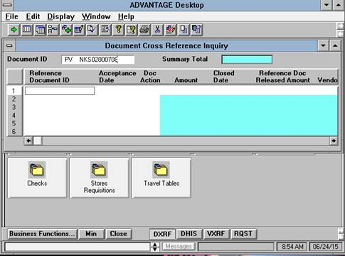

Hit the browse button and it will pull up all the current history for that particular document as shown below:

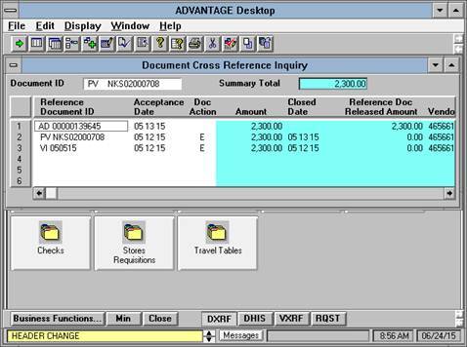

The VI (Vendor Invoice) document is the invoice that was applied by AP and the AD document is the check that was created. To find the status of the check you will need to go to the WREC table and input the check number. In this case the check number is AD00000139645. To find the WREC table in GUI, click on the green arrow under the word ‘FILE’ on the upper left-hand side of your screen. This will bring up a new screen. Ensure the View By area is set to ‘Code’ and enter the letters WREC in the space under the word ‘Windows’, as shown below:

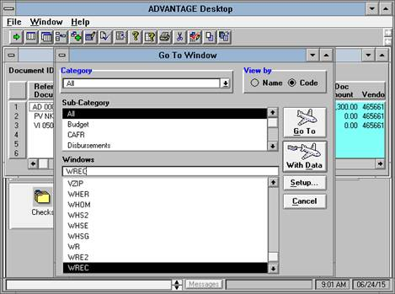

Then hit the ‘Go To’ button and it will take you to the next screen. The Bank Account is always 01. Enter 01 and your check number as pictured below:

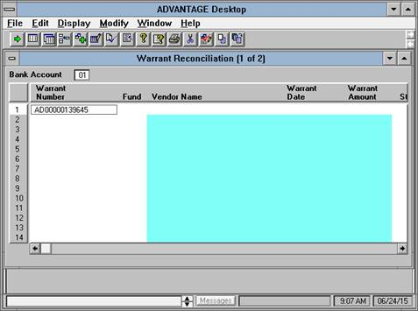

Then hit your browse button (the one to the right of the green arrow) to pull up the check and your screen will appear as below:

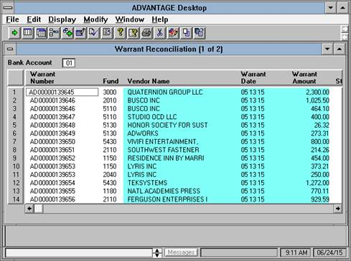

To check the status of your check, use the right arrow button on the bottom of the table to scroll to the right as shown below. The Status code will be one of the following; O, C, or V. In this case it is O. ‘O’ mean that the check was sent but it is outstanding and has not been cashed. ‘C’ means that the check has been cashed. And ‘V’ means that the check was voided.

