To determine if a check has cleared, you may check the status by first going to the DXRF screen and entering the PV #. The check # will be here (SEE GREEN HIGHLIGHT):

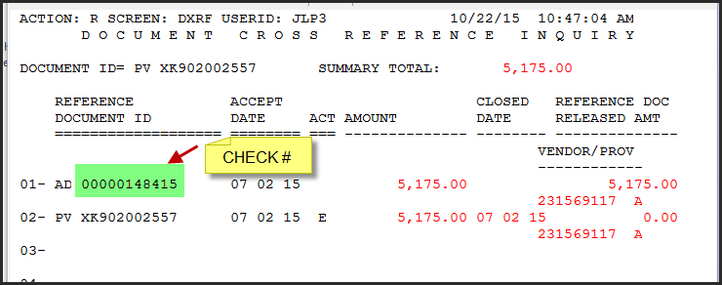

Once you have the check #, you can navigate to the WREC screen in Advantage to verify the status of the check (highlighted in yellow). In this case, the check status is “C”. This means the check has been cashed on 7/16/2015. If the check were not cashed, the status would be “O” for open, or “V” for void.

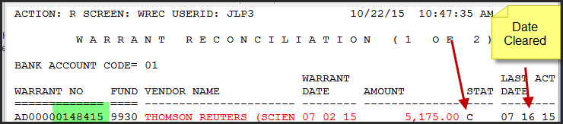

If a department needs a copy of a cashed check, they should email treasury@asu.edu and include the following information:

- name of payee
- check number
- date cleared

