Standard Operating Procedure
Nitromethane

This is an SOP template and is not complete until: 1) lab specific information is entered into the box below 2) lab specific protocol/procedure is added to the protocol/procedure section and
3) SOP has been signed and dated by the PI and relevant lab personnel.
Print a copy and insert into your
Laboratory Safety Manual and Chemical Hygiene Plan.
Refer to instructions for assistance.
School / Department: | Click here to enter text.
SOP Preparation Date: | Click here to enter a date. | SOP Approval Date: |  | Click here to enter a date.
Principal Investigator: | Click here to enter text.
Lab Manager Name: | Click here to enter text.
Laboratory Phone: | Click here to enter text. |  | Office Phone: | Click here to enter text.
Emergency Contact: | Click here to enter text. |  | Contact Phone: | Click here to enter text.
Laboratory locations covered by this SOP (building / room number):
Click here to enter text.

Type of SOP: | ☐ | Process | ☒ | Hazardous Chemical | ☐ | Hazardous Class

Purpose
Nitromethane has a variety of uses. It is used as a stabilizer for chlorinated solvents, used in dry cleaning, semiconductor processing, and degreasing. It is most commonly known for its use as a fuel in motor racing, as well as rockets.

Physical and Chemical Properties / Definition of Chemical Group

CAS: | 75-52-5 | 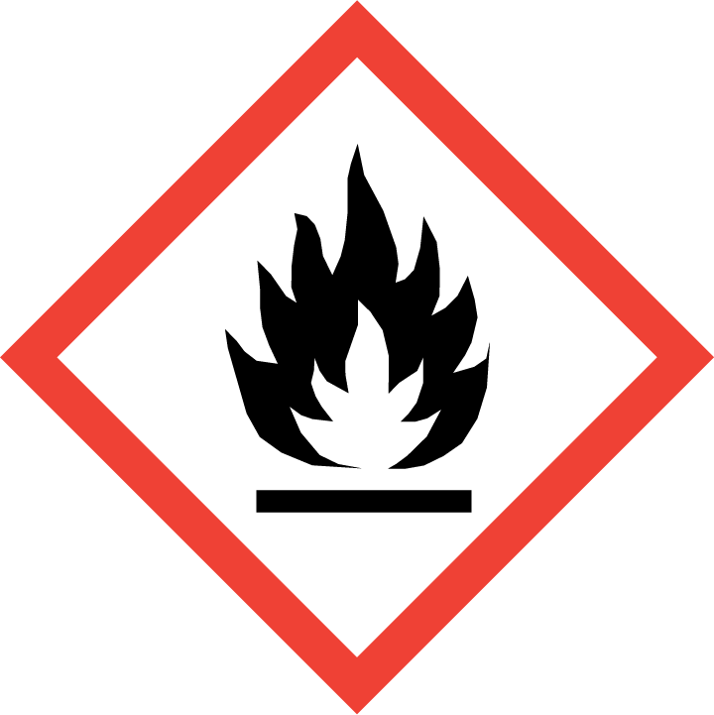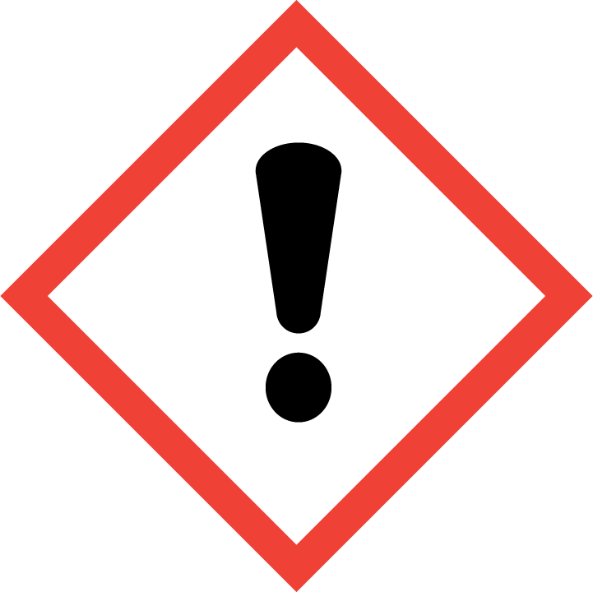
Class: | Flammable, Carcinogen, Target organ effect
Molecular Formula: | CH₃NO₂
Form (physical state): | Liquid
Color: | N/A
Boiling Point: | 101.2 ºC
Potential Hazards / Toxicity

Potential Health Effects
Target Organs: | Liver, Kidney, Central nervous system
Inhalation: | May be harmful if inhaled. May cause respiratory tract irritation.
Skin: | Harmful if absorbed through skin. May cause skin irritation.
Eyes: | May cause eye irritation.
Ingestion: | Harmful if swallowed.

Personal Protective Equipment (PPE)

Respiratory Protection
Where risk assessment shows air-purifying respirators are appropriate use a full-face respirator with multi-purpose combination (US) or type ABEK (EN 14387) respirator cartridges as a backup to engineering controls. If the respirator is the sole means of protection, use a full-face supplied air respirator. Use respirators and components tested and approved under appropriate government standards such as NIOSH (US) or CEN (EU).

Respirators should be used only under any of the following circumstances:
- As a last line of defense (i.e., after engineering and administrative controls have been exhausted).
- When Permissible Exposure Limit (PEL) has exceeded or when there is a possibility that PEL will be exceeded.
- Regulations require the use of a respirator.
- An employer requires the use of a respirator.
- There is potential for harmful exposure due to an atmospheric contaminant (in the absence of PEL)
- As PPE in the event of a chemical spill clean-up process

Lab personnel intending to use/wear a respirator mask must be trained and fit-tested by EH&S. This is a regulatory requirement.
http://www.asu.edu/ehs/documents/asu-respiratory-protection-plan.pdf

Hand Protection
Handle with gloves. Use proper glove removal technique to avoid skin contact with this product. Fluorinated rubber gloves are recommended.

NOTE: Consult with your preferred glove manufacturer to ensure that the gloves you plan on using are compatible with nitromethane.
Refer to glove selection chart from the links below:
http://www.ansellpro.com/download/Ansell_8thEditionChemicalResistanceGuide.pdf
OR
http://www.allsafetyproducts.biz/page/74172
OR
http://www.showabestglove.com/site/default.aspx

Eye Protection

- Wear chemical splash goggles or a face shield to protect from splash hazards and chemical vapors.

Skin & Body Protection

- Fire/flame resistant lab coat, preferably made from antistatic material
- Full-length pants
- Closed-toe rubber or leather shoes

Hygiene Measures

Avoid contact with skin, eyes, and clothing. Wash hands before breaks and immediately after handling the product.

Engineering Controls

Operate using a chemical fume hood with adequate exhaust and capture filtration, as well as electrically grounded lines and equipment.

First Aid Procedures

If inhaled… Move to fresh air. If the person is not breathing, give artificial respiration. Avoid mouth to mouth contact. If breathing is difficult, give oxygen. Call 911 from a campus phone or (480) 965-3456. Call EH&S at (480) 965-1823.

In case of skin contact… Remove all contaminated clothing. Immediately (within seconds) flush affected area for FIFTEEN (15) minutes. Call 911 from a campus phone or (480) 965-3456 from a cell phone. Call EH&S at (480) 965-1823.

In case of eye contact… Remove any contact lenses. Use nearest emergency eyewash immediately for at least FIFTEEN (15) minutes. Call 911 from a campus phone or (480) 965-3456 from a cell phone. Call EH&S at (480) 965-1823.
If swallowed… DO NOT INDUCE VOMITING. Never give anything by mouth to an unconscious person. Rinse mouth with water. Call 911 from a campus phone or (480) 965-3456 from a cell phone. Call EH&S at (480) 965-1823.

Special Storage & Handling Requirements

Storage
- Ensure the container is tightly closed at all times.
- Keep in a cool, dry, well-ventilated area away from incompatible materials and conditions.
- Open containers must be carefully resealed and kept upright to prevent leakage.
- Store under inert gas.

Handling
- The lab where the material is being handled has an approved / certified emergency eyewash and safety shower.
- Ensure you are wearing the following minimum PPE: tightly fitting safety goggles and face shield, fire/flame resistant lab coat, full length pants, close-toe rubber or leather shoes, fluorinated rubber gloves.
- Lab emergency contact information must be readily posted. Easy access to a cellular phone or land line is readily available.
- Avoid contact with skin, eyes, and clothing.
- Avoid inhalation and ingestion.
- Use spark-proof tools and explosion-proof equipment.
- Ensure normal measures for preventative fire protection.
- Keep away from heat and other sources of ignition.
- Prevent buildup of electrostatic charge.

Spill and Accident Procedure

Personal precautions
Avoid breathing vapors, mist or gas. Ensure adequate ventilation. Evacuate personnel to safe areas. Do not attempt clean-up without minimum PPE. Beware of vapors accumulating to form explosive concentrations. Vapors can accumulate in low areas.

Environmental precautions
Prevent further leakage or spillage – if safe to do so. Do not allow product to enter drains.

Methods and materials for containment and clean-up
Consider material compatibility prior to clean-up. Verify spill kit is available. Absorb spills with inert material.

- Immediately assess amount spilled, follow posted ASU Emergency Response Guide procedures for hazardous materials incidents.
- If a chemical exposure has occurred, a fellow lab worker shall call 9-1-1 and EH&S at (480) 965-1823.
- Don compatible gloves and other protective PPE if not already being worn.
- Secure / restrict access to the area of the spill to prevent spread of the chemical.
- Use the available spill kit to stop and contain the spill. Bag the collected material.
- Label and tag as hazardous waste and submit a pick-up request to EH&S using EHS Assistant.

Decontamination / Waste Disposal Procedure
Wearing proper PPE, decontaminate equipment using soap and water. Dispose of the used chemical and contaminated disposables as hazardous waste following the guidelines below.

Label waste
- Attach a completed ASU Hazardous Waste tag to all waste containers as soon as the first drop of waste is added to the container.
Store waste
- Store hazardous waste in closed containers, in secondary containment and in a designated storage location.
- Double-bag dry waste using sealable transparent bags.
- Waste must be under the control of the person generating and disposing of it.

Dispose of waste
- Dispose of regularly generated chemical waste within 90 days.
- Use EHS Assistant online hazardous waste pick-up request system.
- Contact ASU EH&S at (480) 965-1823 with questions.

Protocol / Procedure

Laboratory-specific procedures
Add your lab’s specific procedures in this section.
Click here to enter text.

IMPORTANT NOTE: Any deviation from this SOP requires advance PI approval.

Documentation of Training

- Prior to conducting any work with this material, Principal Investigator or designee must provide to his/her laboratory personnel specific to the hazards involved in working with this substance, work area decontamination, and emergency procedures.
- The Principal Investigator must provide his/her laboratory personnel with a copy of this SOP and a copy of the MSDS provided by the manufacturer.
- The Principal Investigator must ensure that his/her laboratory personnel have attended appropriate/required laboratory safety training or refresher training within the last one year.

I have read and understand the content of this SOP.

Employee Name | ASU Affiliate No. | Signature | Date
Click here to enter text. | Click here to enter text. |  | Click here to enter a date.
Click here to enter text. | Click here to enter text. |  | Click here to enter a date.
Click here to enter text. | Click here to enter text. |  | Click here to enter a date.
Click here to enter text. | Click here to enter text. |  | Click here to enter a date.
Click here to enter text. | Click here to enter text. |  | Click here to enter a date.
Click here to enter text. | Click here to enter text. |  | Click here to enter a date.
Click here to enter text. | Click here to enter text. |  | Click here to enter a date.

