Standard Operating Procedure
Benzoyl peroxide

This is an SOP template and is not complete until: 1) lab specific information is entered into the box below 2) lab specific protocol/procedure is added to the protocol/procedure section and
3) SOP has been signed and dated by the PI and relevant lab personnel.
Print a copy and insert into your
Laboratory Safety Manual and Chemical Hygiene Plan.
Refer to instructions for assistance.
School / Department: | Click here to enter text.
SOP Preparation Date: | Click here to enter a date. | SOP Approval Date: |  | Click here to enter a date.
Principal Investigator: | Click here to enter text.
Lab Manager Name: | Click here to enter text.
Laboratory Phone: | Click here to enter text. |  | Office Phone: | Click here to enter text.
Emergency Contact: | Click here to enter text. |  | Contact Phone: | Click here to enter text.
Laboratory locations covered by this SOP (building / room number):
Click here to enter text.

Type of SOP: | ☐ | Process | ☒ | Hazardous Chemical | ☐ | Hazardous Class

Purpose
Benzoyl peroxide is used as a radical initiator to induce polymerizations. Other major applications include its antiseptic and bleaching properties.

Physical and Chemical Properties / Definition of Chemical Group

CAS: | 94-36-0 | 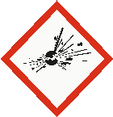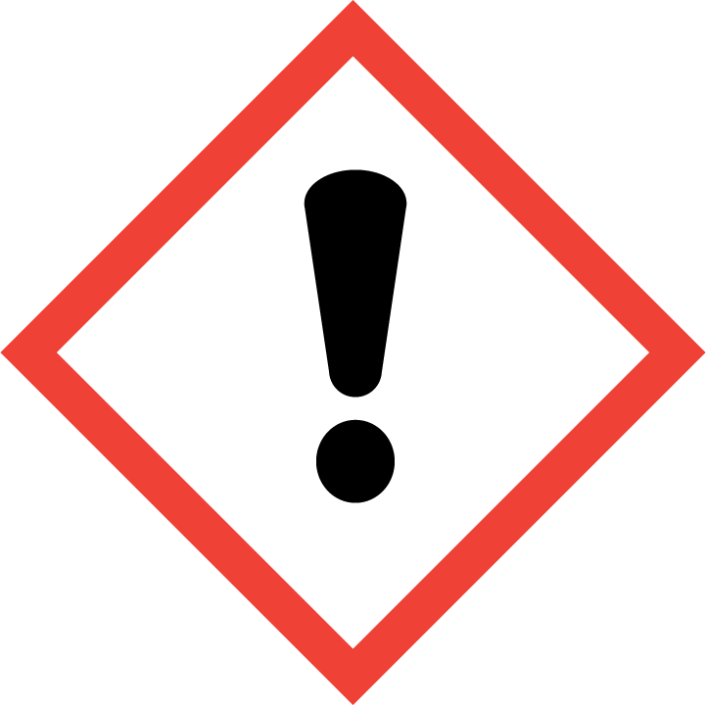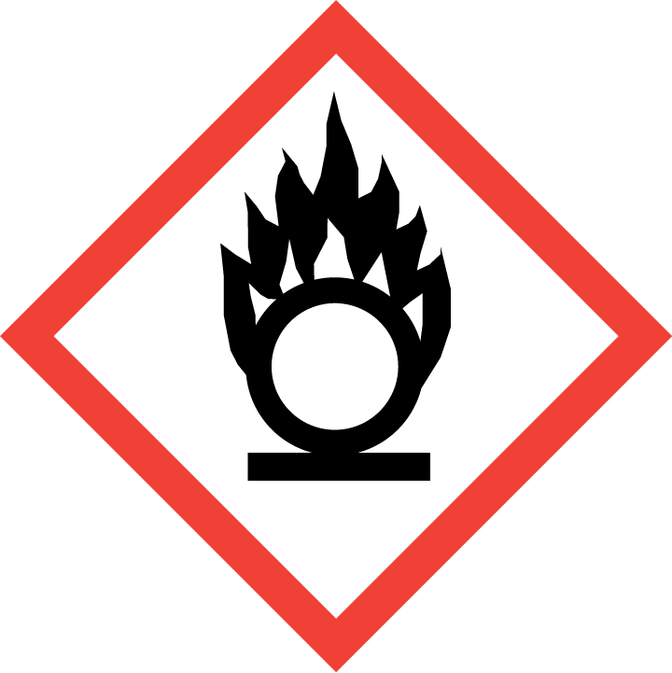
Class: | Organic peroxide, Oxidizer, Irritant
Molecular Formula: | C₁₄H₁₀O₄
Form (physical state): | Solid, Powder
Color: | White
Boiling Point: | N/A
Potential Hazards / Toxicity

Potential Health Effects
Target Organs: | Lungs, Nerves
Inhalation: | May be harmful if inhaled. May cause respiratory tract irritation. Note: decomposition products are toxic, inhalation of these products can produce life threatening health effects.
Skin: | May be harmful if absorbed through skin. Causes skin irritation.
Eyes: | Causes eye irritation.
Ingestion: | May be harmful if swallowed. May cause gastrointestinal tract irritation.

Personal Protective Equipment (PPE)

Respiratory Protection
Use respirators and components tested and approved under appropriate government standards such as NIOSH (US). Where risk assessment shows air-purifying respirators are appropriate, use a full-face particle respirator type N100 (US) respirator cartridge as a backup to engineering controls. If the respirator is the sole means of protection, use a full-face supplied air respirator.

Respirators should be used only under any of the following circumstances:
- As a last line of defense (i.e., after engineering and administrative controls have been exhausted).
- When Permissible Exposure Limit (PEL) has exceeded or when there is a possibility that PEL will be exceeded.
- Regulations require the use of a respirator.
- An employer requires the use of a respirator.
- There is potential for harmful exposure due to an atmospheric contaminant (in the absence of PEL)
- As PPE in the event of a chemical spill clean-up process

Lab personnel intending to use/wear a respirator mask must be trained and fit-tested by EH&S. This is a regulatory requirement.
http://www.asu.edu/ehs/documents/asu-respiratory-protection-plan.pdf

Hand Protection
Handle with gloves. Use proper glove removal technique to avoid skin contact with this product. Nitrile, neoprene, natural rubber, butyl-rubber, PVC, or Viton gloves are acceptable.

NOTE: Consult with your preferred glove manufacturer to ensure that the gloves you plan on using are compatible with benzoyl peroxide.
Refer to glove selection chart from the links below:
http://www.ansellpro.com/download/Ansell_8thEditionChemicalResistanceGuide.pdf
OR
http://www.allsafetyproducts.biz/page/74172
OR
http://www.showabestglove.com/site/default.aspx

Eye Protection

- Wear chemical splash goggles to protect from splash hazards and chemical vapors.

Skin & Body Protection

- Fire/flame resistant lab coat (100% cotton based)
- Cotton based clothing/attire
- Full-length pants
- Closed-toe rubber or leather shoes

Hygiene Measures

Avoid contact with skin, eyes, and clothing. Wash hands before breaks and immediately after handling the product.

Engineering Controls

All operations involving benzoyl peroxide should be carried out in a ventilated enclosure chemical fume hood to keep airborne concentrations below recommended exposure limits. Chemical fume hoods used as containment areas for particularly hazardous chemicals must have a face velocity of 100 cfm, averaged over the face of the hood and must be certified annually. Laboratory rooms must be at negative pressure with respect to the corridors and external environment. The laboratory/room door must be kept closed at all times.

First Aid Procedures

If inhaled… Move to fresh air. If the person is not breathing, give artificial respiration. Avoid mouth to mouth contact. If breathing is difficult, give oxygen. Seek immediate medical attention. Call 911 from a campus phone or (480) 965-3456. Call EH&S at (480) 965-1823.

In case of skin contact… Remove all contaminated clothing. Immediately (within seconds) flush affected area for FIFTEEN (15) minutes. Seek immediate medical attention. Call 911 from a campus phone or (480) 965-3456 from a cell phone. Call EH&S at (480) 965-1823.

In case of eye contact… Remove any contact lenses. Use nearest emergency eyewash immediately for at least FIFTEEN (15) minutes. Seek immediate medical attention and continue eye rinse during transport to hospital. Call 911 from a campus phone or (480) 965-3456 from a cell phone. Call EH&S at (480) 965-1823.

If swallowed… DO NOT INDUCE VOMITING. Never give anything by mouth to an unconscious person. Rinse mouth with water. Drink 2-4 cups of milk or water. Seek immediate medical attention. Call 911 from a campus phone or (480) 965-3456 from a cell phone. Call EH&S at (480) 965-1823.

Special Storage & Handling Requirements

Storage
- Ensure the container is tightly closed at all times.
- Keep in a cool, dry, well-ventilated area away from incompatible materials and conditions.
- Store away from heat, sparks, flame, and other sources of ignition.
- Avoid direct sunlight.
- Recommended storage temperature: below 4 ºC
- DO NOT store near flammables.
- Benzoyl peroxide should be stored in secondary containment.
- Containment, designated work area, and storage location of benzoyl peroxide must be labeled with “EXPLOSION RISK & STRONG OXIDIZER” warning signage.

Handling
- The lab where the material is being handled has an approved / certified emergency eyewash and safety shower.
- Ensure you are wearing the following minimum PPE: tightly fitting safety goggles and face shield, 100% cotton based clothing/attire, fire/flame resistant lab coat, full length pants, close-toe rubber or leather shoes, nitrile or other acceptable gloves.
- Lab emergency contact information must be readily posted. Easy access to a cellular phone or land line is readily available.
- Avoid contact with skin, eyes, and clothing.
- Avoid dust formation.
- Avoid inhalation and ingestion.
- Keep away from heat, sparks, flame, and other sources of ignition.
- Handle and open with caution- product can explode without warning when caps of old containers are unscrewed.
- Use only polyethylene tools and containers.

Spill and Accident Procedure

Personal precautions
Wear respiratory protection. Avoid creating dust. Avoid breathing dust, vapors, mist or gas. Ensure adequate ventilation. Remove all sources of ignition. Evacuate personnel to safe areas. Do not attempt clean-up without minimum PPE.

Environmental precautions
Prevent further leakage or spillage – if safe to do so. Do not allow product to enter drains.

Methods and materials for containment and clean-up
Consider material compatibility prior to clean-up. Verify spill kit is available. Do not use combustible materials to clean up spill. Spilled material should be mixed with water-wetted vermiculite, swept up, and placed in suitable closed container for immediate disposal. Spilled material not immediately cleaned up may increase the fire hazard due to evaporation of water away from the benzoyl peroxide.

- Immediately assess amount spilled, follow posted ASU Emergency Response Guide procedures for hazardous materials incidents.
- If a chemical exposure has occurred, a fellow lab worker shall call 9-1-1 and EH&S at (480) 965-1823.
- Don compatible gloves and other protective PPE if not already being worn.
- Secure / restrict access to the area of the spill to prevent spread of the chemical.
- Use the available spill kit to stop and contain the spill. Bag the collected material.
- Label and tag as hazardous waste and submit a pick-up request to EH&S using EHS Assistant.

Decontamination / Waste Disposal Procedure

Label waste
- Attach a completed ASU Hazardous Waste tag to all waste containers as soon as the first drop of waste is added to the container.
Store waste
- Store hazardous waste in closed containers, in secondary containment and in a designated storage location.
- Double-bag dry waste using sealable transparent bags.
- Waste must be under the control of the person generating and disposing of it.

Dispose of waste
- Dispose of regularly generated chemical waste within 90 days.
- Use EHS Assistant online hazardous waste pick-up request system.
- Contact ASU EH&S at (480) 965-1823 with questions.

Protocol / Procedure

Laboratory-specific procedures
Add your lab’s specific procedures in this section.
Click here to enter text.

IMPORTANT NOTE: Any deviation from this SOP requires advance PI approval.

Documentation of Training

- Prior to conducting any work with this material, Principal Investigator or designee must provide to his/her laboratory personnel specific to the hazards involved in working with this substance, work area decontamination, and emergency procedures.
- The Principal Investigator must provide his/her laboratory personnel with a copy of this SOP and a copy of the MSDS provided by the manufacturer.
- The Principal Investigator must ensure that his/her laboratory personnel have attended appropriate/required laboratory safety training or refresher training within the last one year.

I have read and understand the content of this SOP.

Employee Name | ASU Affiliate No. | Signature | Date
Click here to enter text. | Click here to enter text. |  | Click here to enter a date.
Click here to enter text. | Click here to enter text. |  | Click here to enter a date.
Click here to enter text. | Click here to enter text. |  | Click here to enter a date.
Click here to enter text. | Click here to enter text. |  | Click here to enter a date.
Click here to enter text. | Click here to enter text. |  | Click here to enter a date.
Click here to enter text. | Click here to enter text. |  | Click here to enter a date.
Click here to enter text. | Click here to enter text. |  | Click here to enter a date.

