CRM Basic Guide

The Link or URL for CRM is https://crm.oasis.asu.edu/.

You may find it more convenient to access CRM via a link provided on the
My ASU page https://webapp4.asu.edu/myasu

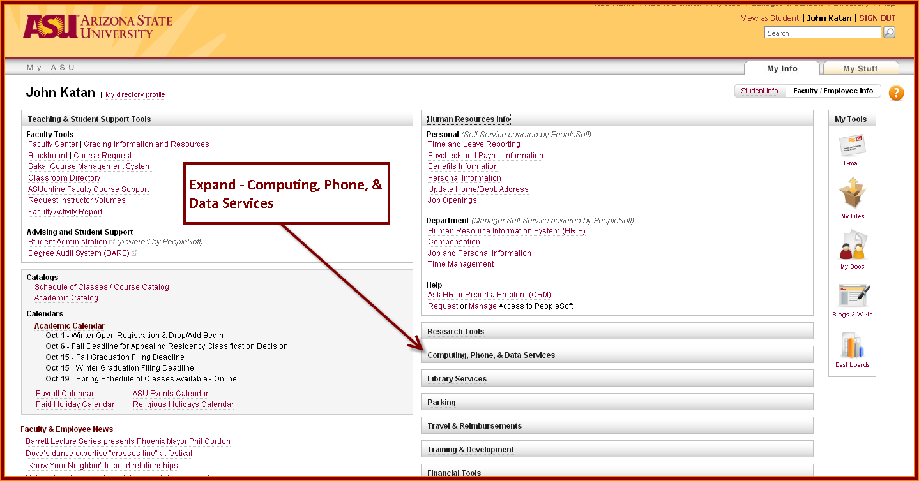

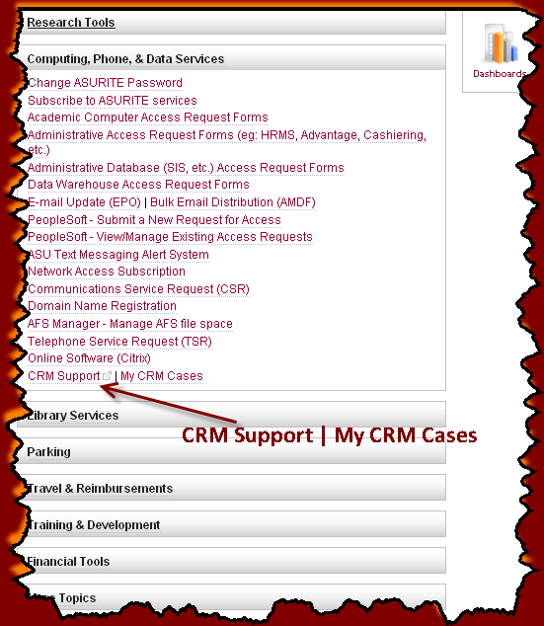

On the Menu at the left, find the Support menu item.

Search Cases

Browsing Cases

Click on Support > Search Cases from the left hand menu.
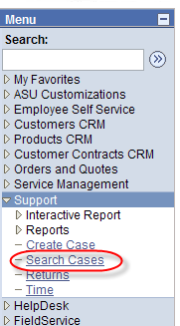

Once there, enter the search criteria, change Business Unit, select Provider Group, etc.
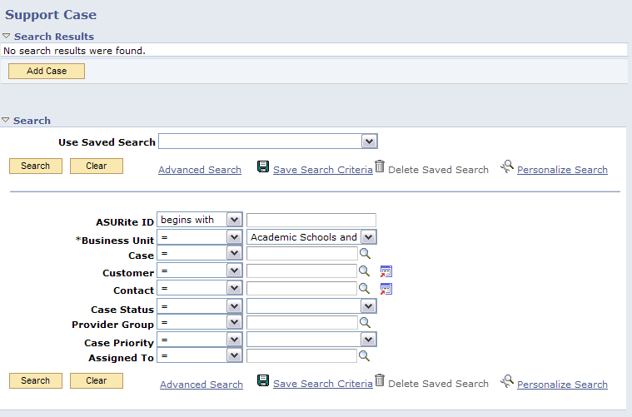
Saved Searches

If you are frequently performing Case Searches for the same criteria (same Provider Groups, same Case Status, etc.), you can save the criteria of those searches under a specific name. You can then automatically re-enter that same search criteria with only a mouse click.

Once you have all the criteria set, click the '''Save Search Criteria''' button, rather than clicking the '''Search''' button.
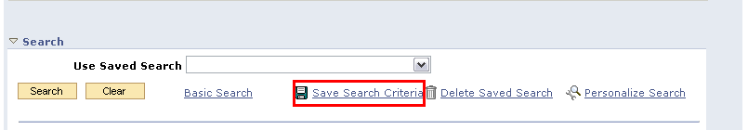

You will then be prompted to enter Save Search As name for this search criteria. It is best to choose a name which expresses the major criteria of the search, e.g., Open Cases in UTO Netcom.
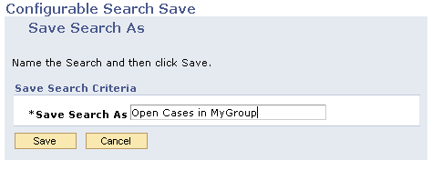

Once this is done, click '''Save'''. Your saved search criteria will now appear in the drop-down menu labeled ''Use Saved Search''.
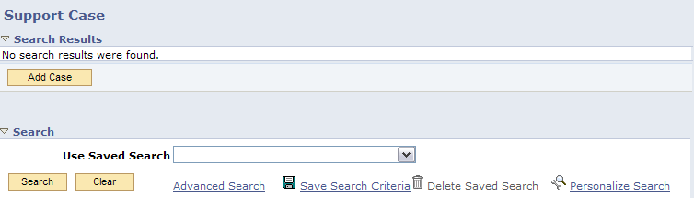

Deleting a saved search is as easy as clicking the '''Delete Saved Search''' button, selecting it from your available searches, and then clicking '''Delete''' to confirm.

Working / Managing Cases
Select a Case
After Searching Cases, select one by clicking on the Case Number.
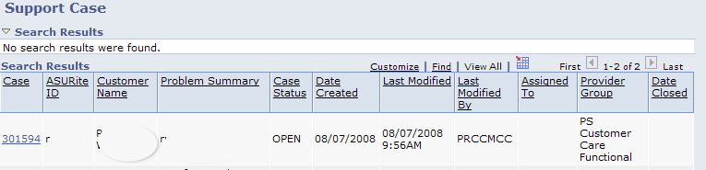

Updating Case Status

If you are performing work / testing relating to a particular Case and are going to need some time before obtaining a resolution, please be sure to update that particular Case's Status.
Open - WIP (work in progress), Open - Awaiting User, Open – Research

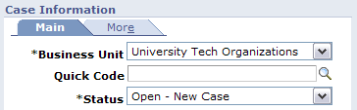

Notes
It is always recommended that you enter a Note each time you work on a case.
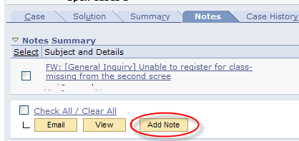
Click Add Note. Briefly, describe the work / testing you are performing.

Attachments
The customer may have supplied attached files or you can also Attach files to provide documentation.
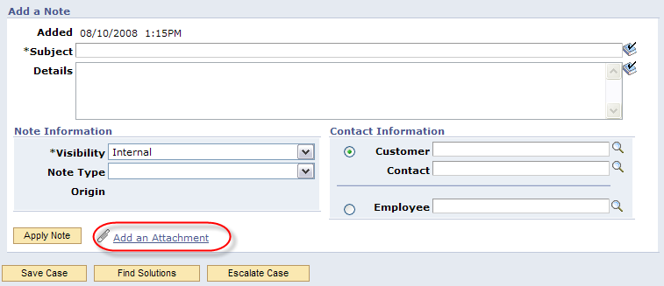
Click Browse, locate the file on your PC. Then Click Upload.
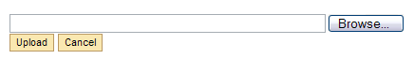
When you are all finished documenting this note, click Apply Note.

Notify

Using Notify vs Email
If you use the Notify feature to communicate with the user rather than the Email feature, it will append a link in the e-mail that allows the customer to send an e-mail response which will be recorded in the Case Interactions section.

Selecting Notify also adds the name of any Interested Party assigned to the case. Check the box next to their name to include them in Ad Hoc notifications.
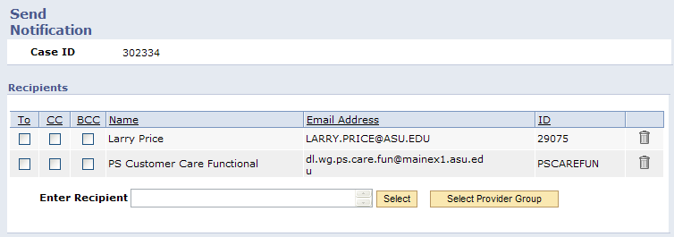
You can use email templates to pre-fill Subject and Message. You can Attach files. When finished, click Send.

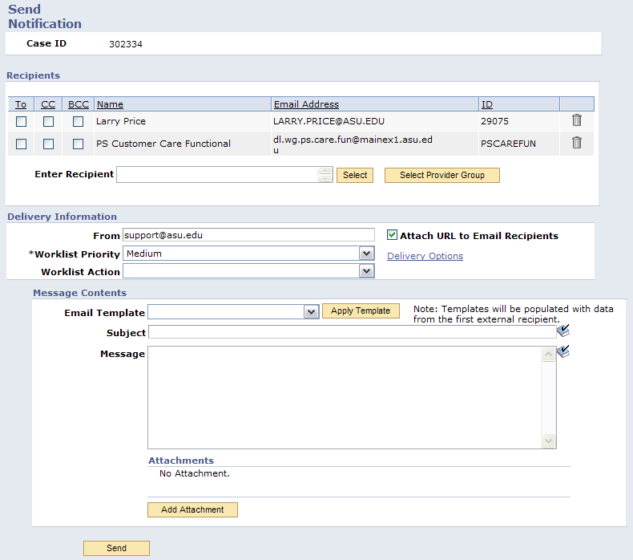

Emails
Email is similar to notify but once you send an email, you cannot get back to the case unless you select History and choose Case.
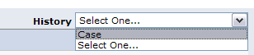

Solutions
Solving a Case

Entering a Solution

Click on New solution.
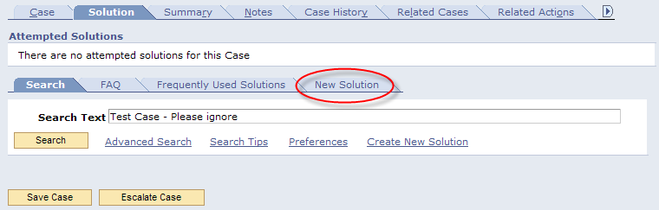

If you are unable to directly resolve the issue (e.g. if the customer themselves needs to perform an action) or are unable to confirm that your action has resolved the issue, click the 'Attempt' button when entering the solution.
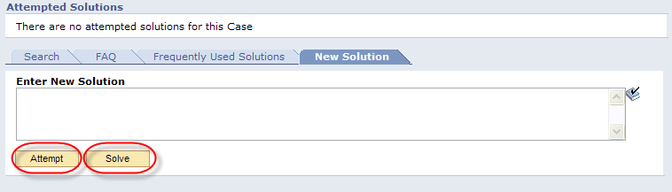
Select the proper Status for the Solution ('Waiting on Customer'), then select the check mark next to the solution and click 'Email'. This will prompt you to send an e-mail to the customer containing the selected solution(s).
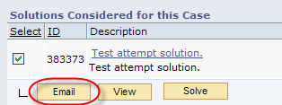

Working in Multiple Browser Tabs / Windows

It is possible to have multiple different CRM Web pages open and active at the same time (e.g. viewing and modifying two different Cases at once).

Once you are viewing a content page, you need to click on New Window link near the top right of the web page. A new Browser Tab/Window should open. From this new Tab/Window, you can navigate to other CRM content pages while still being able to interact with each with the content Tab/Window.

Customizing Home Page
You can customize the content CRM displays when you first log in; in particular, you can configure your CRM Homepage to display all unresolved cases currently assigned to you, as well as all unresolved cases in your Provider Group that are currently not assigned to a specific worker. You can also configure your homepage to display recent cases that have been submitted by a particular customer.

To add new content (called "Pagelets") to your CRM Homepage, follow the steps below:
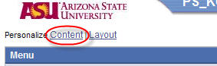

You can check Agent-My Cases and Recent Support Cases and then click Save.
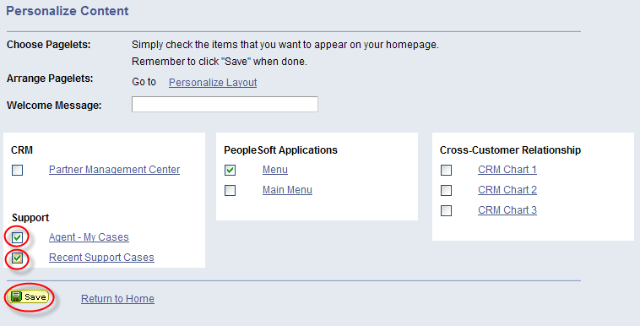
To change Layout of the Pagelets to your CRM Homepage, follow the steps below:
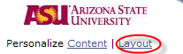

You can select Agent-My Cases or Recent Support Cases and click the arrows to move them around and then click Save.
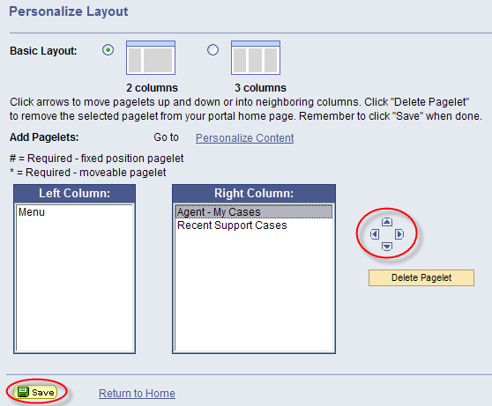

Case List Next/Add
If you are viewing a list of Cases (possibly from a Case Search) and select a particular Case from the list, you can still move forward/backward through the different Cases in the list by using the Next/Previous buttons.

First, you need to be viewing a case. Then follow the steps below.
- Click on the 'Personalize' link in the top right.
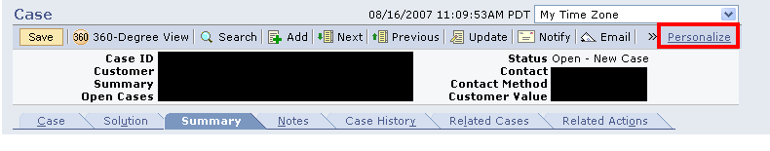
- Use the arrows to move/remove options in Selected Controls, which are the buttons that will appear on your toolbar whenever you are viewing a case. You should then click the Preview button in order to see how your toolbar will look with these new settings. Please note that only so many buttons can fit on the toolbar; make sure that the most frequent buttons you use appear at the top of that list.
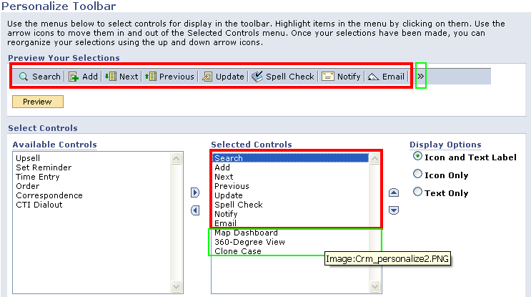
- To get even more space so that you can fit more options on the initial toolbar, you might want to consider changing the Display Options on the right to Text Only (or Icon Only, whichever suits you).
Keyboard Shortcuts
CRM accepts certain keyboard combinations which can perform certain tasks, and which you might find to be quicker than navigating with your mouse. The following shortcuts should be accepted by your web browser when you are on the CRM Web page . Note that a '+' symbol indicates that the two keys must be pressed at the same time, i.e. 'ALT+6' means you need to hold down the 'ALT' key and then press the '6' key on your keyboard.

ALT+1 Saves a page in a transaction.
Moves to the Search or Add button on a search or look up page.
Moves to the OK button on a secondary page.
ALT+2 Returns to the search page from the transaction page.
ALT+3 View the next row in the list when the button is active.
ALT+4 View the previous row the in list when the button is active.
ALT+5 Accesses the Look Up page.
Opens the calendar prompt.
ALT+6 Opens the pop-up window on a page.
ALT+7 Inserts a row in a grid or scroll area.
ALT+8 Deletes a row in a grid or scroll area.
ALT+0 When in Expert Entry mode, activates the Refresh button, which validates the data entered on the page.
ALT+ . View the next set of rows in a grid or scroll area.
ALT+ , View a previous set of rows in a grid or scroll area.
ALT+ / Finds data in a grid or scroll area.
ALT+ ' View all rows of data in a grid, scroll area, or search page results list.
ALT+ \ Toggles between Add a New Value and Find an Existing Value on a search page.
CTRL+J Displays the system information page.
CTRL+K When on a search or transaction page, accesses a page with a list of keyboard navigation shortcuts using hot keys and access keys.
CTRL+Y Toggles the menu pagelet between collapse and expand.
CTRL+TAB Toggles the focus through the frame set.
ENTER Activates the OK button, where appropriate.
On a search page, activates the Search button.
On a look up page, activates the lookup button.
ESC Activates the Cancel button, where appropriate.

