BLACKBOARD HOME PAGE
Add/Remove Modules – a module is a collection of information or a tool on your Blackboard Home page.
BB8 | BB9
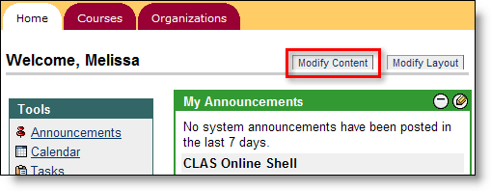 | 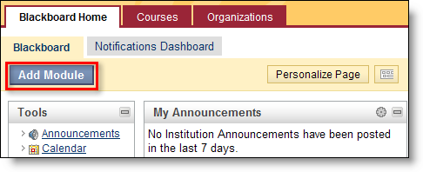

Notifications Dashboard – this new feature can help users keep track of course deadlines (past, current and future due dates), alerts, items needing attention and new content. Information for all of a student’s courses are funneled to this page. For instructors, the information funneled to this page pertains to the courses they are teaching.
Contextual menus are available to help users dismiss, open, expand or collapse alerts. Users should always refresh to ensure current information is displayed.
BB8 | BB9
 | 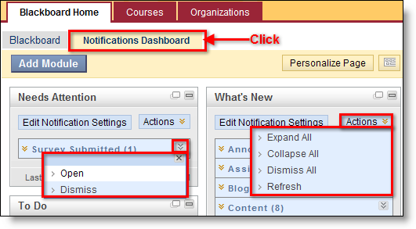

Tools Menu – this menu was divided into two menus: Tools contains Blackboard-specific links, and Hot Links contains ASU-specific links.
NAVIGATION & EDITING IN A COURSE
Control Panel (Location Change) – is no longer a separate area within Blackboard. It now resides on the main page of the course under the course menu, enabling editors to see changes as they are made.
Control Panel (Accessing) – to access the various tools, click on the name to expand the sub-menu. Click on the tool name to access options, which will display in the main area.
BB8 | BB9
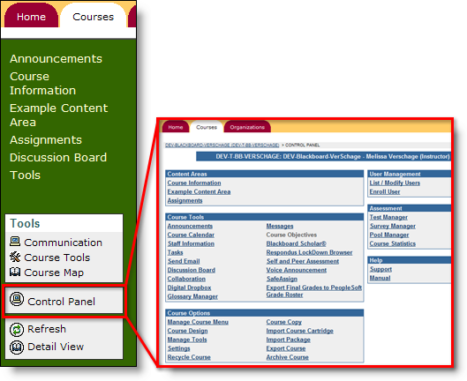 | 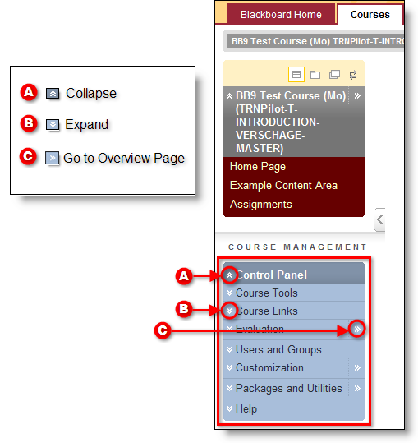

Edit Mode – a toggle switch in the upper right corner that shows or hides the instructor menus for editing information throughout the course. In Blackboard 8, Edit View was only available in Content Areas.
BB8 | BB9
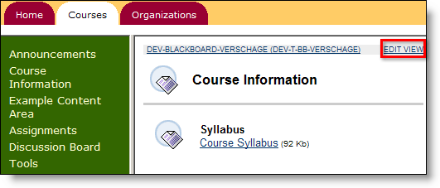 | 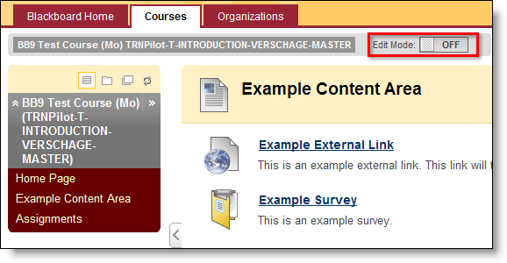

When the Edit Mode is ON, contextual menus and other editing tools will be available to manage the content.
BB8 | BB9
 | 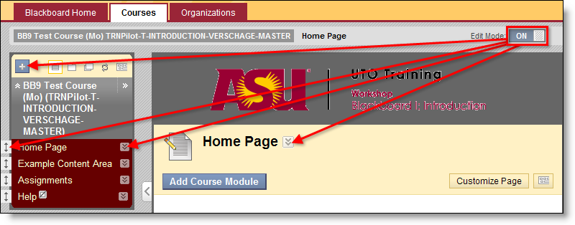

Contextual Menus – expandable menus containing options for each item and are visually represented by two downward facing arrows. Each menu may contain different options depending on the item or its current status. You must be in Edit Mode to see the contextual menus. In Blackboard 8, contextual menus were only available in the Grade Center.
BB8 | BB9
 | 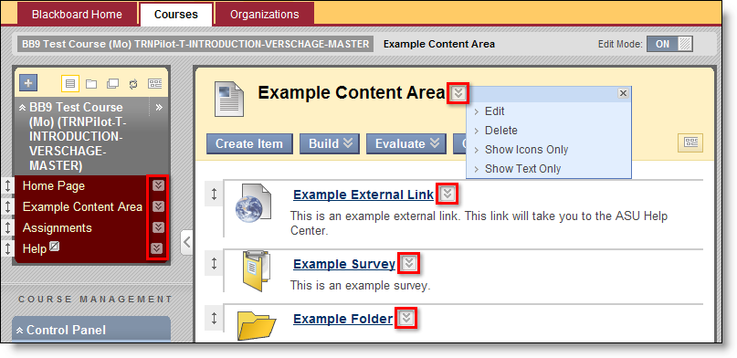

Drag-n-Drop – an easy-editing feature that allows for quick rearranging of content. Simply hover over the vertical, double-sided arrow and drag the item to the new location indicated by the dotted line. For modules, drag using the heading. In Blackboard 8, this was achieved choosing a position from a choice list.
BB8 | BB9
 | 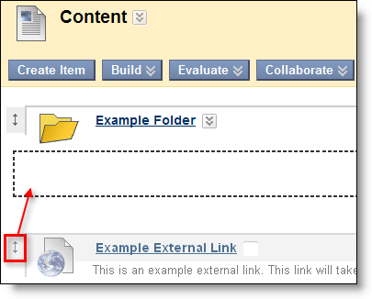

COURSE MENU
Overview – the Course Menu has been redesigned for easier management. The images and descriptions below describe the differences:
BB8 | BB9
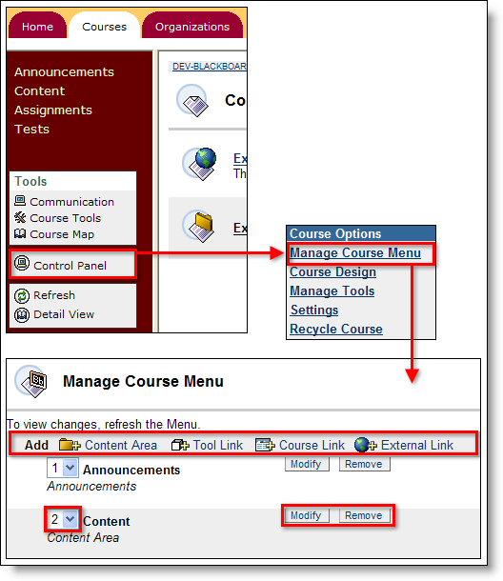 | 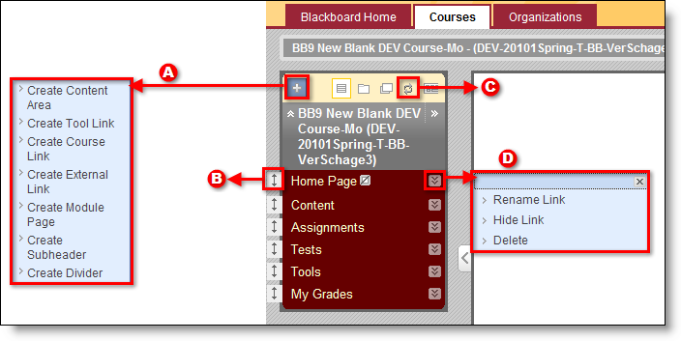

Managing Course Menu – managing the course menu is conveniently achieved directly on the course menu using a variety of functionalities described below:
BB8 |  | BB9
Click Control Panel | Manage Course Menu | choose type from action bar | A  Add Link | Click + icon to access choice list for adding links to the menu
Click drop-down menu left of item name and choose the position from the list | B  Change Order | Click and drag vertical, two-side arrow to change menu order
 | C  Refresh | Refreshes the current page without leaving the page
Click Modify button to rename and show/hide; click Remove button to delete menu item | D  Modify/Delete | Contextual menu contains options to rename, hide/show and delete link

ADDING CONTENT – is still done in content areas using content types. Content types are now organized under choice lists (exception: of Create Item is still a button). Each menu is shown below:
BB8 | BB9
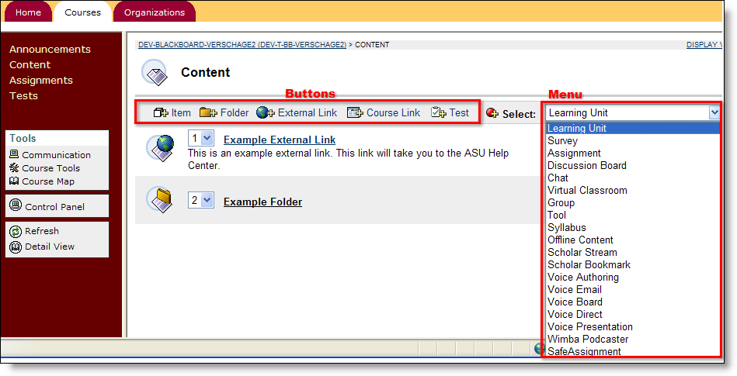 | 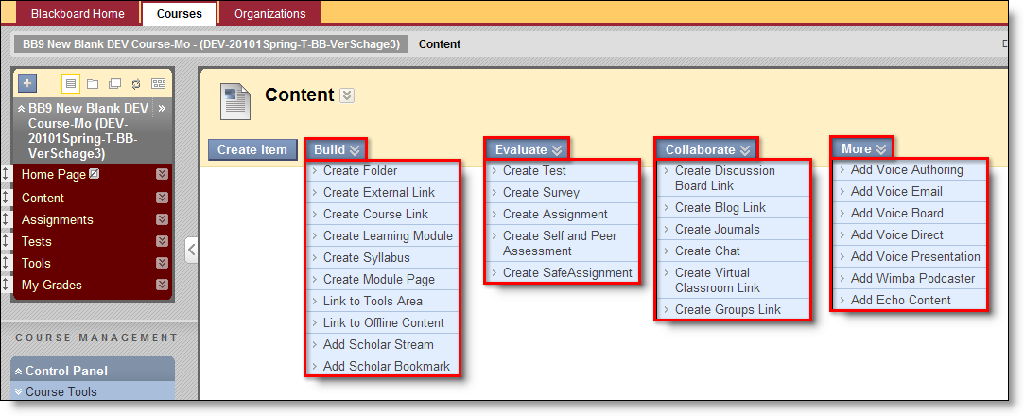
CREATE ITEM – Create a content item on your new page. (just like Bb8) Information delivery (syllabus, lecture notes, text, graphics, video, etc.)

BUILD – add links, folders, tools to your page

EVALUATE – Add tests, assignments, surveys, safe assignments to your page. NOTE: Digital Drop box is no longer available, use assignments instead – which now offer multiple attempts, and assignment to groups.

COLLABORATE – Add links to discussion boards, groups, blogs, journals and Chat

MORE – Currently houses the voice tools – new building blocks will be available here in the future.

MODULE PAGE
A new page very similar to the Dashboard Notifications tab on the Blackboard Home page.
- Modules contain information for instructors and students about new content and due dates for the current course. Use drag-n-drop controls to rearrange the order and contextual menus to refresh the information.
- Access is controlled by the instructor. The instructor can allow students to personalize the page.
BB8 | BB9
 | 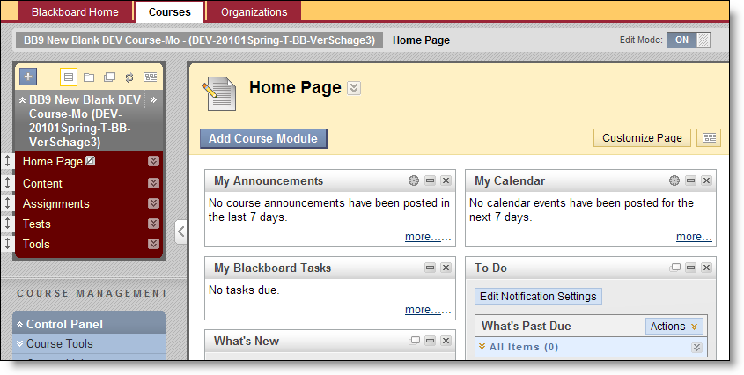

FROM THE CONTROL PANEL  The Evaluation menu on the Control Panel, holds the Grade Center, Performance Dashboard and Tracking Reports (formerly Course Statistics).  DISCUSSION BOARDS – are in the Control Panel and function in the same manner as in Blackboard 8. The only notable difference is the Control Panel is located on the main page.  TESTS – are still located in the Control Panel and function in the same manner as in Blackboard 8. Look in the Course Tools area.  RESPONDUS LOCKDOWN BROWSER (RLDB) – is still available through the Control Panel, under Course Tools, and functions in the same manner. The only difference in Blackboard 9 is that the tool is defaulted to available for instructor use. In Blackboard 8, instructors had to enable the building block prior to use. | 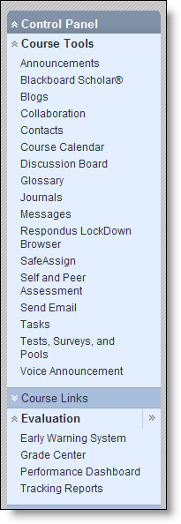

BLOGS – are new to Blackboard. Instructors can release the Blog tool to a group, to the course users or to individuals for weekly or monthly posts. All blogs can be read by all users enrolled in the course. Students and instructors can comment on users’ posts.
BB8 | BB9
 | 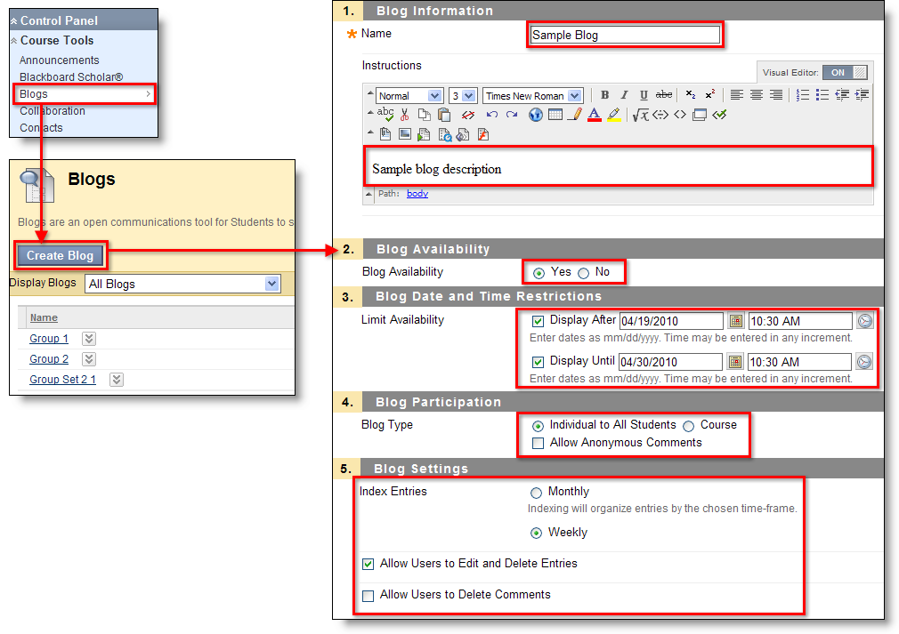

JOURNALS – are new to Blackboard. Instructors can release the Journal tool to a group or to individuals. Instructors can also choose to keep the individual journals private or visible to other users. Students and instructors can comment on users’ entries, but only add entries in their own journals.
BB8 | BB9
 | 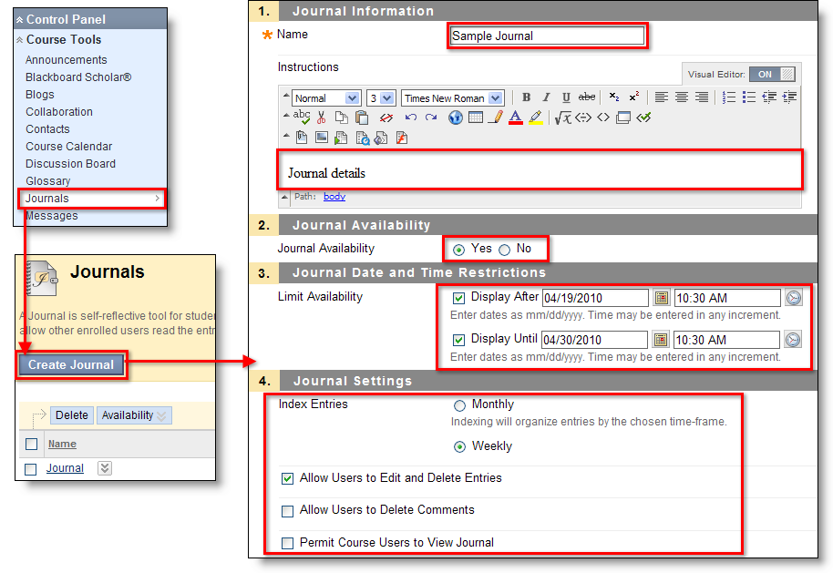

COURSE DESIGN
Menu Access – Course Entry Point, Course Banner and Course Menu Design are all accessed on the Control Panel under Customization | Style. In Blackboard 8, the Course Design menu was accessed through the Control Panel.
BB8 | BB9
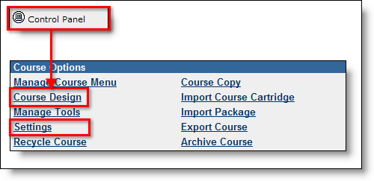 | 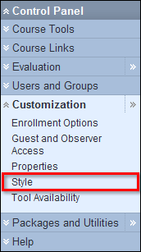

Course Entry Point – In Blackboard 9, this item has been moved to Customization | Style on the Control Panel.

Course Banner – is now managed by going to Customization | Style. A large difference is that the Course Banner is located at the top of the Course Entry Point, no matter what page it is.
In Blackboard 8, the Course Banner only displays at the top of the Announcements page. If another page is designated as the Course Entry Point, the course banner will not be visible.

Course Menu – is now managed by going to Customization | Style. The tool works the same with one enhancement – instructors can use specific Web Colors in addition to swatches.

COURSE TOOLS – are still located in the Control Panel, which now resides on the course’s main page under the course menu. The same Course Tools are available with the addition of Tests, Surveys and Pools (moved from Assessment) and the newly added Blogs and Journals.

COURSE OPTIONS – has been divided into two new sections in the Control Panel: 1) Customization and 2) Packages and Utilities. All of the tools within both sections function in the same manner with the addition of contextual menus rather than buttons.

USERS – are accessed through Control Panel | Users & Groups | Users.

BB8 | BB9
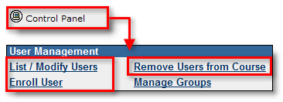 | 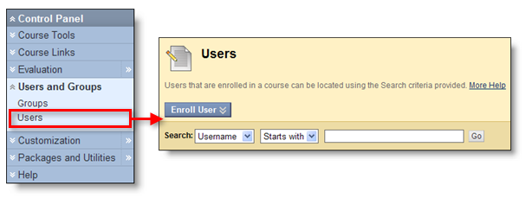

List Users – has changed in Blackboard 9 – the List All feature has been removed.
BB8 | BB9
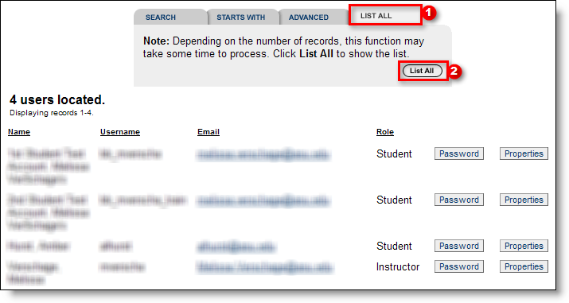 | 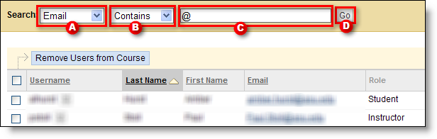  A Choose Email | B Choose Contains |  C Type @ symbol | D Click Go

Enroll Users – is generally the same in that you can browse for users or simply type the ASURITE ID. The main difference is that in Blackboard 9 instructors can select the role when adding the user. In Blackboard 8, the user was first enrolled as a student, then the role had to modified separately to a TA or Instructor.
BB8 | BB9
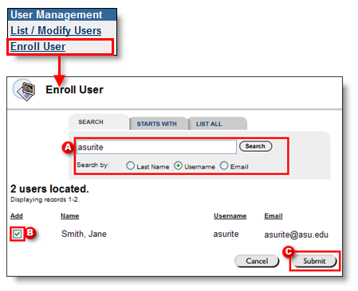  A Search | B Click checkbox | C Click Submit | 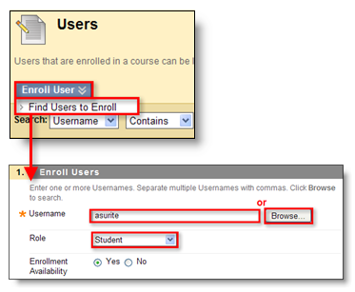
GROUPS – are accessed through Control Panel | Users & Groups | Groups, and have been enhanced. The primary differences with Groups are described below: Single Group, Group Set and Group Settings. One new feature throughout Groups is the option for instructors to allow students to customize their Group page.
BB8 | BB9
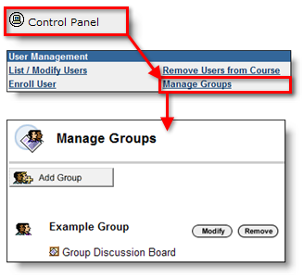 | 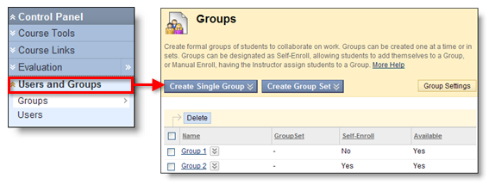

Group Settings – is a new feature in Blackboard 9, where the instructor can permit students to create their own-self-enrolled groups, and also permit them to edit their student-created groups. Both are defaulted enabled.
BB8 | BB9
 | 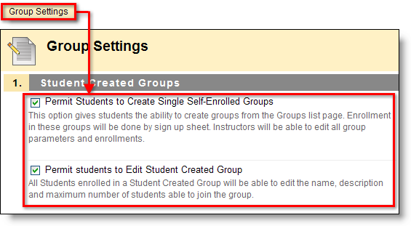

Single Group – is quite similar to Blackboard 8 in that the instructor adds one group at a time. The differences with this tool is that the instructor can now add members while setting up the group, or can choose to use the newly added self-enroll option where students can enroll themselves using a sign-up sheet. In Blackboard 8, instructors had to create the group first, then modify it manually add users.
BB8 | BB9
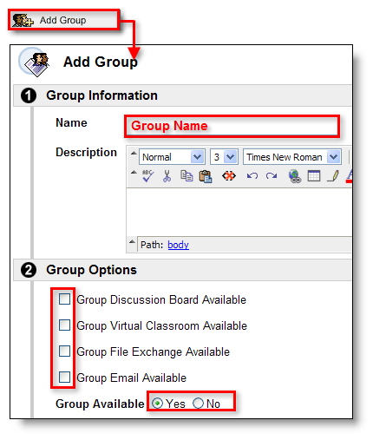  Once created, Modify the group and Add Users.  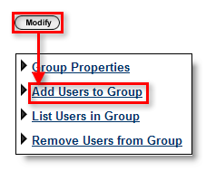 | 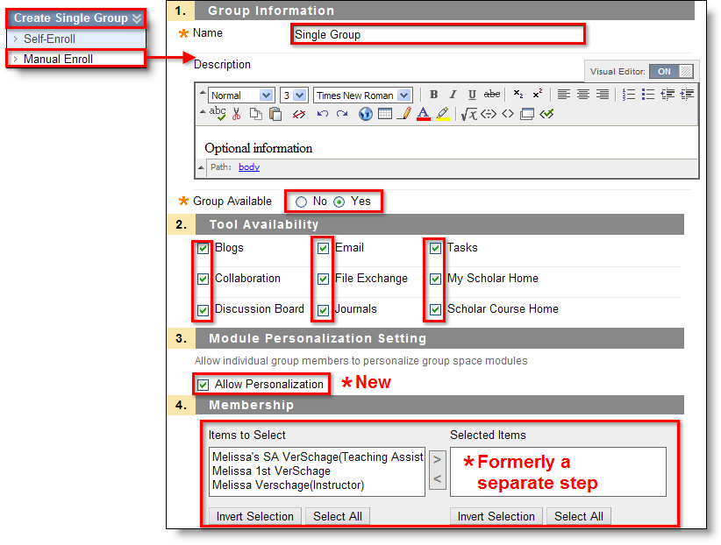

Group Set – is a new feature to Blackboard that enables instructors to easily create multiple groups with the same settings and quantity of members with the creation of one. Like Single Group, this tool allows for manual or self-enroll, and has an additional option of random enroll where Blackboard chooses and enrolls members randomly. Image below demonstrates Group Set | Random Enroll. The only difference in the creation screen from Single Group is the Membership Options in Section 4, which are shown below.
BB8 | BB9
 | 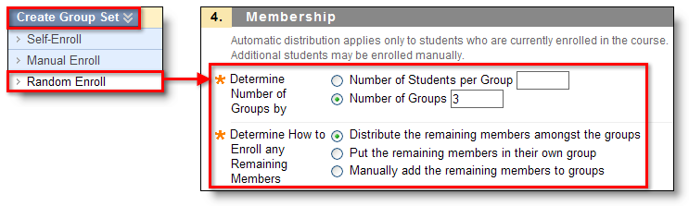

Training and Getting Help
- http://help.asu.edu – Click on the Blackboard 9 Guide or the What’s new in Bb9 on the left under “Faculty and Researchers”
- Training is available throughout August. Details at http://help.asu.edu/node/1778
- Walk-in help available on the Tempe campus, CPCOM 202. Aug 2-27, 8-5p.
- 24/7 support: Phone 965-6500, Email UTOBB@asu.edu

Want to schedule a What’s New session for your department? We’ll come to you! Email UTOTraining@asu.edu.

