SETS and COUNTING FORMULAS

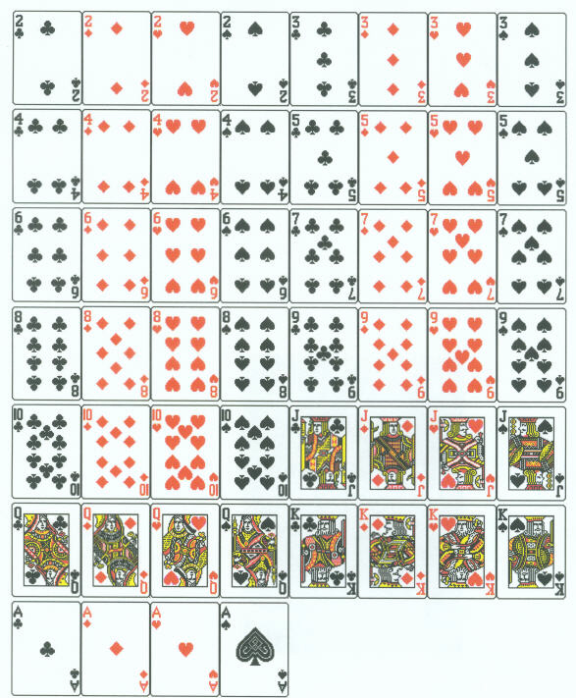
DeMorgan’s Laws for Set:
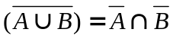
and
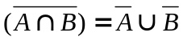

Cardinal Number Rules:

for unions and intersections:
and
for complements:
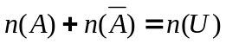

Permutations: 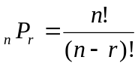
Combinations: 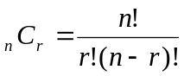

Factorials:
and
0! = 1

