Probability Test Formulas
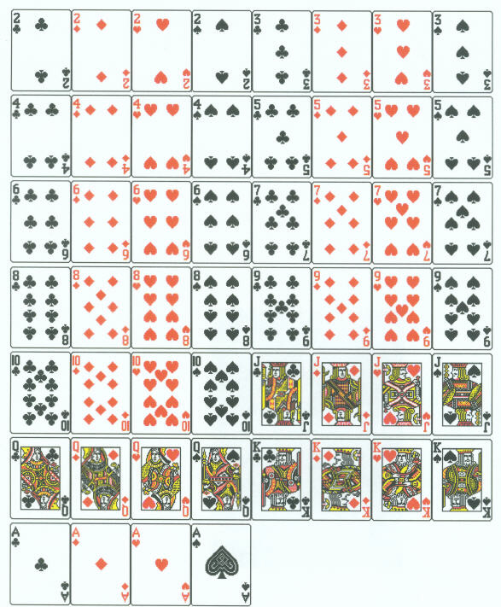
Probability of an event, E:
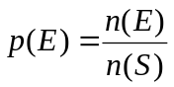
Odds FOR an event, E:
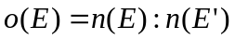
If 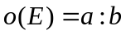, then 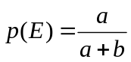.

Cardinal number rules for probability:
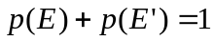

Conditional Probability:
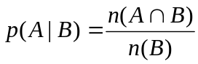

Product Rule:
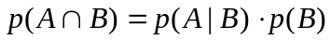

Sample Space of Rolling a Pair of Dice
Sum | (1, 1) | (1, 2) | (1, 3) | (1, 4) | (1, 5) | (1, 6)
2 | (2, 1) | (2, 2) | (2, 3) | (2, 4) | (2, 5) | (2, 6)
3 | (3, 1) | (3, 2) | (3, 3) | (3, 4) | (3, 5) | (3, 6)
4 | (4, 1) | (4, 2) | (4, 3) | (4, 4) | (4, 5) | (4, 6)
5 | (5, 1) | (5, 2) | (5, 3) | (5, 4) | (5, 5) | (5, 6)
6 | (6, 1) | (6, 2) | (6, 3) | (6, 4) | (6, 5) | (6, 6)
7 | 8 | 9 | 10 | 11 | 12

