“Art-Cinema Narration”
by David Bordwell
The predominance of classical Hollywood films, and consequently classical narration, is a historical fact, but film history is not a monolith. Under various circumstances, there have appeared alternative modes of narration, the most prominent one of which I shall consider in this chapter. As a start, ostensive definition might be best. L'Eclisse, The Green Room, Rocco and His Brothers, Repulsion, Scenes from a Marriage, Accident, Teorema, Ma nuit chez Maude, Rome Open City, Love and Anarchy: whatever you think of these films, they form a class that filmmakers and film viewers distinguish from Rio Bravo on the one hand and Mothlight on the other. Not all films shown in "art theaters" utilize distinct narrational procedures, but many do. Within a machinery of production, distribution, and consumption—the "international art cinema," as it is generally known—there exists a body of films which appeal to norms of syuzhet and style which I shall call art-cinema narration.
We could characterize this mode by simply inventorying our theoretical categories. We could say that the syuzhet here is not as redundant as in the classical film; that there are permanent and suppressed gaps; that exposition is delayed and distributed to a greater degree; that the narration tends to be less generically motivated; and several other things. Such an atomistic list, while informative, would not get at the underlying principles that enable the viewer to comprehend the film. Our study of The Spider's Stratagem in Chapter 6 has already shown how its temporal manipulations are based on three broader interlocking procedural schemata—"objective" realism, "expressive" or subjective realism, and narrational commentary. The same schemata explain the various narrational strategies, and their instantiation in syuzhet and style, characteristic of this mode of filmmaking.
Objectivity, Subjectivity, Authority
The Russian Formalist critics pointed out that artists often justify novelty as a new realism, and this observation is borne out by art-cinema narration. For the classical cinema, rooted in the popular novel, short story, and well-made drama of the late nineteenth century, "reality" is assumed to be a tacit coherence among events, a consistency and clarity of individual identity. Realistic motivation corroborates the compositional motivation achieved through cause and effect. But art-cinema narration, taking its cue from literary modernism, questions such a definition of the real the world's laws may not be knowable, personal psychology may be indeterminate. Here new aesthetic conventions claim to seize other "realities": the aleatoric world of "objective" reality and the fleeting states that characterize "subjective" reality. In 1966, Marcel Martin summed up these two new sort of verisimilitude. The contemporary cinema, he claimed, follows Neorealism in seeking to depict the vagaries of real life, to "dedramatize" the narrative by showing both climaxes and trivial moments, and to use new techniques (abrupt cutting, long takes) not as fixed conventions but as flexible means of expression. Martin added that this new cinema deals with the reality of the imagination as well, but treats this as if it were as objective as the world before us.¹ Of course the realism of the art cinema is no more "real" than that of the classical film; it is simply a different canon of realistic motivation, a new vraisemblance, justifying particular compositional options and effects. Specific sorts of realism motivate a loosening of cause and effect, an episodic construction of the syuzhet, and an enhancement of the film's symbolic dimension through an emphasis on the fluctuations of character psychology.
The art film's "reality" is multifaceted. The film will deal with "real" subject matter, current psychological problems such as contemporary "alienation" and "lack of communication." The mise-en-scene may emphasize verisimilitude of behavior as well as verisimilitude of space (e.g., location shooting, non-Hollywood lighting schemes) or time (e.g., the temps mort in a conversation). Andre Bazin emphasized such aspects of the art cinema when he praised Neorealist films for employing non-actors to achieve a behavioral concreteness. Bazin also analyzed how specific stylistic devices, such as deep focus and the long take, could record the phenomenal continuum of space and time.
Such localized aspects do not, however, do justice to the extent to which an "objective" realism becomes a pervasive formal principle. In the name of verisimilitude, the tight causality of classical Hollywood construction is replaced by a more tenuous linking of events. In L'Avventura, for instance, Anna is lost and never found; in Bicycle Thieves, the future of Antonio and his son remains uncertain. We find calculated gaps in the syuzhet, as Bazin writes of Paisa: "This fragment of the story reveals enormous ellipses—or rather, great holes. A complex train of action is reduced to three or four brief fragments, in themselves already elliptical enough in comparison with the reality they are unfolding."² The viewer must therefore tolerate more permanent causal gaps than would be normal in a classical film.
Gapping the syuzhet's presentation of the fabula is not the only way that art-cinema narration loosens up cause and effect. Another factor is chance. Contingency can create transitory, peripheral incidents—the locus classicus is the unexpected rainstorm and the chattering priests in Bicycle Thieves—or it can be more structurally central. It is by chance that Anna is not found in L'Avventura; and by chance that Antonio discovers, then again loses, his bicycle. It is only coincidence that in Wild Strawberries Isak Borg's path crosses that of young people who trigger such significant memories. In this mode of narration, scenes are built around chance encounters, and the entire film may consist of nothing more than a series of them, linked by a trip (The Silence, La Strada, Alice in the Cities) or aimless wanderings (La Dolce Vita, Cleo from 5 to 7, Alfie). The art film can thus become episodic, akin to picaresque and processional forms, or it can pattern coincidence to suggest the workings of an impersonal and unknown causality. Here is Bazin on Diary of a Country Priest:
If, nevertheless, the concatenation of events and the causal efficiency of the characters involved appear to operate just as rigidly as in a traditional dramatic structure, it is because they are responding to an order, that of prophecy (or perhaps one should say of Kierkegaardian "repetition") that is as different from fatality as causality is from analogy.³
After working to open gaps, chance can also close off the syuzhet. When, at the end of Nights of Cabiria, the youths miraculously materialize to save Cabiria from despondency; or when the mimes make their calculatedly unexpected reappearance at the close of Blow-Up; or when two thugs emerge to rob and kill Fox at the close of Fox and His Friends—in each case, the narration asks us to unify the fabula by appeal to the plausible improbabilities of "real life."
We have seen that the classical film focuses the spectator's expectations upon the ongoing causal chain by shaping the syuzhet's dramatic duration around explicit deadlines. But the art film typically lacks such devices. How long do the searchers in L'Avventura have before Anna's fate is sealed? What could limit the time span of Marcello's adventures in La Dolce Vita or Alma's disintegration in Personae? By removing or minimizing deadlines, not only does the art film create unfocused gaps and less stringent hypotheses about upcoming actions; it also facilitates an open-ended approach to causality in general. While motivated as "objectively" realistic, this open-endedness is no less a formal effect than is the more tightly "economical" Hollywood dramaturgy.
The loosening of causal relations is aided by a second sort of schema, that of a subjective or "expressive" notion of realism. The art film aims to "exhibit character." But what kind of character, and how to exhibit it?
Certainly the art film relies upon psychological causation no less than does the classical narrative. But the prototypical characters of the art cinema tend to lack clear-cut traits, motives, and goals. Protagonists may act inconsistently (e. g., Lidia in La Notte) or they may question themselves about their purposes (Borg in Wild Strawberries, Anna in Les rendezvous d'Anna). This is evidently an effect of the narration, which can play down characters' causal projects, keep silent about their motives, emphasize "insignificant" actions and intervals, and never reveal effects of actions. Again consider L'Avventura. Anna's disappearance is motivated to some degree: she is dissatisfied with Sandro, she is capricious, and she yearns for solitude. But once she vanishes, all our hypotheses become equally probable: she has died (by accident? by suicide?) or fled (in a passing boat). In the second half of the film, Claudia and Sandro take as their putative goal the tracing of clues to Anna's whereabouts. But the film's syuzhet devotes so much time to the couple's emotional reactions and to the other people they encounter that their objective starts to collapse. The recovery of Anna is no longer the causal nexus of the action, and our hypotheses turn to the development of the Claudia-Sandro affair.
Equivocating about character causality supports a construction based on a more or less episodic series of events. If the Hollywood protagonist speeds toward the target, the art-film protagonist is presented as sliding passively from one situation to another. Especially apt for the art-film fabula is the biography of the individual (Ray's Apu trilogy, Truffaut's Antoine Doinel series) or the slice-of-life chronicle (Alfie, Cleo from 5 to 7). If the classical protagonist struggles, the drifting protagonist traces out an itinerary which surveys the film's social world. Certain occupations (e.g., journalism, prostitution) favor an encyclopedic, "crosssectional" syuzhet pattern. In general, as causal connections in the fabula are weakened, parallelisms come to the fore. The films sharpen character delineation by impelling us to compare agents, attitudes, and situations. In The Seventh Seal, the Knight's tour of medieval society is enhanced by the juxtaposition of flagellants and buskers; Watanabe, the protagonist of Ikiru, must encounter the denizens of night town and the kindly factory girl Toyo. At its limit, the device of parallellism can form the explicit basis of the film, as in Chytilova's Something Different and Pasolini's Pigpen. The art film's thematic crux, its attempt to pronounce judgments upon modem life and la condition humaine, depends upon its formal organization.
It is only in this sense that the art cinema counters Hollywood's interest in "plot" by an interest in "character." If the classical film resembles a short story by Poe, the art cinema is closer to Chekhov. Indeed, early-twentieth-century literature is a central source for art-cinema models of character causality and syuzhet construction. Horst Ruthrof points to the emergence of a new sort of short story in the modem period, one which is "organized towards pointed situations in which a presented persona, a narrator, or the implied reader in a flash of insight becomes aware of meaningful as against meaningless existence."⁴ Typical of this is what Ruthrof calls the "boundary-situation" story, in which the causal chain leads up to an episode of the private individual's awareness of fundamental human issues. Examples would be Joyce's "Araby" and Hemingway's "Snows of Kilimanjaro." The boundary situation is common in art-cinema narration; the film's causal impetus often derives from the protagonist's recognition that she or he faces a crisis of existential significance.
A simple instance is Fellini's 8 ¹/₂ (1963). Guido, the womanizing film director, has coaxed cast and crew out on location to make a film whose point and script he cannot articulate. He also brings his Mistress, thus creating marital problems for himself. And he is plagued by memories of his childhood, guilty feelings toward his family, fantasies of his dominance over women, and the vision of an idealized muse. As the film progresses, Guido becomes trapped in the world of his problems until a press conference called by his producer forces him to choose some course of action. What he chooses remains uncertain (he may kill himself), but that Guido reaches a boundary situation with respect to the purpose of his life is beyond doubt. A different sort of boundary situation can be found in The Spider's Stratagem, when Athos Magnani discovers that his father was a traitor.
How heavily the film weights the boundary situation depends partly on the syuzhet's expositional procedures. The syuzhet can lead up to the situation by dramatizing the pertinent causal chain, as in The World of Apu when the hero's youth gradually prepares us for his recognition of the meaninglessness of art after his wife's death. Or the syuzhet can confine itself more stringently to the boundary situation itself, providing prior fabula information by exposition. Ruthrof points out the tendency of modem literature to focus on the boundary situation by compressing duration and restricting space. In theater, the Kammerspiel tradition achieved a comparable end. The habit of confining the syuzhet to the boundary situation and then revealing prior events to us through recounting or enactment became a dominant convention of the art film, seen in Rashomon, Ikiru, Death in Venice, The Go-between, The Model Shop, The Immortal Story, and most of Rohmer's films. Bergman, with his strong affinities with Kammerspiel, provides perhaps the most obvious examples.
The boundary situation provides a formal center within which conventions of psychological realism can take over. Focus on a situation's existential import motivates characters' expressing and explaining their mental states. Concerned less with action than reaction, the art cinema presents psychological effects in search of their causes. The dissection of feeling is often represented as therapy and cure (e.g., many of Bergman's films), but even when it is not, causation is often braked and the more introspective characters pause to seek the etiology of their feelings. Characters retard the movement of the syuzhet by telling stories—autobiographical events (especially from childhood), fantasies, and dreams. Even if a character remains unaware of or inarticulate about his or her mental state, the viewer must be prepared to notice how behavior and setting can give the character away. The art cinema developed a range of mise-en-scene cues for expressing character mood: static postures, covert glances, smiles that fade, aimless walks, emotion-filled landscapes, and associated objects (e.g., Valentina's wire toy in La Notte or Catherine's hourglass in Jules and Jim). Within the fabula world—one that is usually as autonomous and internally consistent as that of the Hollywood film—psychological realism consists of permitting a character to reveal the self to others and, inadvertently, to us.
This is a fully expressive realism in that the syuzhet can employ film techniques to dramatize private mental processes. Art-cinema narration employs all the sorts of subjectivity charted by Edward Branigan.⁵ Dreams, memories, hallucinations, daydreams, fantasies, and other mental activities can find embodiment in the image or on the sound track. Consequently, the behavior of the characters within the fabula world and the syuzhet's dramatization both focus on the character's problems of action and feeling; which is to say that "inquiry into character" becomes not only the prime thematic material but a central source of expectation, curiosity, suspense, and surprise.
Conventions of expressive realism can shape spatial representation: optical point-of-view shots, flash frames of a glimpsed or recalled event, editing patterns, modulations of light and color and sound—all are often motivated by character psychology. In Repulsion, Belle de Jour, Juliet of the Spirits, and many other films, the surroundings may be construed as the projections of a character's mind. Similarly, the syuzhet may use psychology to justify the manipulation of time. The flashback is the most obvious instance (Hiroshima mon amour, Wild Strawberries, A Man and a Woman). Subjectivity can also justify the distension of time (slow motion or freeze frames) and manipulations of frequency, such as the repetition of images. (Hiroshima mon amour, The Spider's Stratagem). As V. V. Ivanov notes, the distortions in modern cinema are often motivated not by "Newtonian" time but rather by "psychological" time of the sort discussed by Bergson.⁶
One major consequence of the goal-bereft protagonist, the episodic format, the central boundary situation, and the spatiotemporal "expressive" effects is to focus on the limitations upon character knowledge. Unlike most classical films, the art film is apt to be quite restricted in its range of knowledge. Such restriction may enhance identification (character knowledge matches ours), but it may also make the narration less reliable (we cannot always be sure of the character's access to the total fabula). Sometimes the syuzhet will confine itself to what only one character knows, as in Blow-Up or The Wrong Move; sometimes the syuzhet splits knowledge between two central characters, as in Antonioni's trilogy. The narrow focus is complemented by psychological depth; art-film narration is more subjective more often than is classical narration. For this reason, the art film has been a principal source of experiments in representing psychological activity in the fiction film.
To "objective" and "subjective" verisimilitude we may add a third broad schema, that of overt narrational "commentary." In applying this schema, the viewer looks for those moments in which the narrational act interrupts the transmission of fabula information and highlights its own role. Stylistic devices that gain prominence with respect to classical norms—an unusual angle, a stressed bit of cutting, a striking camera movement, an unrealistic shift in lighting or setting, a disjunction on the sound track, or any other breakdown of objective realism which is not motivated as subjectivity—can be taken as the narration's commentary. Recall the "prophetic" camera movement in The Spider's Stratagem (figs. 6.28-6.32), or the satiric freeze frame in Viridiana that invites the spectator to compare the beggars' feast to the Last Supper. The marked self-consciousness of art-cinema narration creates both a coherent fabula world and an intermittently present but highly noticeable external authority through which we gain access to it.
Thanks to the intrusive commentary, the self-conscious points in the classical text (the beginning and ending of a scene, of the film) become fore grounded in the art film. The credits of Persona and Blow-Up can tease us with fragmentary, indecipherable images that announce the power of the author to control what we know. The narrator can begin a scene in a fashion that cuts us adrift or can linger on a scene after its causally significant action has been completed. In particular, the "open" ending characteristic of the art cinema can be seen as proceeding from a narration which will not divulge the outcome of the causal chain. V. F. Perkins objects to the ending of La Notte on the grounds that "the 'real ending' is knowable but has been withheld .... The story is abandoned when it has served the director's purpose but before it has satisfied the spectator's requirements."⁷ To complain about the arbitrary suppression of the story's outcome is to reject one convention of the art film. A banal remark of the 1960s, that such films make you leave the theater thinking, is not far from the mark: the ambiguity, the play of alternative schemata, must not be halted. Thus the unexpected freeze frame becomes the most explicit figure of narrative irresolution. Furthermore, the pensive ending acknowledges the narration as not simply powerful but humble; the narration knows that life is more complex than art can ever be, and—a new twist of the realistic screw—the only way to respect this complexity is to leave causes dangling and questions unanswered. Like many art films, La Notte bares the device of the unresolved ending when a woman at the party asks the writer Giovanni how a certain story should end. He answers: "In so many ways."
Art-film narration goes beyond such codified moments of overt intervention. At any point in the film we must be ready to engage with the shaping process of an overt narration. A scene may end in medias res; gaps are created that are not explicable by reference to character psychology; retardation may result from the withholding of information or from overloaded passages that require unpacking later. Lacking the "dialogue hooks" of classical construction, the film will exploit more connotative, symbolic linkages between episodes. Scenes will not obey the Hollywood pattern of exposition, pickup of old line of action, and start of new line. Irony may burst out: in The Loneliness of the Long-Distance Runner, Richardson cuts between a borstal choir singing "Jerusalem" and a captured boy being beaten. More generally, the canonic story schema we bring to the film may be disarrayed. There may be little or no exposition of prior fabula events, and even what is occurring at the moment may require subsequent rethinking (Sternberg's "rise and fall of first impressions"). Exposition will tend to be delayed and widely distributed; often we will learn the most important causal factors only at the film's end. Like classical narration, art-film narration poses questions that guide us in fitting material into an ongoing structure. But these questions do not simply involve causal links among fabula events, such as "What became of Sean Regan?" (The Big Sleep) or "Will Stanley seduce Roy's husband?" (In This Our Life). In the art film, as we saw in our analysis of The Spider's Stratagem, the very construction of the narration becomes the object of spectator hypotheses: how is the story being told? why tell the story in this way?
Obvious examples of such manipulation are disjunctions in temporal order. One common strategy is to use flashbacks in ways that only gradually reveal a prior event, so as to tantalize the viewer with reminders of his or her limited knowledge. The Conformist is a good example. Such a flashback is also usefully equivocal; it might be attributable to the character's spasms of memory rather than to the narration's overt suppressiveness. A more striking device is the flashforward—the syuzhet's representation of a "future" fabula action. The flashforward is unthinkable in the classical narrative cinema, which seeks to retard the ending, emphasize communicativeness, and play down self-consciousness. But in the art film, the flashforward flaunts the narration's range of knowledge (no character can know the future), the narration's recognition of the viewer (the flashforward is addressed to us, not to the characters), and the narration's limited communicativeness (telling a little while withholding a lot).
What the flashback and flashforward do in time can also take place in space. Odd ("arty") camera angles or camera movements independent of the action can register the presence of self-conscious narration. The "invisible witness" canonized by Hollywood precept becomes overt. In La Notte, for example, the bored wife Lidia leaves a party with the roué Roberto. As they drive in his car down a rainy street, they talk and laugh animatedly. But we never hear the conversation, and we see only bits of it, because the camera remains obstinately outside the closed car, tracking along with it as it passes through pools of light. The narration has "chosen" to "dedramatize" the most vivacious interpersonal exchange in the film. Such procedures tend to set an omniscient narration's range of knowledge in opposition to the character's; effects of irony and anticipation are especially prominent. In the La Notte example, the camera position deflating the scene foreshadows the somber turn the action will take when Roberto soon tries to seduce Lidia. Unlike the classical film, however, which usually makes the profilmic event only moderately self-conscious, art-cinema narration often signals that the profilmic event is also a construct. This can be accomplished by means of unmotivated elements in the mise-en-scene, such as the sourceless strips of pink and blue light sliding through Fassbinder's Lola. Alternatively, stylized treatment of situations, settings, or props, or of an era or milieu, can seem to proceed from the narration. In Senso and 1900, events are presented with an operatic opulence that invites us to consider the profilmic event itself as the narration's restaging of history.
The result is that a highly self-conscious narration weaves through the film, stressing the act of presenting this fabula in just this way. Deviations from classical norms can be grasped as commentary upon the story action. More generally, the degree of deviation from the canonic story becomes a trace of the narrational process. Syuzhet and style constantly remind us of an invisible intermediary that structures what we see. Marie-Claire Ropars's discussion of ecriturethe tendency of directors like Resnais and Duras to bar direct access to a profilmic reality—emphasizes the general tendency of the art film to flaunt narrational procedures.⁸ When these flauntings are repeated systematically, convention asks us to unify them as proceeding from an "author."
In Chapter 4, I argued that there was no good reason to identify the narrational process with a fictive narrator. In the art cinema, however, the overt self-consciousness of the narration is often paralleled by an extratextual emphasis on the filmmaker as source. Within the art cinema's mode of production and reception, the concept of the author has a formal function it did not possess in the Hollywood studio system. Film journalism and criticism promote authors, as do film festivals, retrospectives, and academic film study. Directors' statements of intent guide comprehension of the film, while a body of work linked by an authorial signature encourages viewers to read each film as a chapter of an oeuvre. Thus the institutional "author" is available as a source of the formal operation of the film. Sometimes the film asks to be taken as autobiography, the filmmaker's confession (e.g., 8 ¹/₂, The 400 Blows, many of Fassbinder's works). More broadly, the author becomes the real-world parallel to the narrational presence "who" communicates (what is the filmmaker saying?) and "who" expresses (what is the artist's personal vision?).
The consistency of an authorial signature across an oeuvre constitutes an economically exploitable trademark. The signature depends partly on institutional processes (e.g., advertising a film as "Fellini's Orchestra Rehearsal") and partly upon recognizably recurring devices from one film to another. One could distinguish filmmakers by motifs (Bunuel's cripples, Fellini's parades, Bergman's theater performances) and by camera technique (Truffaut's pan-and-zoom, Ophuls's sinuous tracks, Chabrol's high angles, Antonioni's long shots). The trademark signature can depend upon narrational qualities as well. There are the "baroque" narrators in the films of Cocteau, Ophuls, Visconti, Welles, Fellini, and Ken Russell—narrators who stress a spectacular concatenation of music and mise-en-scene. More "realist" narrators can be found in the films of Rossellini, Olmi, Forman, and others. The art cinema has made a place for satiric narration (e.g., Bunuel's) and for pastiche (e.g., the many homages to Hitchcock). The author-as-narrator can be explicit, as in Le plaisir or The Immortal Story; or the narrator can simply be the presence that accompanies the story action with a discreet but insistent obbligato of visual and sonic commentary. The popularity of R. W. Fassbinder in recent years may owe something to his ability to change narrational personae from film to film so that there is a "realist" Fassbinder, a "literary" Fassbinder, a "pastiche" Fassbinder, a "frenzied" Fassbinder, and so on.
The authorial trademark requires that the spectator see this film as fitting into a body of work. From this it is only a short step to explicit allusion and citation. A film may "quote," as Resnais does when he includes classic footage in Mon oncle d' Amerique; it may be "dedicated," as La sirene du Mississipi is dedicated to Renoir; or it may cite, as when Antoine Doinel steals a production still from Monika. The film can allude to classical genre conventions (Fassbinder recalling the Universal melodrama, Demy the MGM musical). The art film often rests upon a cinephilia as intense as Hollywood's: full understanding of one film requires a knowledge of and a fascination with other films. At its limit, this tendency is seen in those numerous art films about filmmaking: 8 ¹/₂, Day for Night, Everything for Sale, Beware of a Holy Whore, Identification of a Woman, The Clowns, and many more. A film-within-a-film structure realistically motivates references to other works; it allows unexpected shifts between levels of fictionality; it can occasionally trigger parody of the art cinema itself. In La Ricotta, Pasolini's episode of RoGoPaG, Orson Welles plays a director filming the Christ story; he is pestered by a journalist who asks him about his vision of life and his opinion of Italian society. Antonioni's Lady without the Camellias portrays a vacuous starlet who marries a scriptwriter. He immediately forbids her to play in any of the cheap romances that were her forte and instead puts her in a biopic of Jeanne d'Arc: "An art film, something that will sell abroad!"
The art cinema's spectator, then, grasps the film by applying conventions of objective and expressive realism and of authorial address. Yet are these schemata not incompatible? Verisimilitude, objective or subjective, is inconsistent with an intrusive author. The surest signs of narrational omniscience—the flashforward, the doubled scene in Persona, the shifts from black-and-white to color in A Man and a Woman and If—are the least capable of realistic justification. Contrariwise, to push the realism of chance and psychological indefiniteness to its limit is to create a haphazard narrative in which an author's shaping hand would not be visible. In short, a realistic aesthetic and an expressionist aesthetic are hard to merge. The art cinema seeks to solve the problem in a sophisticated way: through ambiguity.
Within some traditional aesthetic positions, ambiguity is what philosophers call a "good-making property." Therefore, Hollywood films would be judged bad because they are denotatively unequivocal, while art films become good because they ask to be puzzled over. Within the framework of this book, however, ambiguity is only one aesthetic strategy among many, all of potentially equal interest. What is significant is that art-cinema narration announces its debt to the arts of the early twentieth century by making ambiguity, either of tale or telling, central.
The syuzhet of classical narration tends to move toward absolute certainty, but the art film, like early modernist fiction, holds a relativistic notion of truth. This effect is achieved by means of a specific strategy. The three principal schemata provide norms, but the puzzling passages of the film will be explained equally well by alternative conventions. We have already seen this ambiguity at work in our analysis of The Spider's Stratagem, where we found contrary cues for whether to assign flashbacks to characters or to the narrational commentary. Antonioni's Red Desert offers another example. Putting aside the island fantasy, we can motivate any scene's color scheme on grounds of subjective verisimilitude (Giulietta sees her life in this way) or of authorial commentary (the narration shows her life as being this way). That these schemata are mutually exclusive creates the ambiguity. Or recall Rashomon, in which any character's account of the rape and murder may be objectively accurate or warped by subjective interests. In Herzog's Kaspar Hauser, the interpolated desert footage may be ascribed to Kaspar's visions or to the narrational commentary.
The art film is non-classical in that it creates permanent narrational gaps and calls attention to processes of fabula construction. But these very deviations are placed within new extrinsic norms, resituated as realism or authorial commentary. Eventually, the art-film narration solicits not only denotative comprehension but connotative reading, a higher-level interpretation. Whenever confronted with a problem in causality, time, or space, we tend to seek realistic motivation. Is a character's mental state creating the difficulty? Is "life" just leaving loose ends? If we are thwarted, we appeal to the narration, and perhaps also to the author. Is the narrator violating the norm to achieve a specific effect? In particular, what thematic significance justifies the deviation? What range of judgmental connotations or symbolic meanings can be produced from this point or pattern? Ideally, the film hesitates, hovering between realistic and authorial rationales. Uncertainties persist but are understood as such, as obvious uncertainties. Put crudely, the procedural slogan of art-cinema narration might be: "Interpret this film, and interpret it so as to maximize ambiguity."
As I have described it, art-cinema narration might seem to encourage what Veronica Forrest-Thomson calls "bad naturalization." She observes of Wallace Stevens, "His obscurity is a kind of coyness, an attempt to stay one step ahead of the reader and so gain a reputation for daring while ensuring that the reader knows exactly where the poet is and how he can take that one step to reach him."⁹ And it is true that at its most banal, art-cinema narration promises complexity and profundity only to settle our attention on stereotyped figures: "reality," neurotic characters, the author as puppeteer. But in many of these films, the narration sustains a complex play within the conventions of the mode. There is the possibility of exploring non-redundant cues and devising new, wholly contextual narrational devices. The film can build up curiosity about its own narrational procedures, thus intensifying the viewer's interest in the unfolding patterns of syuzhet and style. Uncertainty about story events, generated by causal looseness and gaps, can create what Sternberg calls "anticipatory caution," a thwarting of the primacy effect and a discouraging of exclusive and likely hypotheses. The narration can warn us or mislead us. By alternating overloaded with sparse passages, the narration can demand intense attention; and by creating ambiguous organizational patterns, the narration can make such great demands on memory that it may be necessary to see the film more than once (a formal effect not without economic value). Finally, the film can undermine norms far more frequently than can a classical film. The art film plays among several tendencies: deviation from classical norms, adherence to art-cinema norms, creation of innovative intrinsic norms, and the greater or lesser foregrounding of deviations from those intrinsic norms. To see how the game can go, let us look at one film in detail.
The Game of Form
The career of Alain Resnais offers a good instance of how the art cinema as an institution encourages a filmmaker to formulate a discernible "project" running from one film to another. Resnais's recurrent concern has, of course, been the representation of time. In its day, Hiroshima mon amour (1959) caused considerable surprise for its minimal cueing of flashbacks, and L'annee derniere a Marienbad (1961) was widely understood as blurring the line between memory and fantasy. Muriel (1963) contained no flashbacks or hallucination sequences but did exploit a highly elliptical approach to the moment-by-moment unfurling of the syuzhet. I mention these well-known facts because the average spectator of La guerre est finie (1968) is likely to approach the film with some expectations about the principal narrational manipulations the film will offer and to attribute those to an authorial intelligence. In such ways, the creation of a distinct formal project can lead the filmmaker to innovate fresh intrinsic norms from film to film. No two Resnais films treat the same aspects of narrative time, or handle time in quite the same way. The spectator will thus be asked to plot La guerre est finie's particular work against the extrinsic norms of the mode, and the achieving of prominence will have an undeniable ludic component. So will the subsequent deviations from the intrinsic norms. The viewer must draw upon tacit conventions of comprehension characteristic of the art film—objective verisimilitude, expressive realism, overt narrational intervention—in order to construct the fabula and identify the rules unique to this film's narrational work.
The first nineteen shots of La guerre est finie introduce us to its intrinsic norm. The story is this: The agitator Diego is driving back across the Spanish border with Jude, a bookseller who occasionally assists anti-Franco leftists. As they approach the checkpoint, Diego looks forward to safe passage while Jude chats about how the sudden trip spoiled his vacation. But this fabula episode is made difficult by many procedures.
The "objective" verisimilitude of the action is evident location shooting, the general fidelity to the political situation—but it gets overridden by the strongly subjective cast of the narration. The very first shot of the film (fig. 10.1) is from a passenger's optical point of view. Shot 2 (fig. 10.2) enables us to locate the source of the point of view (the character we will later learn to call Diego). The cues for subjectivity are reinforced by the next shot (fig. 10.3), another optical point of view, and by the sound track, for as the camera pans right to show the distant town, a nondiegetic voice is heard:
"You're past the border. Again you see the hill of Biratou." The objective specificity of locale is secondary to the subjective depth, whereby the gaze is linked to a character's reaction. At this point harpsichord music creeps onto the sound track, contributing to the emphasis upon subjective affect. As the camera pans left and the car drives forward, the voice-over asserts: "Once again, you'll get over,"
There is now a shift into a slightly less restricted narrational presentation.
10.1 10.3
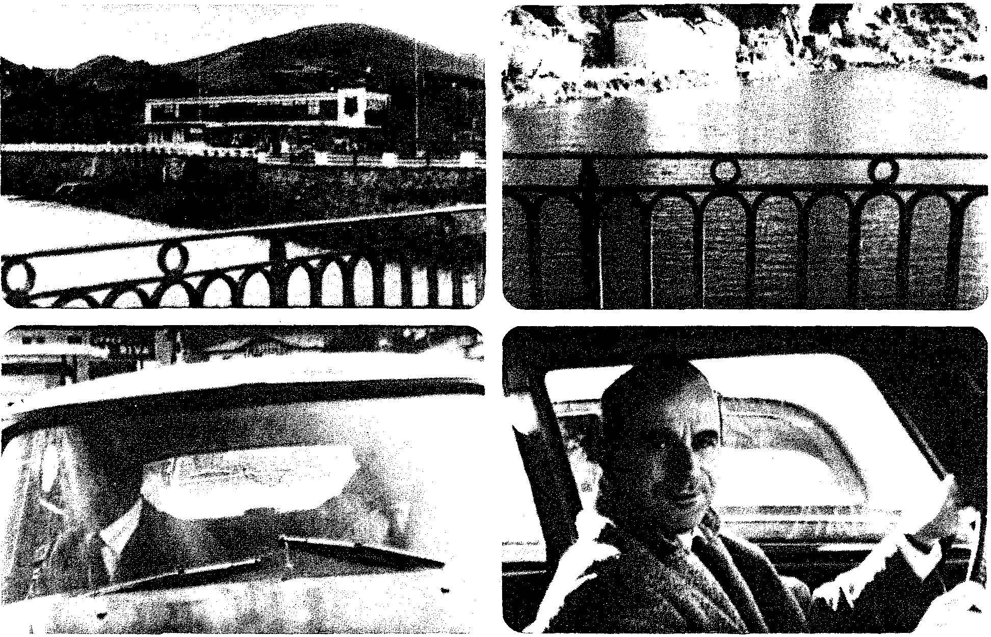
10.2 10.4
In shots 4-7 (figs. 10.4-10.7), Jude and Diego exchange patient glances. Despite the angle of Jude's look, neither man is filmed from the other's optical point of view. In addition, the timing of the glances presents a greater range of narrational knowledge: the camera anticipates each man's look by several moments. The unrestricted presentation in this suite of shots is of course highly conventional.
10.5 10.7
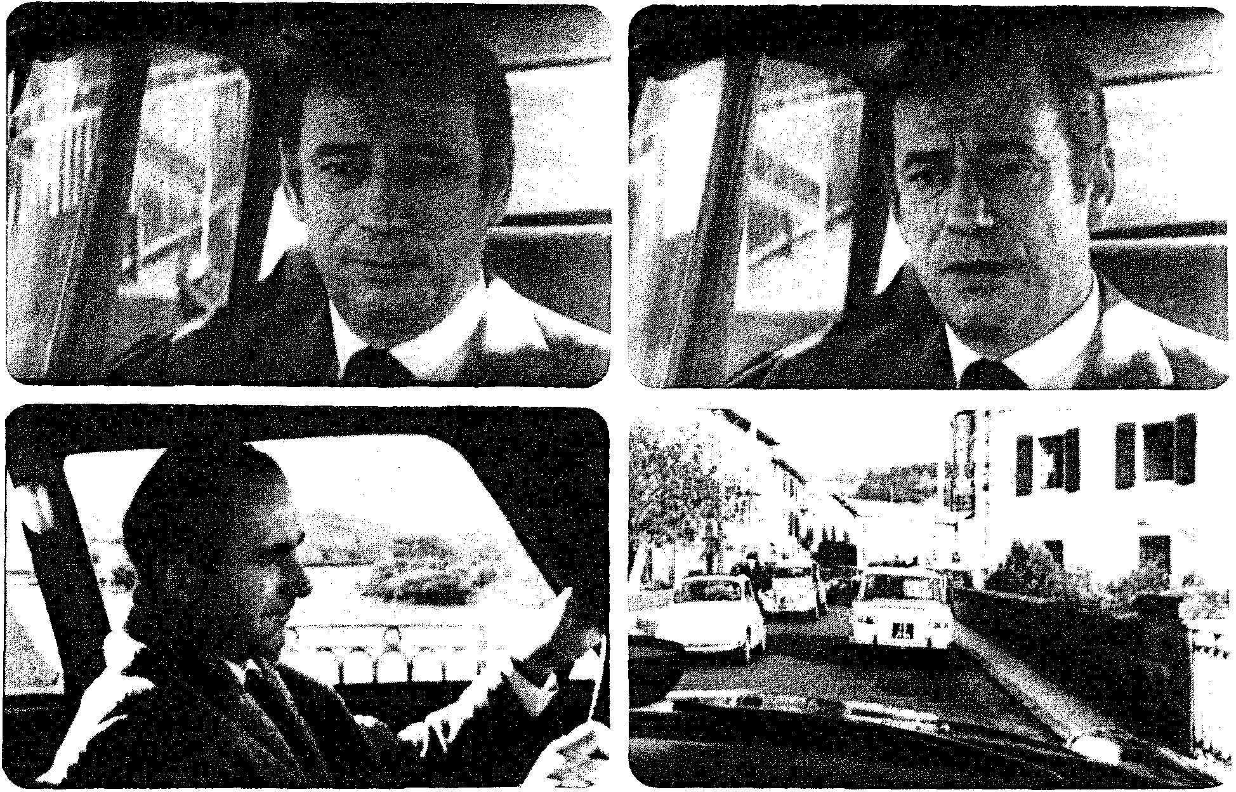
10.6 10.8
Diego's optical point of view returns (shot 8; fig. 10.8) as the car approaches the checkpoint. But now the accompanying sound is Jude's voice offscreen, confessing his worry that the car might have broken down en route. Midway through the sentence, the image track starts to diverge significantly from Jude's chatter. We see several images, rapidly cut. (See figs. 10.9-10.18.) Diego runs out of a train station to catch a cab (shot 9). An apartment door opens to reveal a man and a woman coming forward (10). Diego enters an elevator as the same man strides out of an adjacent one (11). Diego runs out of the station but must wait in line for a cab (12). Diego walks down a train corridor (13). Diego hops onto a train as it pulls out (14).
10.9 10.11
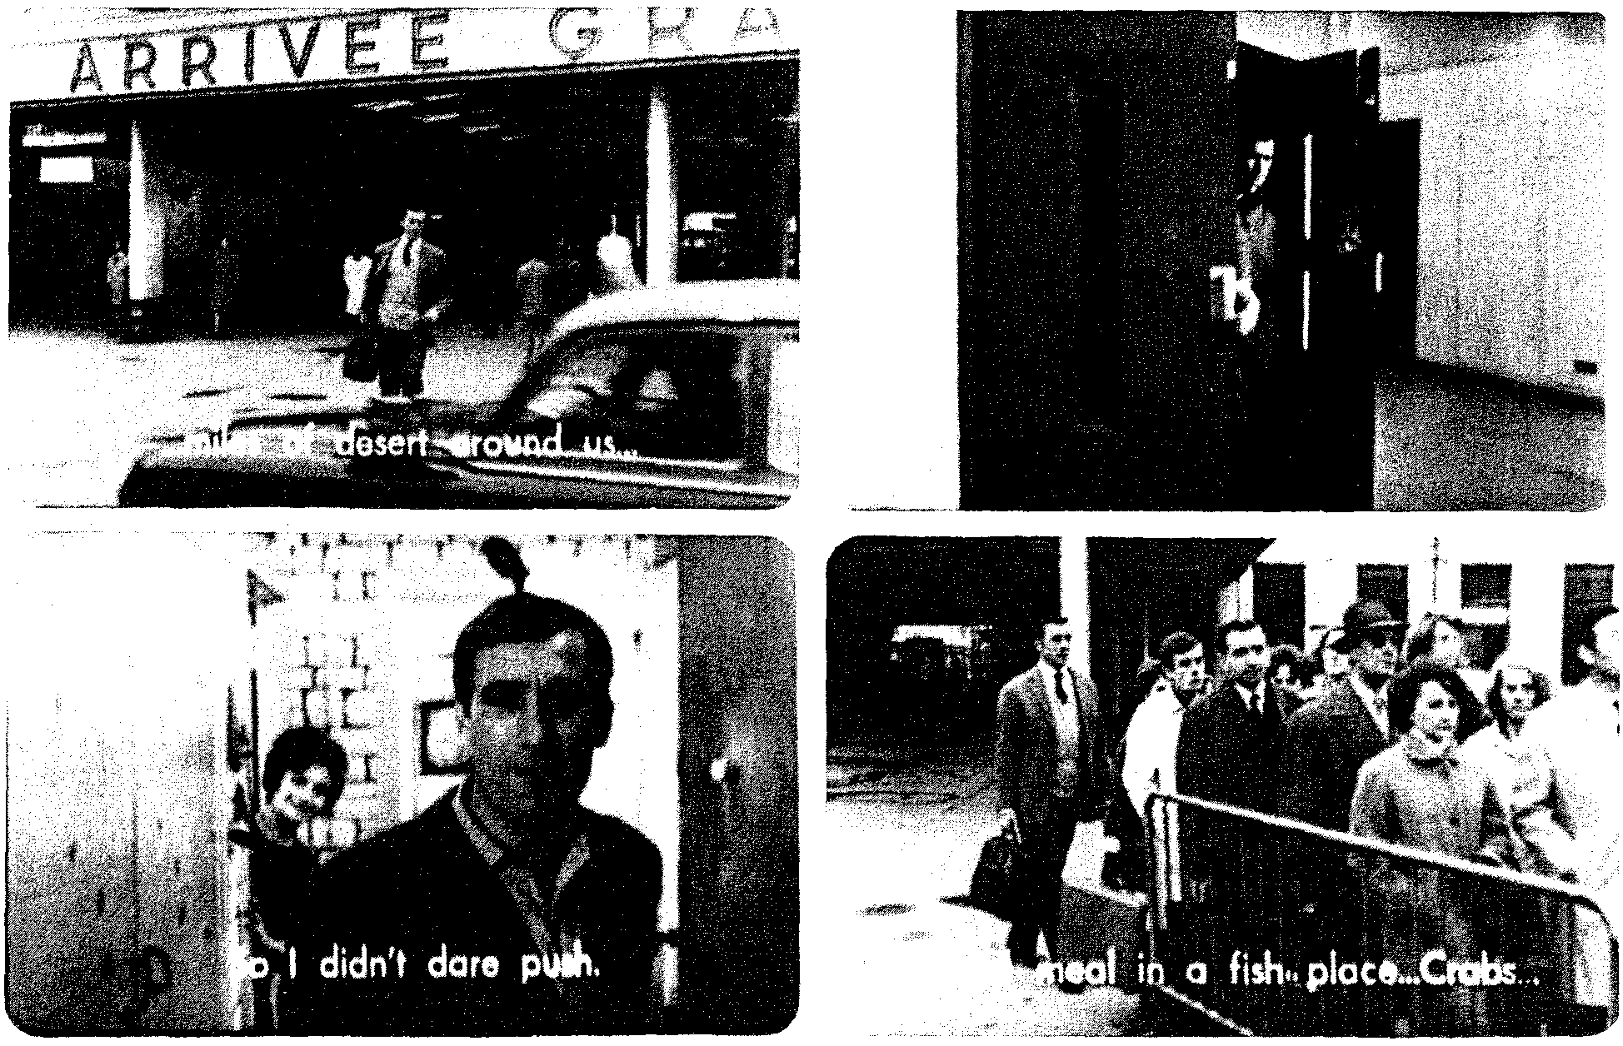
10.10 10.12
Diego runs to a train but misses it (15). Diego leaps from a car as it pulls up to a train station (16). The same unknown man comes into his apartment and greets Diego, who appears to have been waiting for him (17). And all this occurs while Jude's voice continues on the sound track. At shot 18, we are back in the car, with Jude still behind the wheel.
10.13 10.15
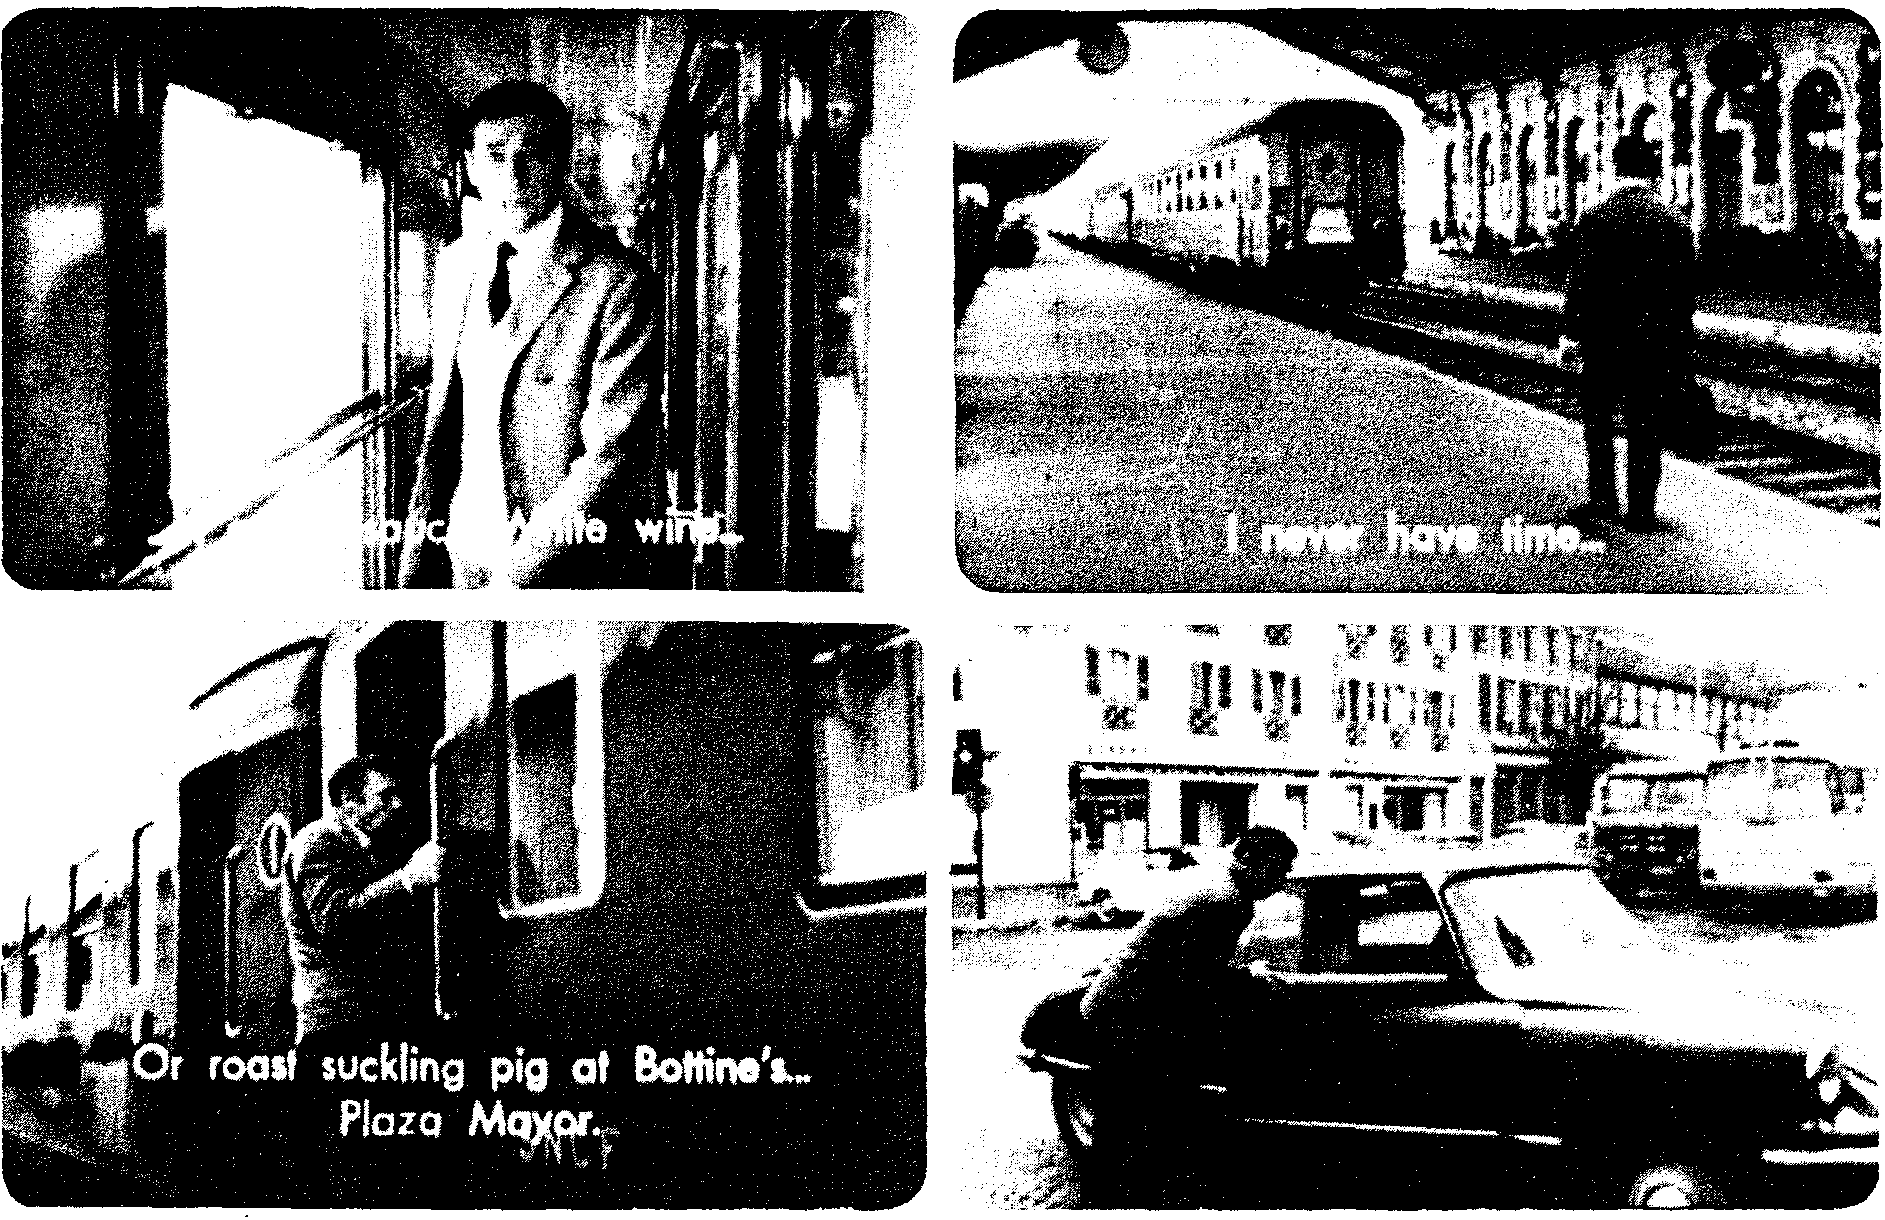
10.14 10.16
10.17
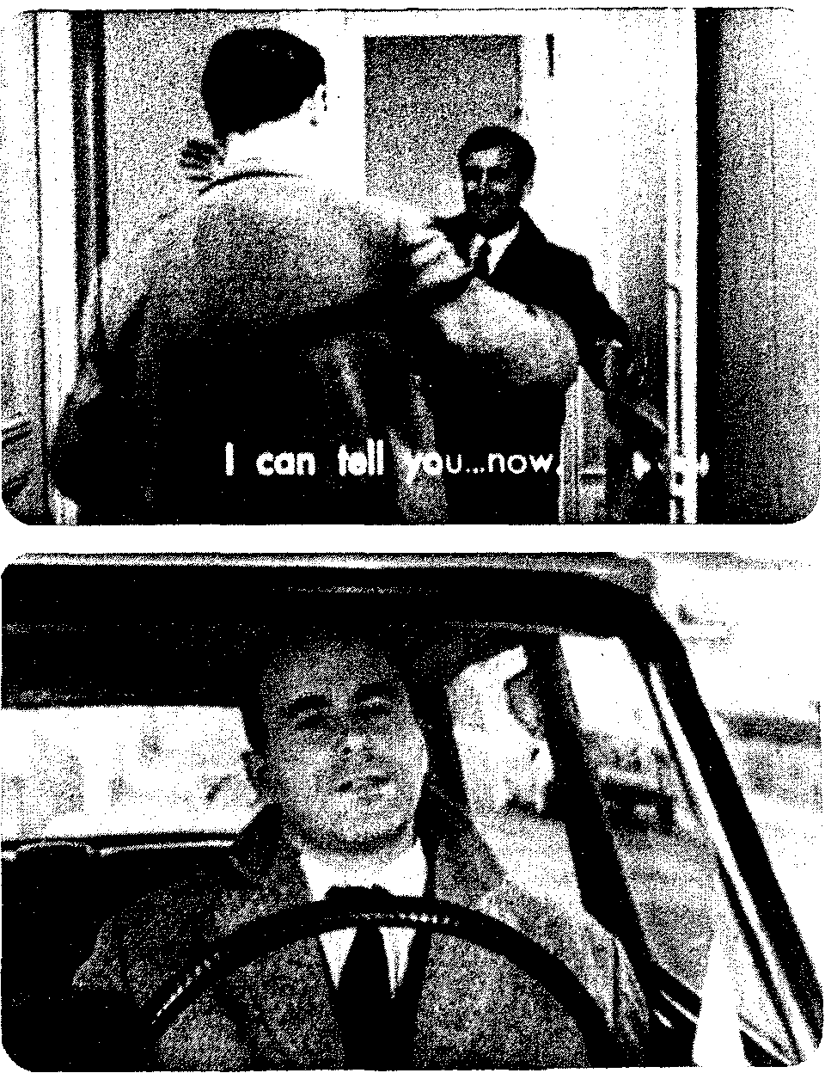
10.18
and image (not the present). But the ambiguities of the sequence thwart an easy comprehension. The most probable hypothesis based on extrinsic norms would be that the image is in the past. Yet this creates a new problem. It is difficult to grasp the series of shots as presenting a single event chain. True, nothing prevents our construing shot 9 this way. (Perhaps Diego caught a train earlier.) And there might be an effort to fit the images into some chronology, on the assumption that arriving at the station (16) preceded catching the train (14) and riding it (13). But all of the shots are not easily explicable as events in any temporal string. Most of them present mutually exclusive alternatives:
1. Diego catches a cab quickly (9); or he has to wait in line (12).
2. Diego calls on Juan and he is home (10); or Diego misses him (11); or Diego calls and Juan arrives later (17).
3. Diego catches the train (14); or he misses it (15).
The all-or-nothing nature of the alternatives is strengthened by the immediate juxtapositions of extremes: Diego finds Juan or misses him (10/11), he catches the train or misses it (14/15). Whatever the spectator eventually makes of this sequence, there are strong cues that it probably does not represent a single stretch of past fabula events.
If this is not a single action in the past, the shots might be construed as an elliptical montage sequence of the "frequentative" type. That is, Diego's regular routine is to take cabs, visit contacts, catch or miss trains, and so forth. This hypothesis is strengthened by the voice-over's insistence upon repeated action ("Again you see the hill of Biratou ... "). Yet Diego wears the same clothes in every shot-hardly a helpful cue for construing these actions as habitual repetitions in the past.
Only one construction accounts for everything in these shots. It is an unlikely one, but it is the one that later passages will confirm. These shots may be taken to represent various possible future events. Put in simple fashion: "I might grab a cab right away or have to wait in line," "I might miss Juan," "What if I can't catch my train?" La guerre est finie will explore character subjectivity according to one principle of the art film; we justify what we see and hear by reference to psychological motivation. The narration creates a unique intrinsic norm by supplying neither flashbacks nor fantasies in the usual sense. We are to share the character's anticipation of events. This also realistically justifies the lack of chronological order in the images. Diego might think of meeting or missing Juan, then of how he will get to Juan's apartment, then of missing the train, and so forth. In a 1966 interview, Resnais asserted that his treatment of anticipation was "realistic" in showing the mind's tendency to leap ahead to a goal and only later speculate on what might happen on the way. Of course, this "realism" is wholly arbitrary. (One could just as easily argue that it's more plausible for the mind to plan its moves in chronological order.) Nonetheless, Resnais opens up a new category of psycho logical experience for narration to dramatize.
Resnais also doubted that all the implications of his treatment would get across. "I do not think that it is understandable to spectators, but they can feel a sort of uneasiness in the fact that the images are in the future.”¹⁰ One can certainly argue that shots 9-17, swiftly cut and referring to characters and places of whom we yet know nothing, are comprehended by most first-time spectators as little more than "images which are probably subjective." This initial difficulty is very important. First, it is typical of the art film to acclimate us gradually to its intrinsic norms. (Recall the cues for flashbacks in The Spider's Stratagem.) Much of the art film's appeal rests upon a tantalizing narration that plays a game of gaps with the viewer, and La guerre's opening quickly sets that game in motion. We become keen to know not only whether Diego will get through the border (suspense) and what his past is (curiosity) but also what this flurry of interspersed images represents, and what the film's own "rules" are. Second, the mutual exclusiveness of the juxtaposed shots maximizes indeterminacy. We are not sure exactly what story event, in what place in the action sequence, we're seeing. Finally, such a striking opening cries out for critical discussion. In reviews and interviews, a commentator or indeed the director himself can call our attention to the difficulty of the device.
Once the sequence returns to Jude (shot 18), we are back in the present, and the next shot of Diego (19) confirms the subjective, digressive nature of the anticipatory images. It is reassuring, at the formal level, to discover that, however puzzling the excursions become, we will return to an "objective" frame of reference. We thus grasp the entire first sequence (in all, twenty-five shots) as a generally and "objectively" coherent scene (durationally continuous and primarily restricted to Diego's knowledge) which a subjective passage interrupts.
Against the overall narrative unity of the sequence must be set certain ambiguities and lacks of redundancy. What about the voice-over that speaks "to" Diego? It is not wholly subjective: it is not his voice, and it uses "you" rather than "I." Is it then the voice of some "authorial" narrator? Or is it a "subjective other," an impersonal objectification of his thoughts? Later scenes will play with possible sources of this voice. And the handling of point-of-view decoupage is somewhat different from the normalized ABA cutting pattern of Rear Window (Jeff looks / shot of what he sees / back to him looking). Here we see through the character's eyes before we see the character (shot 1). Or we have shots A and B, but instead of a return to the looker we cut to another person (shots 2-4). Or a passage involving mental subjectivity begins on the musing character (shot 8) but ends on the other character (shot 18). Or we have mentally subjective images that work against consistent optical subjectivity (shot 11). Not that any of these tactics is fundamentally disquieting, but they do bring out how the classical paradigm uses many redundant cues; our comprehension does not necessarily flag if some are withheld.
As in this sequence, the whole film's syuzhet coheres around Diego, as both agent and psychological subject. Our range of knowledge is almost completely restricted to his. In this respect he resembles Philip Marlowe in The Big Sleep or Murder My Sweet: the syuzhet is constructed around gaps in the hero's knowledge. More to the point for art-cinema norms, however, is that restriction to Diego's range of know 1edge is necessary for the central device—the anticipatory flashforward—to work. If we should learn Juan's fate or witness events of which Diego is ignorant, his visions would register simply as narrational irony. (He's right about this, wrong about that.) Confinement to what Diego knows not only justifies withholding information, as in the detective tale, but also increases the indeterminacies of "expressive realism" and permits the plumbing of elusive states of mind for their own sake. How much less confident would we feel about Marlowe's inferential powers if The Big Sleep dramatized, in abrupt flashes, all the alternative hypotheses that flit through his mind!
Later we will not be completely restricted to Diego's range of knowledge. There are brief, patterned violations that function to prepare the female characters to take over his role at the film's end. In scene 17, while Diego sleeps, there is a brief shot of his lover, Marianne, looking in on him. Five sequences later, Nadine Sallanches comes down the steps of a cafe while Diego's back is turned. In scene 27, when Diego goes into a drugstore to phone Nadine, the camera holds on Marianne. At the film's climax, the narration has recourse to crosscutting among these three characters: while Diego drives to Spain, Nadine is visited by a policeman and Marianne prepares to cross the border to warn him. The very last shots of the film identify Marianne and Diego, making her our new (and limited) protagonist; she now obtains, perhaps, a depth of subjectivity commensurate with that earlier assigned to Diego.
If Diego is our virtually constant point of reference, the overall composition of the film assures that we do not lose our bearings in a morass of subjectivity. For one thing, each gap is flaunted; we may be in the dark about the narration's goal, but we can pinpoint where we lose our bearings. (Contrast in this respect the suppressed gaps of L'annee derniere a Marienbad.) Moreover, just as the first sequence framed Diego's anticipations within the "objective" action of crossing the border, so the narration always takes care to include stable expository portions. After the disorienting series of shots we have already considered, the narration goes objective for three scenes. Diego is questioned at the border and his false identity is tested. He escapes because the young woman who answers the phone at "his" address backs up his story. Here the restriction to Diego's range of knowledge yields orthodox results, a curiosity gap: why would Nadine Sallanches lie to protect a stranger who has apparently stolen her father's passport? In the next scene, Diego's discussions with Jude and Jude's wife explain to us the faked passport, his bluff before the border officer, and so on. Just as important, it is during the stay at Jude's shop that clear cues are supplied about the nature of the subjective passages. If the flurry of Diego's anticipations in scene 1 was graspable only as "perhaps not flashbacks," the narration now takes pains to explain the device.
Over a medium shot of Diego, Jude's voice-off asks if Diego knows the Sallanches family. Nondiegetic piano music comes softly up. Diego responds: "No, none of them." This creates a primacy effect: we will evaluate what we see in the light of this statement. Ten shots follow, all but the last accompanied by the piano music. Each of the first five shots shows a young woman walking in medium shot away from the camera as it tracks to follow her. Similarity balances difference: graphically matched compositions and figure/ camera movements play against the fact that each young woman is unique. (See figs. 10.19-10.21) The next two shots show, again in graphically matched fashion, two different women entering a building. The eighth shot tracks in on yet another young woman talking on the phone. As in the first sequence, the "objective" conversation continues on the sound track, signaling that the series of shots is Diego's mental event. But instead of the several either/or pairings presented in the overloaded first passage, here a single piece of information—Diego's musing on what Nadine looks like—is reinforced by the musical cue, by his verbal declaration, and by a series of shots that reiterate ten alternatives. The same sort of point is made in the last two shots: on the sound track Diego says he's never seen their house, and the narration immediately supplies images of a street and a house number.
The viewer's prevailing hypothesis about the film's intrinsic narrational norm emerges: any images or sounds that cannot be related to an "objective" construction of the scene are then most likely Diego's subjective anticipation. Scene 5 reinforces this hypothesis immediately. After more conversation, Jude remarks to Diego that Antoine must be at the station. Cut to a man at a railway bookstall turning to look at the camera. Cut to the same man, now at the ticket window, turning to the camera. Cut to the same man in another spot, again turning to look at the camera. And cut to a long shot of Jude and Diego coming downstairs, their footsteps having sounded over the three interpolated shots. Finally, this scene links the device to the first, most puzzling subjective passage. After Diego says that Juan can't be across the border, the narration cuts to a shot of the man we saw in the first sequence, riding in a car. From ten inserted shots to three shots to one: after a trio of interpolations, we are primed to construe even a single disparate image as Diego's projection. By the end of scene 5, not only have we received a major portion of expository material about Diego's mission and his tactics, we have also found the key to the film's narrational method. This key, however, will not unlock anything unless the spectator is prepared to apply the art cinema's conventional schemata.
10.19, 10.20, 10.21
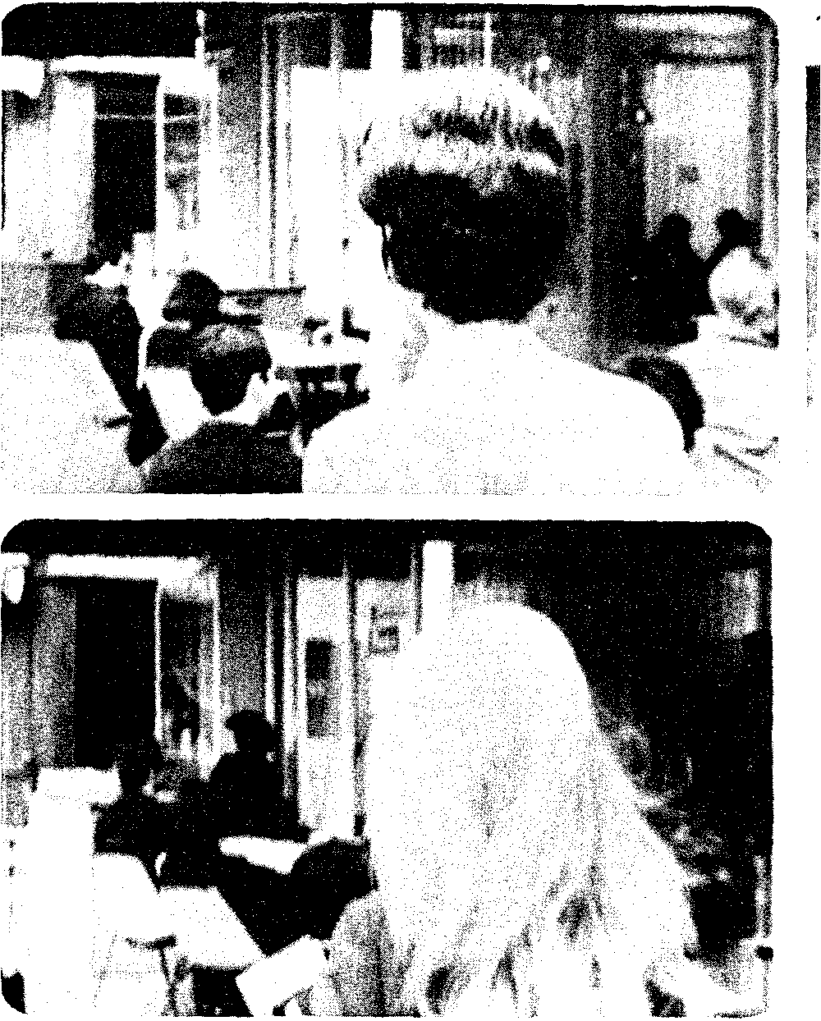

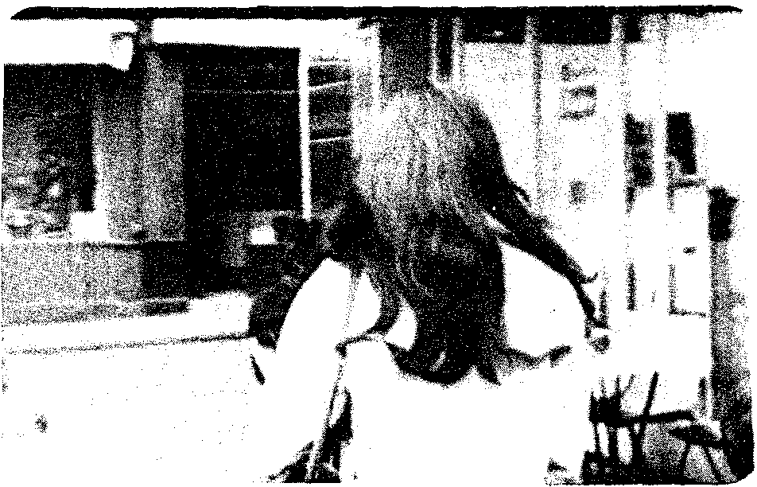
It is worth stressing just how redundant all this is. At the level of the fabula, characters' traits and functions are mutually compatible. At the level of the syuzhet, the narration's repeated alternation of subjective passages with objective ones and its adherence to a consistent point of view guarantee considerable predictability. And the narration presents the fabula so that we have ample opportunity to pick up information, especially in the expository conversation scenes. In scene 5, we not only understand what transpired in scene 2, when Diego was challenged by the border chief, but also learn the background to his underground activities. Even the content of Diego's anticipations is eventually clarified through repetition. Only certain aspects of the narration are not redundant, some bearing chiefly on a key plot point—what has become of Juan?-and some bearing on how certain narrational devices are to be interpreted, as we shall see. The ambiguity of the art cinema is of a highly controlled and limited sort, standing out against a background of narrational coherence not fundamentally different from that of the classical cinema.
La guerre est finie builds its story upon the base established in the opening scenes. The principal fabula lines involve Diego's mission to convince his leftist compatriots that the Spanish police have discovered Juan's plans; his love affair with Marianne, a book designer; and his involvement with Nadine, daughter of the man whose passport he carries and member of a youthful leftist group which is hoarding explosives for terrorist ends. These lines of action interweave across a syuzhet duration of four days (18-21 April 1968), each strand serving to retard resolution of the others. To this calendric verisimilitude the film adds other realistic touches: mishaps and coincidences (warning Juan, Diego's encounter with a cop in a cafe), reallocations, allusions to political events, and a general depiction of debates within the French left (Old Left patience versus terrorism, etc.). There is also the convention of expressive realism, incarnated here as Diego's psychological crisis. Is he right to insist on warning Juan? Has he lost track of the political game he plays? His colleagues charge him with being blinded by the daily trivia of his job; he begins to doubt his judgment. "We're finicky about details," he tells Nadine. "It's the total picture we lose sight of." Marianne notices as well, asking him whether he is not confused about where he's going. Diego makes slips: he may have betrayed himself to the Spanish police, he forgets to turn on his headlights and is stopped by a policeman, and after a heated quarrel with Nadine's cadre, he realizes that he has led the police to them. His boundary situation is as much personal and political, since he desires Nadine but comes to realize that he wants to clear a place for Marianne in his life. All of these factors work to ensure that the film is unified by realistic motivation of an art-cinema stripe.
The realism of Diego's comportment also justifies the syuzhet's expositional tactics. The narration gives us information piecemeal and retards our complete understanding of the situation. Not until a later scene do we learn the basis for Diego's belief that Juan is walking into a trap. Still later, we learn that Diego has some relation to a woman named Marianne, and we see her somewhat after that. The narration also delays revealing Nadine's affiliation with the young leftists. Thus the film engages the spectator's interest with suspense gaps (e.g., will the police nab Diego?) as well as many curiosity gaps (what is Diego's relation to Marianne? how is Nadine connected to Diego's activities?). The curiosity gaps are motivated by Diego's state of mind in two ways: the restriction placed on his knowledge and the very nature of his mental activities. For instance, of course Diego knows about Marianne at the start, but the narration does not inform us of her existence for some time. This omission is justified by the way his mind is shown to work. He is characterized as cautious, so he is unlikely to volunteer information about Marianne in scenes with other characters. Since he is preoccupied with the mechanics of his border crossing and the possible peril to Juan, none of his anticipations involve Marianne until he approaches her apartment. The narration justifies its distributed and delayed exposition by making its central character ignorant, closemouthed, and so perpetually focused on the future that he does not occupy himself with the past. Hence the need for several lengthy scenes in which Diego and other characters pass expositional information along to the viewer.
La guerre est finie, then, appeals to conventional structures and cues while at the same time introducing significant innovations. The narration employs art-cinema principles of psychological verisimilitude but finds a new domain for them (the anticipatory flashforward). The film fulfills our expectations about ambiguity (e.g., the opening sequence) while also defining the range of permissible constructions (e.g., "probably not flashbacks"). Early on, the film tutors us in its methods, giving us a unique but comprehensible hypothesis to help us construct the story action. The film's problem now is to maintain psychological coherence—the focus on Diego's political and personal experience—while varying the narrational ploys. Once we have the key, the narration could become wholly predictable. How is the narration to engage that overt play with expectation characteristic of the art film?
One way that the game is sustained involves marking each subjective sequence unequivocally but also varying the particular filmic devices employed. In this film, two stylistic cues are necessary for a sequence to be identifiable as imaginary: a cut (visual cue) to images from which no diegetic sound is forthcoming (auditory cue). Thus the first sequence cuts to Juan leaving his apartment, Diego missing a train, and so on, but we do not hear voices, the throb of the train, or other diegetic sounds. These cues are accompanied by more contextual ones. Diego must be present, and the anticipation must be plausibly triggered by something in the current scene. Otherwise the flashforwards display great freedom in their stylistic figures. On the image track, the subjective shot often includes a tracking camera movement and characters' turning to the camera—both techniques suggesting Diego's optical point of view—but these are not always present. And no single sound cue will unequivocally assure us that a subjective sequence is coming up or in progress. Given the silence within Diego's mental image, the sound track may let dialogue in the present continue (e.g., Jude's chatter in the first scene) or supply diegetic noise from the present (e.g., the two men's footsteps in scene 5), nondiegetic music, the voice-over, silence in the present, or any combination of these. For example, Diego's anticipations of Nadine in scene 5 are accompanied by piano music for nine of the ten shots and dialogue in the present during eight of them. This means that the subjective sequences may be accompanied by a rich variety of sounds. In scene 1, Jude's complaining about the vacation he had hoped for while Diego is occupied with his own anticipations exemplifies how the range of sonic options can indirectly reinforce the image.
The narration can also withhold some cues. We have already seen that the first anticipatory sequence can be construed as Diego's subjective "insert" even though it ends not with a shot of Diego but with a shot of Jude. Such slight deviations from extrinsic norms can suffice to destabilize our expectations. A subjective insert can thus come along in a wide range of circumstances. There is no need for a lead-in shot of Diego, or a musical cue, or explicit discussion of the subject of the anticipation. This is comparable to the variation of cues for order and duration at work in The Spider's Stratagem. The narration can also mislead us by foregoing a subjective passage when we might expect one. On several occasions, Diego will pause reflectively—on a train, in his study—and the next shot will prove not to be an index of his thoughts. When Diego burns his false passport photo, we hear his voice, as if in voice-over; yet it is not the internal voice that addresses him, and we must conclude that he is murmuring off-screen. Such a play with our expectations remains within the boundaries codified by the film. It is the trigger and the timing of the mental imagery that the spectator can never exactly predict. To the end, the eruption of a subjective sequence remains only more or less probable, never certain.
The narration maintains its game with the viewer in still more ways. Consider, for instance, the difficulty that crops up if we cut from a shot of Diego to a close-up of some act, say a valise being slid into a locker. If there is no "present-tense" sound on the track, there are two possible assumptions: that it is a subjective flashforward or that it is the first shot of a new, objective scene. One effect of some flashforwards can thus be an uncertainty as to whether we are yet "into" the next present-tense scene. There are several other, equally slight, dislodgings of expectation that the anticipatory sequences create, but I want here to focus on two of great importance, both revolving around time.
By scene 5, I have argued, redundant cues have established the reigning hypothesis for grasping narrational disjunctions: when in doubt, look for cues for Diego's subjective anticipations. This hypothesis is strengthened in scene 6, when at Hendaye station Diego reflects on how Juan might be captured and how Diego might prevent it. In scene 7, aboard the train to Paris, the narration provides a summary of most of the subjective motifs we have seen: Diego getting out of a cab, Diego arriving at Juan's apartment, Diego meeting his leftist cronies, Juan being captured, Diego spotting young women who might be Nadine. Both scenes 6 and 7 are accompanied by present-tense sound: dialogue in the first, the train rumble and whistle in the second. The film is now in danger of becoming predictable. In the next scene, some ground rules get modified, albeit in equivocal fashion.
We are first given to wonder whether Diego is now not occasionally conjuring up past events. In scene 8, a quick shot of Madame Lopez and a longer take of the apartment complex are accompanied by voice-over remarks that suggest flashbacks: "You visited Juan a year ago-building G, tenth floor, number 107—care of Madame Lopez, you thought." The case for a flashback is not clear-cut, though, since one could also consider the shots of Madame Lopez and the apartment complex as anticipatory; only the commentary would then pertain to the past. There follows a shot of Juan driving off which can be taken as Diego's imagining of a past event ("Juan has probably already left") but could also be taken as another anticipation ("If Juan has yet to leave ... "). In scene 11, the promise is fulfilled. When Diego leaves Ramon's, the narration gives us another ambiguous image—a track back from the corridor of Juan's apartment and then a definite flashback: a shot of Madame Jude, as she had been seen earlier that day when Diego talked with her. Here we have a case of foregrounding, the violation of an established intrinsic norm. It is not, however, a strong case, for it varies along only one dimension, temporal order.· (Recall that fore grounding gets stronger according to how many dimensions of syuzhet or style are involved and how predictable the deviation is with respect to intrinsic and extrinsic norms.) Indeed, this deviation quickly gets absorbed into the intrinsic norm. From this point on, the film will have occasional recourse to flashbacks. Thus the narration teasingly asks the spectator to modify the initial hypothesis: assign any deviation from objective continuity to Diego's mind, either most probably as an anticipation or secondarily as a flashback. The strategy suits the art-cinema mode. Instead of opening the film with the more conventional device of the flashback and moving on to include flashforwards, the narration starts with the more unpredictable device and introduces the conventional one in a way which yields uncertainty.
Along with the flashback there is another fore grounded temporal device, used only once. We have seen that as a rule Diego's subjective flashforwards are presented as silent images, although they may be accompanied by dialogue or noise in the present. The temporal disjunction occurs only on the image track. But in one scene we are disoriented by an apparent violation of this rule. Diego and Nadine have agreed to meet at the Bullier Building at 6:00. There follows a pursuit: Nadine and her boyfriend, Miguel, are followed by a policeman, who is in turn followed by Diego. Over the third shot of the pursuit, nondiegetic xylophone music gives way to the disembodied voices of Nadine and Diego. He is telling her that she has been followed; she denies it. After several moments of conversation, cut to Nadine, turning in medium shot and saying: "Miguel?" Now she and Diego are in the Bullier Building, their rendezvous point. Like the images in earlier scenes, the sound track here is equivocal. It could represent Diego's anticipation of what their conversation will be, in which case it would be the only auditory anticipation in the film. Or the passage can be taken as a more "objective" aural flashforward: the sound of their conversation at Bullier at one point of fabula time is laid over images of action at an earlier point. Either way, the narration is only stretching the rules. Allowing one instance of auditory anticipation still adheres to the basic principles of Diego's subjectivity, while the "authorial" trick of letting the sound of scene B lie over the end of scene A would be quite conventional in the art cinema generally. In either event, the image/sound interaction here, like the occasional flashbacks, works to keep the film from falling into easily predictable patterns.
One more way that the narration maintains its game with viewer expectation deserves notice because it is quite particular to La guerre est finie. We have already seen that the film spectator's interest is essentially future oriented; under the pressure of time created by the viewing situation, we are more geared to suspense than curiosity. To some extent, the art cinema works against this by stressing curiosity and delaying expositional material. But the narration of La guerre trades upon future-oriented interest to a great degree. Obviously, at the level of causality, there is the what-will-happen-next sort of interest. At the level of narration, the handlings of the intrinsic norms also solicit spectator surprise. (Will the device of sequence 1 be explained? Once it is explained in sequence 5, will it vary?) The peculiarity of this film is that the particular narrational tactics it exploits create diffused gaps with respect to past events but unusually focused expectations about future ones. Because Diego is constantly anticipating his actions, our awareness of them is sharpened. Will the events he envisions take place? If so, will they occur in the way that he expects? The most obvious and pervasive instance is Juan's trip. Since the film enacts (and not merely recounts) many possible fates which could befall Juan, we take a keen interest in finding which will be actualized. On a more local level, Diego's anticipations of what Nadine will look like, where she will live, how he will encounter Juan's wife, and how he and his colleagues will conduct their meeting are all precise enough to let us look forward to measuring the fit between subjective image and objective event. To some degree, the film makes up for the widely distributed and delayed exposition of prior fabula events by an unusually high degree of control over the spectator's hypotheses about upcoming ones. Our hypotheses are highly exclusive (Diego constructs clearly defined alternatives) and often simultaneous. Which is to say that because of the narration's enactment of Diego's mental activity, the film invites us to make his expectations our own.
Yet this tactic too is modified so as not to become predictable. At two points, Diego doubts the efficacy of his (and our) hypothesis forming. His chief charges him with subjectivism, with misjudging the danger to Juan, and though he puts up resistance he ends by accepting the criticism. More vividly, in scene 30, Nadine's Leninist group confronts him with the possibility that he led the police to them. Surprised, he imagines an agent filming from a car (another "speculative flashback"). One effect of any highly restricted and deeply subjective narration is to make us forget the extent to which we and the character may be led astray. In the course of the narration, Diego is forced to consider that his hypotheses are often not as probable or as exclusive as he had assumed. Once we learn the narration's devices, we are inclined to trust Diego's judgment; when that fails, we suffer what Sternberg calls the "rise and fall of first impressions."¹¹
The anticipatory image and its varied manifestations, functions, and effects maintain the intermittent overtness of narration characteristic of the art cinema. That stress is also apparent in the way that the film employs ambiguity. The complexity of certain images and sounds is not a reflection of their ambiguity for Diego. (He knows who Juan is, when he must have left, what was actually said to Nadine at the Bullier Building.) The ambiguity is largely the result of an omniscient narration's overt play with audience expectation. Sometimes it is a matter of communicativeness-holding back the identification of Juan in the first scene, for instance. Sometimes it is a question of self-consciousness, as when the narration supplies images and sounds that are most comprehensible as coming from an overriding consciousness (the narrator).
A simple example is the love scene with Nadine. After Diego has met her, they make love. But the scene is staged and cut in a stylized fashion uncharacteristic of the rest of the film. A montage of body parts is accompanied by high-key lighting, overexposed images, and abstract white backgrounds. The effect is to code the scene as both "reality" (the couple did make love) and "fantasy" (connotations of impossibly pure pleasure). In retrospect, the treatment appears even more stylized by comparison with Diego and Marianne's lovemaking later, handled in longer takes and without the abstract visual effects. The question is: to "whom" do we attribute the fantasy connotations in the scene with Nadine? We can take it as a piece of character psychology (Diego "seeing" Nadine as a fantasy of desire) or as commentary (the narration informs us of this fantasy as Nadine's role, although Diego is unaware of it). The ambiguity plays between a relatively unselfconscious presentation of character subjectivity and a highly self-conscious intervention of the "author."
While the love scene is fairly ordinary in its ambiguity, the narration is somewhat more inventive in its use of the voiceover commentary. We have already noticed that this internal speaker, using a voice which is not Diego's and addressing him as "you," is inherently equivocal. It could be the "subjectively objective" voice of his own mind, a kind of internalized Other that ponders his actions in an impersonal way. This alternative is reinforced by the commentary's habit of coldly summing up what has happened and of projecting future possibilities that accord with what we see. "Antoine's right," the voice says. "Go to Paris"—this over a shot of Diego jumping on a train. The commentary often chimes with the anticipatory images, giving us a greater confidence that it is in some mediated way Diego talking to himself. Yet one could also construe the voice as that of a highly knowledgeable and unusually intimate narrator, one deliberately letting us "overhear" its address to Diego. This would justify the use of "you," the disparity in vocal qualities, and Resnais's own comment that the narration aims to admit to the spectator, "We are in the cinema."¹² The difficulty of choosing one source over another is revealed in two later scenes.
When Diego is meeting with his leftist colleagues, a voiceover commentary is heard. At first, we might be inclined to take the voice as Diego's inner Other ("Again the feeling you've lived through this experience before ... "), but when Diego and the chief start to debate in Spanish, the voice comes to function as a translator's. It renders the speeches into French, while in an undercurrent we still hear the characters speaking Spanish—a technique trans textually coded as "documentary" from its use in television reportage. When Diego speaks, the commentary continues to render his Spanish with a shift in person: "You never said that, that we ought to give ourselves up to spontaneity ... " We are forced to posit either that Diego is thinking in French while speaking in Spanish or that a self-conscious narrator is translating this speech for the benefit of the viewer while still retaining access to Diego's attitudes; Moreover, in this scene the commentary utilizes a new voice, not the one we have heard over earlier scenes. This of course exacerbates the problem of the source. There is no way to resolve these disparities; we can only note them as ambivalent effects, working to jar our expectations and to make the film an object of interpretation.
The most striking ambiguity surrounding the voice-over commentary occurs when we last hear it. In scene 31, Diego returns to his compatriots' apartment. Manolo is standing morosely by the window. As Diego walks in, the commentary delivers a remarkable passage.
You didn't know that Ramon was dead, they're going to announce the news to you in a second. Dead Sunday night, a few hours after you saw him. His heart gave out, as the saying goes. And now you're going to leave in his place, because the work has to go on, no single death can interrupt it.¹³
This is most plausibly grasped as the voice of an omniscient narrator who has decided to intervene overtly. Only such an entity could confidently assert, "They're going to announce the news to you ... " Yet some degree of ambiguity remains. Leaps into the future are compatible with Diego's habits of mind, however unlikely it is that he could anticipate Ramon's death in such detail. Moreover, the trip planning is soon interspersed with Diego's anticipation of Ramon's funeral, at which he is sometimes seen as present, sometimes treated as absent. To make Diego the source of the voice-over is tantamount to granting him second sight, but it could well be the climax of the film's use of subjective anticipation. Self-conscious narrator, or unselfconscious character? The uncertainty is never dispelled.
It is at the film's close that the play between clear, even redundant narration and the expansion of ambiguity becomes strongest. Diego meets his new driver, Salart, and they set off for Spain. In extreme long shot, the car drives off (fig. 10.22). This is the first time we have been so spatially distant from Diego. And now there is a dissolve to Juan, walking toward us as the camera tracks back (fig. 10.23). The image hangs suspended between character and narrator. Until now, we have seen Juan only through Diego's imaginings, so this shot may constitute his last anticipation. But many of the previously affirmed cues for subjectivity are absent: no cut (rather, a dissolve); no subjective camera; no contextual cues that could trigger a flashforward (Diego has departed, we hear no dialogue).

10.22 10.23
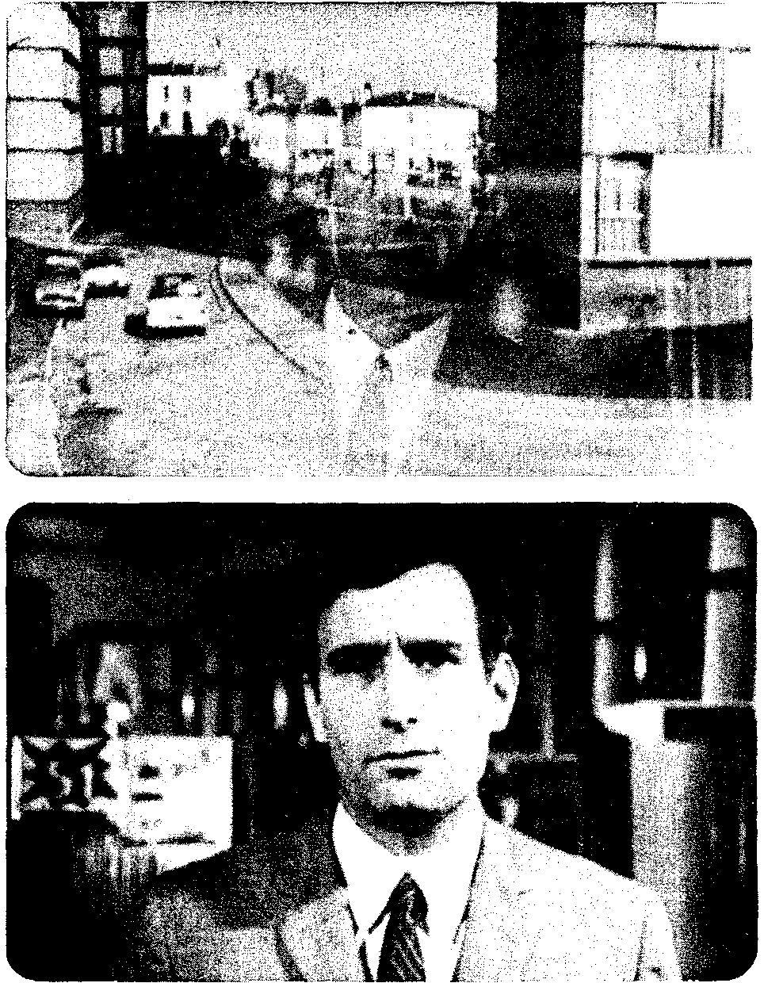
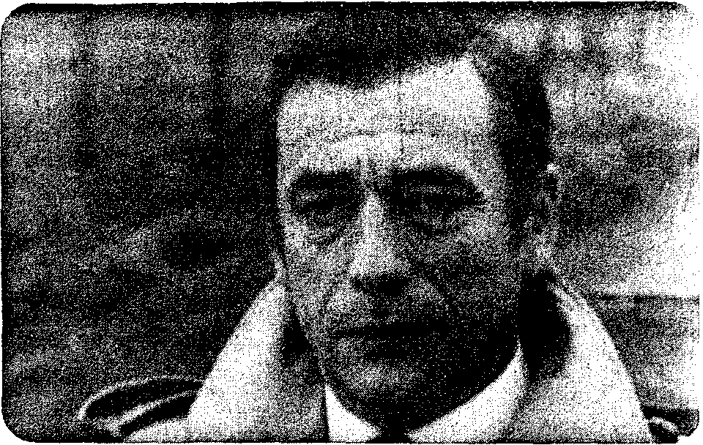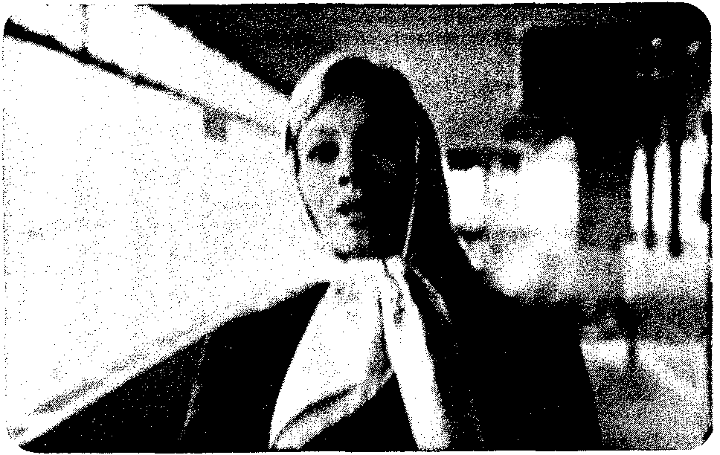
10.24 10.25
Immediately after this equivocal, fore grounded image, however, the narration supplies a highly normalized sequence. The long shot turns out to be our farewell to Diego as a bearer of information. Now the film crosscuts a cop's interrogation of Nadine with shots of Diego and Salart speeding to the border. Nadine learns that the police have set out to trap Diego and she calls her father, telling him to warn his Spanish friends. As soon as she hangs up, there is a curt shot of Diego's passport being stamped at the border. Side by side stand a highly ambiguous shot and a passage that employs unrestricted narration for the sake of suspense.
The same juxtaposition occurs in the very last scene. Manolo and Marianne are at Orly airport. She will depart for Barcelona to warn Diego. The spatial and temporal construction of the scene is unequivocal, with shot/reverse shot predominating. Then there is a cut from Manolo at Orly to Diego riding in a car (fig. 10.24), much as we have seen him in the first sequence (fig. 10.7). A very slow dissolve takes us back to Orly, where Marianne hurries down a corridor toward the camera. Diego's face is held superimposed over her, as guitar and choral music rises on the sound track (the same music used in their lovemaking scene). Diego's face finally fades out, leaving only Marianne hurrying toward us as Juan had at the closing of the earlier sequence (fig. 10.25).
The scene reveals that the narration has moved us to closure. The characters have become predictable, their actions thoroughly motivated, the alternative outcomes simplified. Just before this scene, Diego's psychological crisis has been resolved: he has broken with Nadine, has offered to take Marianne to Spain, and has renewed his political commitment by envisioning Ramon's funeral as an occasion for solidarity: "You're caught up again by the fraternity of long combats, by the stubborn joy of the action." Now Marianne has found the place in Diego's life that she has sought. Yet the last scene also generates considerable ambiguity. Two flaunted gaps in the syuzhet become permanent ones: we will never learn what became of either Juan or Diego. The dissolved image of Diego, like that of Juan earlier, can be understood as the narration's self-conscious juxtaposition (Marianne runs to Diego, or Marianne will become Diego, or Marianne will become Juan) or as her anticipation of Diego's drive (making her the sort of restricted, deeply subjective narrational vehicle that Diego has been during the bulk of the film). It would be wrong to settle on one interpretation, since the film works to create a limited but still "open" ending; in this it fulfills yet another convention of the art cinema.
A full analysis would have to study the film's political themes—its debates about commitment and its stress on individual responsibility. But all I have aimed to show is how the political material has been appropriated and transformed by formal conventions. The film has in fact blatantly announced its conjunction of political substance and narrational protocols. On his way to Ramon's, Diego reflects that Roberto gets upset when "the reality of the world resists us, because he saw what we did as being a dream of infinite progress. He hates it when reality fails to coincide with his dream." Here the political struggle is made analogous to the film's own principal narrational operation—Diego's dreams coinciding more or less with actual events—and, more generally, to the familiar dream/reality theme of the art cinema. By focusing on the individual psyche and maintaining a shifting narrational game with the spectator, La guerre est finie transmutes political material into a unique treatment of the conventions of a particular narrational mode.
The Art-Cinema in History
As a mode of narration, the art cinema forms a paradigm. But as we saw when considering classical Hollywood narration, putting the paradigm into a historical context reveals some narrational options as more likely at certain points than at others. La guerre est finie's use of time and ambiguity would be improbable in a 1950s film, or a 1984 one. The drama of a family's emigration to the city is rendered with "objective" verisimilitude in Visconti's Rocco and His Brothers (1960), while a comparable story is refracted through flashbacks, fantasy scenes, hallucinations, and overt authorial address in Francesco Rosi's Three Brothers (1980). In sum, we have now to sketch out how the weight assigned to narrational options, the shifting of "dominants," has varied across history.
Art-cinema narration has become a coherent mode partly by defining itself as a deviation from classical narrative. This may seem most obvious in the postwar decades, when the dismantling of the studio system enabled highly individualized international auteurs to emerge. Historically, however, the art cinema has its roots in an opposition to Hollywood nurtured within various national film industries of the silent era and sustained by concepts borrowed from modernism in theater and literature.
During the 1920s, when modem art was strongly influencing avant-garde cinema, the grounds for conventions of expressive realism and overt narrational address were laid. The influential Cabinet of Dr. Caligari (1920) took up theatrical techniques (distorted settings, Schrei acting) for representing subjective states, and its equivocal frame story can be seen as a very early case of applying ambiguity to an entire narrative structure, since we must wonder whether the stylized settings proceed from the "narrator" or (as the film tries to suggest at the end) from the character's mind. The film also appears to leave a permanent gap: the distorted settings remain constant to some degree when they reappear in the frame story, and the Doctor's final "I think I know how to cure him now," addressed to the camera, strikes modern viewers as unsettling. ¹⁴ It was in Germany as well that the Kammerspielfilm was initially developed. Films like Scherben (1921), Hintertreppe (1921), and Sylvester (1923), with their confinement of the action to a single locale and a brief time span, showed that cinema could represent existential boundary situations with the same concentration as that achieved in Strindberg's dramas.
In France, the Impressionist school was cultivating a set of devices for the representations of characters' inner states. Abel Gance's La roue (1923) sought to dramatize its characters' fleeting thoughts and moods through superimpositions and other optical effects, point-of-view shots, and rapid editing. In Epstein's Coeur fidele (1923), the heroine's mental distress as she rides a whirling carnival ride is conveyed by frantic cutting. Theorists of the period advocated subjective camera movements to enhance the audience's identification with characters' feelings.¹⁵ The French filmmakers also explored ways to convey narrational comment. Irises and vignettes could soften the image for lyricism. At the start of Coeur fidele, Epstein uses mismatched close-ups-the barmaid's unmoving face alternating with her arms tiredly per forming her chores-to imply a dissociation between her sensitive temperament and her sordid life (figs. 10.26, 10.27). The impressionists were much influenced by post-Symbolist art, so it is not surprising to find Germaine Dulac comparing a film to a Debussy piece, or to see in the complex multiple-narrator structure of Epstein's La glace a trois faces (1927) the influence of Proust, Gide, or Romains. At the same period, Surrealist films like Un chien andalou, in their savage play with the conventions of mainstream storytelling, opened up new paths for the achievement of narrational ambiguity. ¹⁶
10.26
10.27
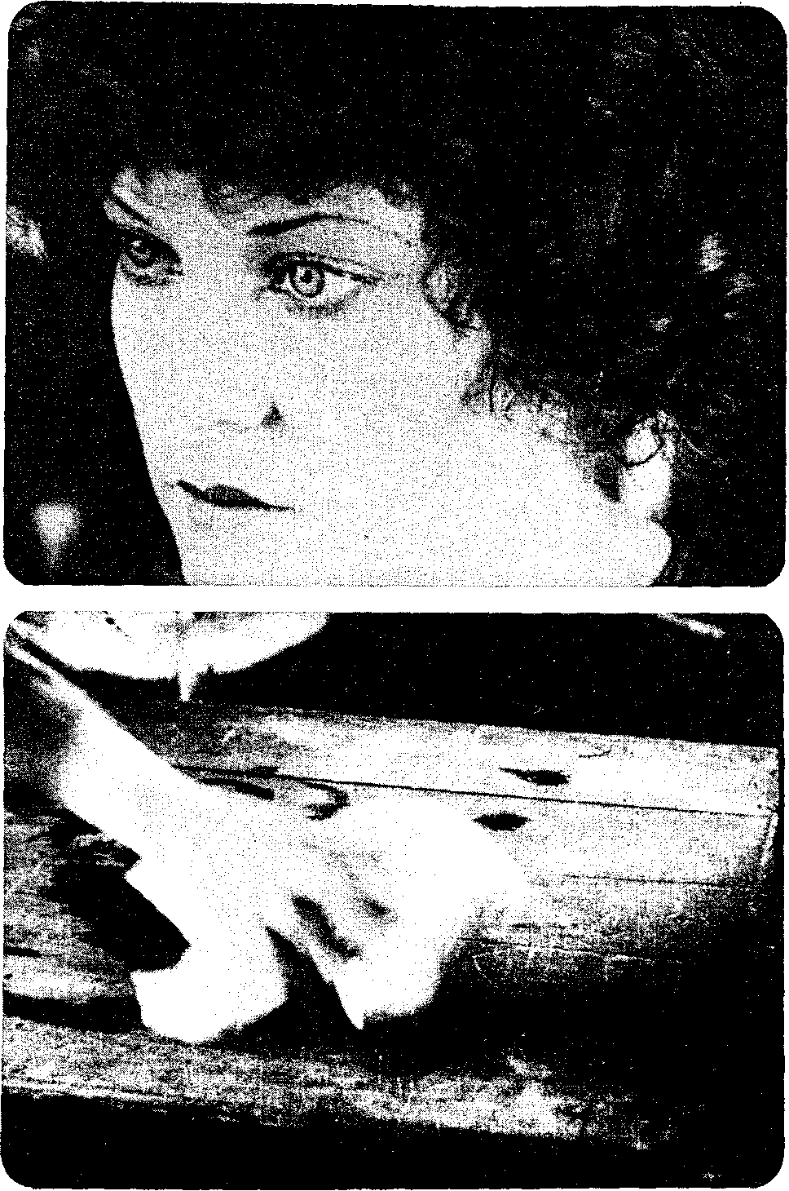
Not until after World War II, however, did the art cinema emerge as a fully achieved narrational alternative. Hollywood's dominance of exhibition, both at home and abroad, began to wane. In the United States, judicial decisions (the Paramount decrees) created a shortage of films. Production firms needed overseas markets; exhibitors needed to compete with television. In Europe, the end of the war reestablished international commerce and facilitated film exports. Thomas Guback has shown how, by 1954, many films were being made for international audiences. ¹⁷ It would be wrong to see this as a case of "Hollywood versus Europe." American firms underwrote much foreign production, and foreign films helped American exhibitors fill screen time. The postwar "art house," a film theater in a city or campus town, was a symptom of the new audience: college-educated, middleclass cinephiles looking for films consonant with contemporary ideas of modernism in art and literature. Parallel audiences emerged in European intellectual centers.
In the light of these developments, Italian neo-realism may be considered a transitional phenomenon. Institutionally, films like Shoeshine (1946), Rome Open City (1945), Paisa (1946), Bicycle Thieves (1948), and Umberto D (1952) functioned as international reportage, addressed as much to the outside world as to Italians. Along with certain French efforts (notably Les enfants du paradis, 1945) and Scandinavian films (e.g., Day of Wrath, 1943), the Neorealist films broke into worldwide markets. Formally, the films contributed to founding conventions of objective verisimilitude. Bazin pointed out the importance of chance (Bicycle Thieves "unfolds on the level of pure accident") and of narrational omission, which he justified as the construction of the film out of "component blocks of reality.”) By the early 1950s, then, filmmakers had at their disposal a tradition embracing both character subjectivity and authorial intervention. And some filmmakers had begun to explore the objective realism of open-ended narratives, a dramaturgy of chance encounters, and above all the essential ambiguity of the fabula world. At this point, however, objective verisimilitude on the Italian model was the dominant narrational convention. It was chiefly the flashback films, such as Rashomon (1950), Miss Julie (1950), Ikiru (1952), Waiting Women (1952), and Lola Montes (1955) that chose to explore subjectivity.
If, in retrospect, art-cinema narration seems so distinctly a creature of the late 1950s and the 1960s, it is partly because the richest play among its three defining schemata took place then. During this period, the ambiguous interaction of objective and subjective realism reached its apogee. Consider just some of the output of those years:
1957: Nights of Cabiria, Wild Strawberries, Aparajito, The Cranes Are Flying
1958: Eroica, Ashes and Diamonds, Brink of Life, The Face, Nazarin, Black Orpheus
1959: L'Avventura, La Dolce Vita, Hiroshima mon amour, The 400 Blows, The Virgin Spring, The World of Apu, Kagi 1960: Les bonnes femmes, Shoot the Piano Player, Zazie dans le metro, Une aussi longue absence
1961: Through a Glass Darkly, Cleo from 5 to 7, Jules and Jim
1962: The Exterminating Angel, 8 ¹/₂, Knife in the Water, The Loneliness of the Long-Distance Runner, Winter Light, The Soft Skin
1963: The Silence, Muriel, The Leopard, The Passenger, The Servant, This Sporting Life
1964: Red Desert, Before the Revolution, The Gospel according to St. Matthew, Identification Marks: None, King and Country
1965: Juliet of the Spirits, Le Bonheur, Walkover, Darling 1966: La guerre est finie, A Man and a Woman, The Hawks and the Sparrows, Barrier, Daisies, Night Games, Young Torless, Persona, Man Is Not a Bird
1967: Belle de Jour, La collectionneuse, China Is Near, Love Affair, Accident, How I Won the War

1968: Everything for Sale, Artists at the Top of the Big Top: Disoriented
1969: My Night at Maud's, The Damned, If ... , The Girls
In retrospect, L'annee derniere a Marienbad (1961) must be seen as a film of great influence, pushing the art cinema toward extreme exploration of character subjectivity. (It was a double-edged influence, however, as I shall show later.) It was still possible, of course, for a film to exploit the objective verisimilitude of Neorealism, either for drama (The Fiancés, 1963) or Chekhovian comic pathos (Closely Watched Trains, 1966). Generally, though, in this period, formal process and economic demands merge: the tendency to playa cognitive game with the spectator, to modify and foreground the text's operations, matches the institution's need for the salable differentiated product. The fullest flower of the art-cinema paradigm occurred at the moment that the combination of novelty and nationalism became the marketing device it has been ever since: the French New Wave, New Polish Cinema, New Hungarian Cinema, New German Cinema, New Australian Cinema ...
A cinema of ambiguity required machinery to interpret it. During the 1960s, film criticism took up a task it has for the most part clung to ever since. Now a critic was expected to explain what a film meant-to fill in the gaps, explicate the symbols, paraphrase the filmmaker's statement. The Cahiers du cinema critics unashamedly interpreted works, sometimes in pseudo-philosophical or pseudo-religious terms. In Britain, Movie subjected films to a detailed explication in the tradition of Oxbridge "practical criticism." Joumals like Sight and Sound, Film Culture, New York Film Bulletin, Moviegoer, Brighton Film Review, Artsept, Positif, Image et son, Jeune cinema, Film Quarterly, and their counterparts all over Europe ran analytical and interpretive essays as well as interviews from an auteurist standpoint. Publishers began to bring out monographs on art-cinema directors and surveys of the art cinema as a whole, such as Parker Tyler's Classics of the Foreign Film (1962), Penelope Houston's The Contemporary Cinema (1963), John Russell Taylor's Cinema Eye, Cinema Ear (1964), and Gilles Jacobs' Le cinema moderne (1964). The onus of interpretation fell even upon journalist-reviewers. Some (e.g., John Simon) took it up gladly, while others—Pauline Kael and Dwight MacDonald are notable instances—somewhat nervously mocked their duty by welcoming films that did not require hyper-intellectual exegesis. The role of critical discourse in comprehending the art film was confessed by Bergman in Not to Speak about all These Women (1964), wherein a shot of a man running down a corridor waving fireworks is interrupted by a title warning critics not to interpret the fireworks symbolically.
So strong an intellectual presence was the 1960s art cinema that it shaped conceptions of what a good film was. Because the film was to be understood as a "personal statement" by the filmmaker, the art cinema effectively reinforced the old opposition between Hollywood (industry, collective creation, entertainment) and Europe (freedom from commerce, the creative genius, art). In 1965, Arthur Knight compared the Hollywood product with the European approach:
Art is not manufactured by committees. Art comes from an individual who has something that he must express, and who works out what is for him the most forceful or affecting manner of expressing it. And this, specifically, is the quality that people respond to in European pictures-the reason why we hear so often that foreign films are "more artistic" than our own. There is in them the urgency of individual expression, an independence of vision, the coherence of a single-minded statement. ¹⁹
To this personalization of creation, the director as artist, there corresponded certain narrational aspects which critics could highlight. Through an emphasis on "character," the cinema could now achieve the seriousness of contemporary literature and drama, insofar as the latter were thought to portray modem man's confrontation with a mysterious cosmos. The individualization of political action in La guerre est finie is only one instance of how the art film's concentration on the boundary situation reinforced widely held notions of the existential problems of the solitary character.
It is in this context that the auteur approach to criticism can be understood historically. The art cinema accustomed critics to looking for personal expression in films, and no one doubted that it could be found in the works of Antonioni, Bergman, et al. Auteur critics went further and applied art-cinema schemata to classical Hollywood films. The critic did not usually bother to explain how individual expression seeped into the Hollywood commodity.²⁰ More commonly, the critic concentrated on describing and interpreting selected films; as Jim Hillier put it in 1975: "The strategy was to talk about Hawks, Preminger, etc. as artists like Bunuel and Resnais."²¹ Scenes in Ray, Minnelli, or Hitchcock could be taken as informed by subjective realism or authorial commentary. (The house in Bigger Than Life imprisons the protagonist; a camera angle in The Birds expresses the narrator's judgment.) V. F. Perkins could interpret a shot in Carmen Jones as if it were by Antonioni: "A metal strut at the center of the widescreen divides the image so as to isolate and confine each character within a separate visual cage .... [This shot] begins as a graphic expression of Joe's personality. It shows us his world as he wishes to see it-a world of order and stability."²² Sirk's objects and decor could be justified as symbols of characters' mental states or as the narrator's ironic asides to the audience. The style of a Hawks or Walsh, on the other hand, was conceived of as avoiding authorial address or expressive realism; these were the "objective" directors. And there was always the possibility of complexity and ambiguity, as in the work of Hitchcock, Preminger, and the American Lang. Ironically, the "rereading" of Hollywood, which has been so central to film theory in recent years, has its roots in the schemata of European "artistic" filmmaking.
Nor were the lessons of art-cinema narration lost on filmmakers. The wheel turned almost full circle: classical Hollywood influenced the art film (often negatively); the art film influenced the "New Hollywood" of the late 1960s and the 1970s. Everything from freeze frames and slow motion to conventions of gapping and ambiguity has been exploited by filmmakers like Donen (Two for the Road, 1967), Lester (Petulia, 1968), Hopper (Easy Rider, 1968), Coppola (The Rain People, 1969), Nichols (Catch-22, 1973), and Altman (Images, 1972; Three Women, 1977). Like its European "New Wave" forebears, the New Hollywood took up an explicit intertextuality, often alluding to the Old Hollywood in parody (Play It Again, Sam, 1972) or pastiche (De Palma's work). More broadly, art-cinema devices have been selectively applied to films which remain firmly grounded in classical genres-the Western (Little Big Man, 1970; McCabe and Mrs. Miller, 1971), the domestic melodrama (The Last Picture Show, 1971), science fiction (2001,1968), the thriller (Sisters, 1973), and the detective film (Klute, 1971; The Conversation, 1974; The Long Goodbye, 1973; Night Moves, 1975). The force of the European art film lay in large measure in making not genre but the author's oeuvre the pertinent set of transtextual relations, but the Hollywood cinema absorbed those aspects of art-cinema narration which fitted generic functions.²³ The process was assisted by those filmmakers like Antonioni and Truffaut who occasionally made Hollywood genre pictures (e.g., Zabriskie Point and Fahrenheit 451).
I write this in 1983, when the intense subjectivity of the 1960s art film is less in evidence. Most current works emphasize an ambiguous play between objective realism and authorial address. Antonioni, Resnais, Fellini, Bergman, Truffaut, Buiiuel, and others of the 1950s and 1960s have been content to repeat themselves, sometimes skillfully. The possibility of authorial differentiation can still be exploited for novelty, as the Tavianis, Bertolucci, Ruiz, Herzog, Fassbinder, and Wenders have shown.
From another angle, the art cinema brought out more radical possibilities. For the postwar decades, the key work is-again-L'annee derniere a Marienbad. Constructed like a nouveau roman, the film solicits comprehension within an art-film frame of reference but goes beyond the limits of that paradigm. The syuzhet is so wrought as to make it impossible to construct a fabula. Cues are either too few or contradictory. One order of scenes is as good as any other; cause and effect are impossible to distinguish; even the spatial reference points change. This might seem the very incarnation of the dream of significant ambiguity, but it is not. Once there is no longer a fabula to interpret, once we have no stable point of departure for constructing character or causality, ambiguity becomes so pervasive as to be of no consequence. Art-cinema narration self-consciously points to its own interventions, but the aim is still to tell a discernible story in a certain way. These schemata are of no help when everything in the film may represent both subjective vision and authorial address. By teasing us to construct a fabula but always thwarting us, Marienbad's narration radically separates the potential "story" from the syuzhet and stylistic patterning that are presented to us. Marienbad invokes conventions of subjectivity only to surpass them, and constitutes an example of yet another mode of film practice, one I shall discuss in Chapter 12 as "parametric" narration. The "realism" of art-cinema narration, as have so many "realisms" before, opened the way for a new stylization.

