Warning: Do not let the cord wrap around the telescope!

- Turn the telescope on. Use the four  arrow keys on hand control to raise the telescope tube up. Your hand control should look like one of the two images on the next page. Remove the cover and place underneath telescope. Check and make sure there is a 40mm eyepiece in the telescope.

- Before beginning alignment, turn on the Telrad. It is a rectangular box on the top of the telescope tube. The switch is on the right-hand side. Look through the site and you should see a bullseye. You can change the brightness of the bullseye by adjusting the on switch. If you can’t see the bulls-eye or don’t think your telrad is working properly, ask your TA for assistance.

- Press ENTER to begin alignment. Use the 6 and 9 buttons (and  or up and down) keys until you see "Auto Two Star," then press ENTER to select that method.

- The hand control will display the last time and location information that was entered or downloaded from GPS. Make sure to give the telescope 10 seconds to update with what it thinks is the correct time. Use the Up and Down buttons to scroll through the information. Press ENTER to accept the downloaded information or press BACK (or UNDO) to manually edit the information.

- The handset screen will bring up a menu to select a bright star to begin the alignment. Use your Star Wheel to figure out which star that is. Use the and  keys to scroll through the stars and pick one that you can see easily with just your eye. I recommend starting with Sirius. It is a brightest star in the sky during the Spring semester and will be found in the southern sky.

- Use the four  arrow keys to move the telescope to point at the star. Start by finding and centering it in the telrad’s bullseye. Then center it in the eyepiece. The slew rate (or turning speed) of the telescope will be large at first. Once you have the star in your eyepiece hit ENTER and the slew rate will decrease. Now get the star in the center of the eyepiece. You can change the slew (turning) speed by pressing the Motor Speed or Rate Button (bottom right button) followed by a number (1-9 buttons) (try 6: "0.5˚/sec"). If you can’t find the star in the eyepiece after centering it with the telrad, ask the TA for help. The telrad could be misaligned.

- When you have the first star nicely centered in the primary field of view (do be sure to look!), press ALIGN.

- Select a second star from the list and hit ENTER. I recommend using the star Polaris. The telescope should automatically slew to where it thinks the star you selected is.

- Repeat 4-6. When you have confirmed the position of the second star, the telescope will report "Alignment Successful." Make sure you turn the Telrad off at this time. You are then ready to find other objects in the sky for the rest of this lab.

- Check your alignment by going to another bright star or object. I suggest the bright orangish star Betelgeuse. Select List on handset and scroll until you find Named Stars and hit enter. Scroll until you find Betelgeuse and hit enter. You may have to start the alignment over if the object doesn’t show up in your eyepiece.

- Press UNDO (one or more times) until you get to the start/home screen. You are now ready to use the telescope.

- How you locate astronomical objects with your telescope will depend on which version of the hand control you have. On the following page are examples of how to locate different types of objects using the hand controls.

Note: When changing eyepieces, you should center the object of interest in the center of the field of view before putting the new eyepiece in. Use the  arrow keys and change the slew rate by pressing either the RATE or MOTOR SPEED button and a numeric number (1-9). Smaller number equals slower slew rate.
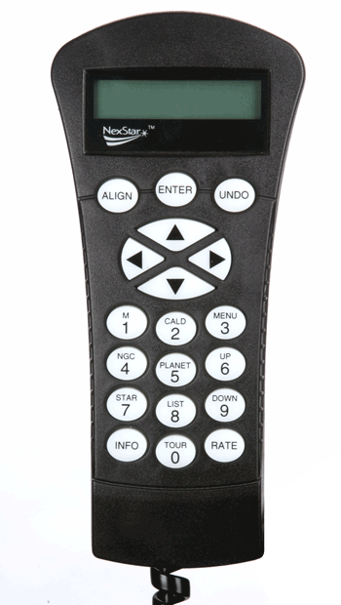
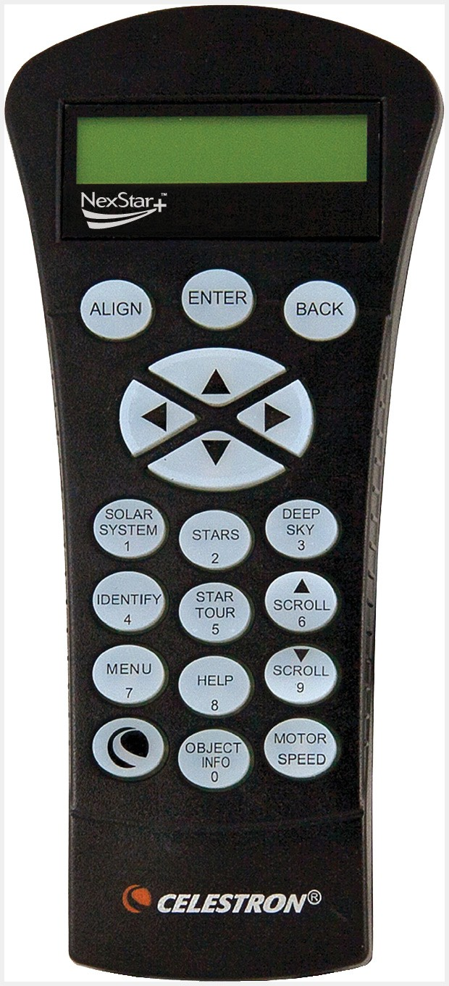

Figure 1: Hand Control Version 1 Figure 2: Hand Control Version 2

- To find named stars or double stars:
Hand Control Version 1: Press LIST. Scroll until you find Named Stars or Double Stars. Press ENTER and Scroll until you find the Star you are looking for. Press ENTER and the telescope will move.

Hand Control Version 2: Press STARS and you will have list to pick from including Named Stars and Double Stars. Press ENTER and Scroll until you find the Star you are looking for. Press ENTER and the telescope will move.

- To find planets and the Moon:
Hand Control Version 1: Press PLANET (#5 Button).

Hand Control Version 2: Press SOLAR SYSTEM (#1 Buton).

- To find Messier Objects:
Hand Control Version 1: Press M (Button #1) Enter the Messier number. Since there are over 100 Messeir objects, to find M45, you would enter 0-4-5. Don’t forget the 0. Press ENTER.

Hand Control Version 2: Press DEEP SKY (#3 Button). Scroll until you find Messier and Press ENTER. Enter the Messier number. Since there are over 100 Messeir objects, to find M45, you would enter 0-4-5. Don’t forget the 0. Press ENTER.

- To find NGC Objects:
Hand Control Version 1: Press NGC (Button #4). Enter the NGC number and Press ENTER.

Hand Control Version 2: Press DEEP SKY (#3 Button). Scroll until you find NGC and Press ENTER. Enter the NGC number and Press ENTER.

- To find other Deep Sky Objects by name:
Hand Control Version 1: Press LIST. Scroll until you find Named Objects. Press ENTER and Scroll until you find the object you are looking for. Press ENTER.

Hand Control Version 2: Press DEEP SKY (#3 Button). Scroll until you find Named Objects and Press ENTER. Scroll until you find the object you are looking for. Press ENTER.

